

School of Public Administration  
Bachelor of Science in Computing

**COMP321 Information System Implementation  
Final Report**Academic Year 2016/17   
2nd semester

|  |  |
| --- | --- |
| Online Shopping Mall | |
|  |  |
| Project number: | A4 |
| Team members: |  |
|  |  |
|  |  |
|  |  |
|  |  |
|  |  |
| Supervisor: |  |
| Assessor: | Your assessor |
|  |  |
| Submission Date: | Apr 13, 2017 |

**Table of Contents**

[1](#_3znysh7) Introduction 6

[1.1](#_2et92p0) Overview 6

[1.2](#_tyjcwt) Objectives 7

[1.3](#_1t3h5sf) Risk Assessment 9

[1.3.1](#_17dp8vu) Risk Description, Precaution and Contingency Plans 10

[1.3.2](#_3rdcrjn) Reassessment of risks after applying the contingency plan 11

[2](#_1ksv4uv) Background and Related Work 12

[2.1](#_44sinio) Background 12

[2.1.1](#_2jxsxqh) Current situation and the idea of S-Mobile 12

[2.2](#_z337ya) Related Work 13

[2.2.1](#_3j2qqm3) Research on exiting online shopping mall 13

[2.2.2](#_1y810tw) Solutions and plans proposed by this project 13

[3](#_4i7ojhp) System Design 15

[3.1](#_2xcytpi) Data Modelling 15

[3.2](#_2bn6wsx) Dynamic Modelling 22

[3.2.1](#_qsh70q) Sequence Diagram 22

[4](#_1pxezwc) System Implementation 24

[4.1](#_49x2ik5) Architecture 24

[4.1.1](#_2p2csry) Layered Architecture 24

[4.1.2](#_3o7alnk) MVC Model 25

[4.2](#_ihv636) Product Search and Detail Display 26

[4.3](#_2grqrue) Image Storage and Handling 28

[4.4](#_2u6wntf) Password Security 30

[4.5](#_3tbugp1) Purchase Order Processing 31

[4.6](#_111kx3o) Customers’ Ratings and Reviews 34

[4.7](#_206ipza) Concurrency Control 35

[4.8](#_2zbgiuw) Notification 36

[5](#_sqyw64) Results and Discussion 38

[5.1](#_3cqmetx) Project Outcome 38

[5.1.1](#_2r0uhxc) Product List 38

[5.1.2](#_1jlao46) Product Detail Page 40

[5.1.3](#_2iq8gzs) Account Management 41

[5.1.4](#_1opuj5n) Shopping Cart 44

[5.1.5](#_2250f4o) Purchase Tracking 45

[5.1.6](#_1gf8i83) Product Catalog Maintenance 46

[5.1.7](#_1ljsd9k) Purchase Order Processing 52

[5.1.8](#_zu0gcz) Customer Rating and Review 53

[5.1.9](#_1d96cc0) Notification 56

[5.1.10](#_rjefff) Price and Inventory Control 57

[5.2](#_2pta16n) Testing and System Evaluations 59

[6](#_14ykbeg) Conclusion and Further Work 66

[References 67](#_3oy7u29)

[Appendix A. Project Management 68](#_243i4a2)

[Appendix B. Peer Assessment Form 69](#_j8sehv)

[Appendix C. Program source code / UML diagram, etc 70](#_338fx5o)

**Table of Figures**

[Figure 1: Impact and Probability of Risk 11](#_2s8eyo1)

[Figure 2: Impact and Probability of Risk after re-assessment 13](#_35nkun2)

[Figure 3: Entity Relationship Diagram (After Normalization) 19](#_1ci93xb)

[Figure 4: Sequence Diagram for User Purchasing 24](#_3as4poj)

[Figure 5: Layered Architecture Diagram 26](#_147n2zr)

[Figure 6: MVC Model Diagram 27](#_23ckvvd)

[Figure 7: Code of Search Function at Vendor Side 29](#_32hioqz)

[Figure 8: Code of Search Function at Vendor Side 29](#_1hmsyys)

[Figure 9: Code of Search Function at Customer Side 30](#_41mghml)

[Figure 10: Code of Search Function at Customer Side 30](#_vx1227)

[Figure 11: Code of Image Storage 31](#_3fwokq0)

[Figure 12: Code of Image Removal 32](#_1v1yuxt)

[Figure 13: Code of Image Retrieval 32](#_4f1mdlm)

[Figure 14: Code of Changing Password 33](#_19c6y18)

[Figure 15: Swap of Purchase Order Status 34](#_28h4qwu)

[Figure 16: Code of Check Out 35](#_nmf14n)

[Figure 17: Code of Order Cancel 35](#_37m2jsg)

[Figure 18: Code of Order Hold 35](#_1mrcu09)

[Figure 19: Code of Order Unhold 36](#_46r0co2)

[Figure 20: Code of Customer Cancel Order 36](#_2lwamvv)

[Figure 21: Code of customers’ rating and reviews 37](#_3l18frh)

[Figure 22: Code of customers’ rating and reviews 37](#_4k668n3)

[Figure 23: Graphic User Interface of Notification 38](#_1egqt2p)

[Figure 24: Graphic User Interface of Notification 39](#_3ygebqi)

[Figure 25: Graphic User Interface of Notification 39](#_2dlolyb)

[Figure 26: Graphic User Interface of Product List 40](#_1664s55)

[Figure 27: Pagination of Product List 41](#_3q5sasy)

[Figure 28: Changing Pagination of Product List 41](#_25b2l0r)

[Figure 29: The Comparison of Filtering the Product List 41](#_kgcv8k)

[Figure 30: Searching the Product List by Keywords and Brand Filter 42](#_34g0dwd)

[Figure 31: Graphic User Interface of Product Detail Page 42](#_43ky6rz)

[Figure 32: Graphic User Interface of Registration Page 43](#_xvir7l)

[Figure 33: Error Message of Registration 43](#_3hv69ve)

[Figure 34: Required Message of Registration 43](#_1x0gk37)

[Figure 35: Graphic User Interface of Registration 44](#_4h042r0)

[Figure 36: Graphic User Interface after Login (Product List) 44](#_2w5ecyt)

[Figure 37: The Validation of Registration 44](#_1baon6m)

[Figure 38: Graphic User Interface of Changing Password 44](#_3vac5uf)

[Figure 39: Validation of Changing Password 45](#_2afmg28)

[Figure 39: Validation of Changing Password 45](#_pkwqa1)

[Figure 41: The Database View of User Account 45](#_39kk8xu)

[Figure 42: Successful Message of Adding Product to Shopping Cart 46](#_48pi1tg)

[Figure 43: Graphic User Interface of Shopping Cart 46](#_2nusc19)

[Figure 44: Graphic User Interface of Purchase Tracking Page 47](#_haapch)

[Figure 45: Graphic User Interface of Order Detail 47](#_319y80a)

[Figure 46: Graphic User Interface of Product Catalog Maintenance 48](#_40ew0vw)

[Figure 47: Searching Function of Product Catalog Maintenance 49](#_2fk6b3p)

[Figure 48: Searching Function of Product Catalog Maintenance 49](#_upglbi)

[Figure 49: The Result of Searching Function of Product Catalog Maintenance 49](#_3ep43zb)

[Figure 50: The Result of Searching Function in Product Catalog Maintenance 50](#_1tuee74)

[Figure 51: The Result of Filtering Function in Product Catalog Maintenance 50](#_4du1wux)

[Figure 52: The Result of Searching and Filtering Function in Product Catalog Maintenance 51](#_2szc72q)

[Figure 53: New Product Creation in Product Catalog Maintenance 51](#_184mhaj)

[Figure 54: Vendor View of Product Detail in Product Catalog Maintenance 52](#_3s49zyc)

[Figure 55: The Promotion Price Changing in Product Catalog Maintenance 53](#_279ka65)

[Figure 56: Graphic User Interface of Product Order 54](#_45jfvxd)

[Figure 57: Graphic User Interface of Product Detailed Order 54](#_2koq656)

[Figure 58: Graphic User Interface of Product Detailed Order 55](#_3jtnz0s)

[Figure 59: Notification of Product Detailed Order 55](#_1yyy98l)

[Figure 60: Customer Rating and Review 56](#_4iylrwe)

[Figure 61: The Update of Customer Rating and Review 57](#_2y3w247)

[Figure 62: Graphic User Interface of Notification 58](#_3x8tuzt)

[Figure 63: Graphic User Interface of Notification 58](#_2ce457m)

[Figure 64: Graphic User Interface of Price and Inventory Control 59](#_3bj1y38)

[Figure 65: Reminder of Price and Inventory Control 59](#_1qoc8b1)

[Figure 66: Graphic User Interface of Price and Inventory Control 60](#_4anzqyu)

# Introduction

This section illustrates threes parts. Firstly, the overview of the current market whole report will be showed. Secondly, the objectives of this project will be indicated. Finally, the risk assessment plus the solutions will be proposed.

## Overview

Currently, mobile phone is indispensable to people’s daily life, and with the speed of smart phones’ updates getting much higher than ever before, people nowadays tend to change their phones much more frequently in order to catch the trend and more essentially, users do need a newer phone to get access to most of the convenient functions.

Online shopping mall is common to daily life since the Internet is almost reach every corner around us. Customer may purchase the product through the browser of PC or Smart Phone. Vendor can also process the order or product online. Perfect market environment plus the great techniques provide a huge opportunity for retailing. So an online distribution channel of mobile phones is needed since online shopping is quite a hit right now. And this project, which is called S-Mobile, is to build such an online shopping mall dedicating mobile phones. We provide any needed functions. For example, consumers can add products to shopping cart and keep tracking the status on them. Vendors can also manage orders and check fund transfer.

This report is all about this online shopping mall, S-Mobile. In the first section, there is a brief introduction about this whole project. In the second part of this report, the background of this S-Mobile project will be talked about as well as some research on some opponents. Thirdly, system design, which is about data modeling and dynamic modeling, will be discussed. And in section four, system implementation will be mentioned. Last but not the least, the end of the report will include results and discussion by showing some project outcomes and doing some testing on this system.

## Objectives

The main objective is to build an online shopping mall system to enable the customers to browse, select, and purchase the products in the shopping mall as well as the vendor to manage, maintain, and process the whole online shopping system.

The section below illustrates the 40 requirements which have been implemented from 8 aspects.

1. **Product List**

As many other online shopping systems, a product list for customer to browse products is designed. Thumbnail image of a products are showed in list. Search function which can find the product by entering some key word of product title. Customer may also sort the product list by price and filter the products by brand.

1. **Product Detail Page**

By clicking a specific product in product list, customer may enter the product detail page. In product detail page, user may view more information of a product.

Detail pictures will be displayed in this page to provide more detail of a product to users. Customer may click button add the product to the shopping cart.

1. **Account Management**

The system provides account registration function to customer. Customer only need to fill some required information to get their account. After registration, customer may use this account to login the system to purchase the product. For security reason, the password of customers are hashed to store in the database.

1. **Shopping Cart**

A shopping cart function is implemented in the system. User can add multiple product into the shopping cart and check out them together. In the shopping cart, customer may modify the quantity of the each product, remove specific product, change or add the shipping address, and check out.

1. **Purchase Tracking**

In this project, customer may view the historical or active orders of him/herself. Customer may look those order in order list. By clicking one order, customer may enter the detail page of the order to view more information. In the order detail page, the customer may cancel the order before it is shipped.

1. **Product Catalog Maintenance**

This system also provides some functions for vendor to maintain the product. By using these special webpages, vendor may browse the product catalog which contains every product. Vendor may create new product, modify information and images of the existing products, and delete some products.

1. **Purchase Order Processing**

Vendor may also process orders through this system. An order list provides every record of order from every customer. Vendor may filter these order by the status of order. By click one record in the order list, vendor may enter the detail page of some specific order. In the detail page, vendor may ship the unship order, hold the order, cancel the order before it is shipped.

1. **Advanced Function**

To improve the using experience of the system, there are some advanced features which are implemented in the project. Notifications function for customer to easily track the order. After the product is shipped, the customer may rate and comment the product. For vendor, hot-selling product, out-of-stock product can also be easily marked.

## Risk Assessment

A robust online shopping mall system requires comprehensive risk assessment and effective contingency plans. Major threats to this project and their probability will be estimated in prioritize in Table 1 and impact and probability of risks are displayed in Figure 2.

|  |  |
| --- | --- |
| Priority | Risk Identifier and Description |
| 1 | Server side data inconsistence |
| 2 | Server overloads when handle too many requests |
| 3 | Server stops working (Hardware Failure) |
| 4 | Session Hijacking |
| Priority 1 is the highest priority | |

**Table 1: Table of Prioritized Risks**

|  |  |  |  |
| --- | --- | --- | --- |
| Impact  Probability | Low | Medium | High |
| Low |  |  | 1. Server hardware failures. 2. Session hijacking |
| Medium |  | 1. Server overloads when handling too much request |  |
| High | 1. Server side data inconsistence |  |  |

**Figure 1: Impact and Probability of Risk**

### Risk Description, Precaution and Contingency Plans

1. Client side data may be different from the database in the server side because the data may not be updated at the very first time.

**Precaution:** The precaution for this risk is hard to design, because the request cannot be send to sever continuously to request update data. But the effect of this problem can be reduced by sending relatively frequently requests.

**Solution:** The best solution is to request the server for the latest data frequently, but this solution may make risk 2 easy to happen.

1. Servers may overload because of too many requests. This might be stands for a good popularity of the system.

**Precaution:** By setting more servers or using better CPU, this problem can be precaution, but it is not absolutely solved since the number of user may increases extremely fast and this may lead extra cost.

**Solution:** If this problem occurs, it will definitely affect the using experience. And it can be solved by increase the quantity or quality of the server.

1. The server may experience hardware failure or power cut off but the chances will be extremely low.

**Precaution:** There is no solution to fix this problem after it occurs. It can only be precaution by well maintenance.

1. The security is a very important aspect of the whole system. Since the system use session, the session may take risk to be hijacked.

**Precaution:** Normally, session hijack can be solved by using a long bits (64, 128) RSA encryption algorithm. If the encryption is broken, there is a little this to solve the problem.

### Reassessment of risks after applying the contingency plan

After applying the contingency plan, two risks reduce the probability to occur. Accordingly, the new table of prioritized risks is depicted below (See Table 2) and impact and probability of risks are displayed in Figure 2.

|  |  |
| --- | --- |
| Priority | Risk Identifier and Description |
| 1 | Server hardware failures |
| 2 | Session Hijacking |
| 3 | Server overloads when handle too many requests |
| 4 | Server side data inconsistence |
| Priority 1 is the highest priority | |

**Table 2: Table of Prioritized Risks after Applying the Contingency Plan**

|  |  |  |  |
| --- | --- | --- | --- |
| Impact  Probability | Low | Medium | High |
| Low | 1. Server side data inconsistence 2. Server overloads when handling too much request | 1. Server programs terminate | 1. Server hardware failures. 2. Session hijacking |
| Medium |  |  |  |
| High |  |  |  |

**Figure 2: Impact and Probability of Risk after re-assessment**

# Background and Related Work

This section would firstly talk about the current situation about online shopping for mobile phones, in which shows the urgent need of an online shopping mall targeting on mobile phones specifically. As for the second part, some existing online shopping mall would be talked about. Because there is no such a website that mainly focuses on mobile phones like ours, only these phone selling sections of each online shopping mall would be compared.

## Background

### Current situation and the idea of S-Mobile

Nowadays, mobile phones are playing a more and more essential role in our daily lives. People now are more willing to accomplish most of the daily tasks by using their phones. And as a result, more and more useful functions are now added to smart phones to make our lives easier, those functions we can’t live without. For instance, 3D Touch, NFC, fingerprint identification, etc. And to get access to these new functions, we would be acquired to get a newer mobile phone. Along with the explosion of technology of smart phone, people tend to change their phones more frequently than before, which means there is a huge market over there.

But when it comes to the distribution channel of mobile phones, except from the traditional ones, there is no such an online shopping mall that focuses on mobile phones only. These so-called distribution channels are just a section of an online shopping mall who sells everything. Consumers would start to wonder which one should they choose to buy mobile phones. However, if there is an online shopping mall leaning focus on selling mobile phones, people would tend to consider this an authoritative way of buying mobile phones. That is how we come up with our idea of S-Mobile.

## Related Work

### Research on exiting online shopping mall

As we discussed above, nearly every popular online shopping mall has a section for selling mobile phones. At this part, we will mainly talk about JD.com and Taobao. Each of these two is now a great hit in both Mainland China and Macao. People love to purchase things on these two online malls. But in terms of buying mobile phones, both JD.com and Taobao receive many complaints.

Firstly, JD.com doesn’t provide the function that predicts the regions of users. And because of that, all the products’ storage places that users browse is set to default as Beijing which will confuse users when they are trying to figure out how many stocks are there in their regions. And when it comes to fill consignee's information, there is no error prevention which will be likely to cause some problems in the near future such as delivering. And JD.com doesn't support Alipay which is the biggest online payment method in Mainland China.

As for Taobao, a certain number of consumers complain about the quality of the phones which Taobao is selling. Consumers doubt that they have bought a used phone or a retreading machine or even worse, an emulational phone according to the appearance of the phones they received. Actually, things like that do happen because some merchants on Taobao are not qualified due to some management mistakes.

On the other hand, emulational phones would not be found on JD.com thanks to its self-support business mode. But issues about used phones and retreading phones still cannot be avoided because JD.com has a returns policy that allows consumers to refund in seven days without any reasons. And it is this policy that makes JD.com owns a lot of sales returns, and to handle these products, JD.com would launch these products back to their supply chains. Problems arise.

### Solutions and plans proposed by this project

Our project devotes in improving current situation which consumers would face when they buy cell phones online. First of all, our selling products are all directly deported from these manufacturers. So issues like retreading machine or emulational phone shall never occur. Secondly, refund service will not be provided on our website, so consumers don’t need to worry about if there are any used phones in our supply chain. And of course, our project would maintain all these advantages that Taobao and JD.com have. With all these convenient that online shopping possesses and some problems solved, our project will be competitive in the market.

The most facilitating thing in our online shopping mall is the UI, all design is in line with habit of usability, from every button to every step are concerned. At upper-right corner, there is a dropdown list of notification. On the other hand, the efficient functionalities like sorting, filtering, searching. Moreover, if a product is out-of-stock, customers can still hold that product in a waiting order.

# System Design

To accomplish the E-business system, a good database structure as well as some special considerations should be implemented. Two phases of system design, the whole database structure overview, detail and special consideration will be indicated below, also the detail of system dynamic data exchange methods between different parts of system, will be illustrated.

To achieve an efficient, robust, developer-friendly development, we choose some popular techniques as the develop tools. The database which used in this system is MySQL. The whole system is implemented by a framework Laravel, which is written by PHP. MVC (Model-View-Controller) design pattern is used in the whole system development.

## Data Modelling

Figure 1 below shows the normalized ER-diagram of the system. There are 7 entities designed in the database modelling.

Entity Product represents the products (smart phones) with a unique product id and some detail attributes (smart information, price, inventory quantity, and images) which are required in the business process. Since one product may have more than one detail pictures, an entity called DetailPicture is created to store the information about those detail pictures. It contains the foreign key which stands for which product it belongs to, an index to represent the order of the pictures. Database, which is MySQL in this system, is not capable to store any formats of image file, therefore the path of pictures are stored in the database instead of the image file.

Customers and vendor are represented by Users entity. It contains some information of customers, for instance, email, user name, address and password. Since a customer may have more than one shipping address, an entity called ShippingAddress is designed to store the addresses. It includes sID as a unique key for an address, uID which is foreign key to Users entity, the address and a default number which is used to identify which address is the default address of a customer.

The online shopping mall system has a shopping cart function, therefore entity ShoppingCart is created to store a product’s information in the shopping cart of a specific user. The entity stores a uID to indicate who is the customer it belongs to, quantity of the product, date when the product is added to the cart, and a foreign key to a specific product. The reason why only a product id is stored is that the price of the every product may change before the user check out, therefore only a reference is stored in the ShoppingCart entity to maintain the consistence of the whole system.

To implement the purchase order tracking and maintaining functions, PurchaseOrder entity is designed to store the data of every purchase order. It includes shipping address, status which only store as a number for save storage and 4 types of date. There is no product store in this entity because one order may have more than one product, therefore PurchaseProducts entity is created to store the information of every product in a specific purchase order. PurchaseProducts entity contains a PONo as foreign key to a specific order, a pID as a foreign key to a specific product, rate, comment and price. Price is also a attribute in the table because of the changeable price of product, to record what the customer paid when he or she checked out, this data is useful.

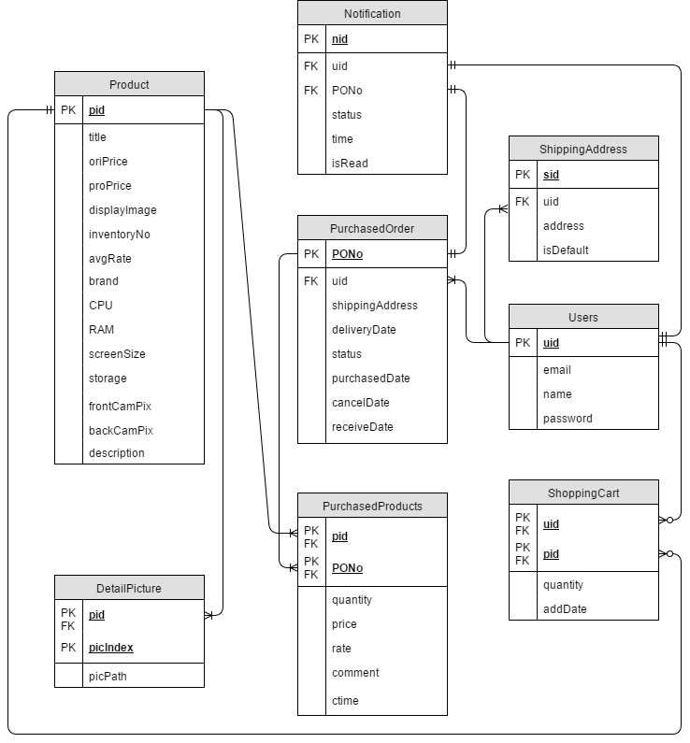

**Figure 3: Entity Relationship Diagram (After Normalization)**

|  |  |  |
| --- | --- | --- |
| **Product** | | |
| Attributes | Description | Data Type(Length, Decimal Point) |
| pID [PK]  title  oriPrice  proPrice  displayImage  inventoryNo  avgRate  brand  CPU  RAM  screenSize  storage  frontCamPix  backCamPix  description | Uniquely identifies the product  Name of product  Original price of product  Promote price of product  Thumbnail of product  Current number of product  Average of customer rating  Brand of product  Type of Central Processing Unit which the product is using  Capacity of Random-access memory of the product  Inches of the product screen  Capacity of product's storage  Pixel of front facing camera of product  Pixel of back camera of product  Short description of product | Integer(10)  Varchar(255)  Double  Double  Varchar(255)  Integer(6)  Double(8,2) [Derived Attribute]  Text  Varchar(255)  Integer(2)  Double(8,2)  Integer(2)  Integer(5)  Integer(5)  Text |

“Product” is a main entity in our database design; it contains detail information of each product. Therefore, pID of “Product” is referenced by three entities called “PurchasedProduct”, “DetailPicture” and “ShoppingCart” to get the information.

|  |  |  |
| --- | --- | --- |
| **Users** | | |
| Attributes | Description | Data Type(Length, Decimal Point) |
| uID [PK]  name  email  password | Uniquely identifies the customer  The full name of the customer  The email address of the customer  The password of the customer’s account | Integer(10)  Varchar(255)  Varchar(255)  Varchar(255) |

“User” is an entity that contains all users’ personal data. uID of “User” is referenced by four entities called “PurchasedOrder”, “ShoppingCart”, “ShippingAddress” and “Notification”.

|  |  |  |
| --- | --- | --- |
| **PurchasedOrder** | | |
| Attributes | Description | Data Type(Length, Decimal Point) |
| PONo [PK]  uID  shippingAddress  deliveryDate  status  purchasedDate  cancelDate  receiveDate | Uniquely identifies the purchase order  Uniquely identifies the user  The address of the destination of this purchase order  The date that the product will be delivered  The product’s delivery status  The date that the products being purchased  The date that the purchase order being canceled  The date that the product being received by customer | Integer(10)  Integer(10)  Varchar(255)  Integer(11) [Can be null]  Integer(1) [1: Pending or 2: Shipped or 3: Canceled by Vendor or 4: Canceled by User or 5: Hold]  Integer(11)  Integer(11) [Can be null]  Integer(11) [Can be null] |

“PurchasedOrder” holds all order in S-Mobile. PONo is referenced by “PurchasedProducts” and “Notification”.

|  |  |  |
| --- | --- | --- |
| **PurchasedProducts** | | |
| Attributes | Description | Data Type(Length, Decimal Point) |
| pID [PK]  PONo [PK]  quantity  price  rate  comment  ctime | Uniquely identifies the product  Uniquely identifies the purchase order  The number of the purchased product  The price of the purchased product  The mark that customer rates for this product  The comment that customer leaves for the product  The date of comment | Integer(10)  Integer(10)  Integer(11)  Double  Integer(1) [Can be null]  Text [Can be null]  Integer(11) |

“PurchasedProducts” has composite primary key, in order to save the corresponding purchased product detail information like its quantity.

|  |  |  |
| --- | --- | --- |
| **DetailPicture** | | |
| Attributes | Description | Data Type(Length, Decimal Point) |
| pID [PK]  picIndex [PK]  picPath | Uniquely identifies the product  Uniquely identifies the picture of the corresponding product  The file path of the corresponding picture | Integer(10)  Integer(1)  Text |

“DetailPicture” is used to arrange the detail picture order of each product.

|  |  |  |
| --- | --- | --- |
| **ShoppingCart** | | |
| Attributes | Description | Data Type(Length, Decimal Point) |
| uID [PK]  pID [PK]  quantity  addDate | Uniquely identifies the user  Uniquely identifies the product  The number of the purchased product  The date of user add product to the shopping cart | Integer(10)  Integer(10)  Integer(5)  Integer(11) |

“ShoppingCart” is an entity to record each users’ wishing products in shopping cart.

|  |  |  |
| --- | --- | --- |
| **ShippingAddress** | | |
| Attributes | Description | Data Type(Length, Decimal Point) |
| sID [PK]  uID  address  isDefault | Uniquely identifies the shipping address  Uniquely identifies the user  The shipping address of the user  Determine the address is default or not | Integer(10)  Integer(11)  Varchar(255)  Tinyint(1) [0 or 1] |

“ShippingAddress” is an entity to record users’ different shipping address and determine the address is using currently or not.

|  |  |  |
| --- | --- | --- |
| **Notification** | | |
| Attributes | Description | Data Type(Length, Decimal Point) |
| nID [PK]  uID  PONo  status  time  isRead | Uniquely identifies the notification  Uniquely identifies the user  Uniquely identifies the purchase order  The record of corresponding order status  (Pending or Shipped or Cancelled by vendor or cancelled by user or Hold)  The time of order status changed  Determine the notification is read by user or not | Integer(10)  Integer(10)  Integer(10)  Integer(1) [1: Pending or 2: Shipped or 3: Canceled by Vendor or 4: Canceled by User or 5: Hold]  Integer(11)  Tinyint(1) [0 or 1] |

“Notification” is an entity to record every changes of the order status.

All relationships between Entities:

|  |  |
| --- | --- |
| **PurchasedOrder** | |
| PONo  uID | FK to Users(uID) |
| **PurchasedProducts** | |
| pID  PONo | FK to Product(pID)  FK to PurchasedOrder(PONo) |
| **DetailPicture** | |
| pID  picIndex | FK to Product(pID) |
| **ShoppingCart** | |
| uID  pID | FK to User(uID)  FK to Product(pID) |
| **ShippingAddress** | |
| sID  uID | FK to Users(uID) |
| **Notification** | |
| nID  uID  PONo | FK to Users(uID)  FK to PurchasedOrder(PONo) |

## Dynamic Modelling

In this section, the dynamic modelling in S-Mobile is specified as the use of sequence diagram.

### Sequence Diagram

The following figure describes how a customer finishes the whole purchasing process in our system.

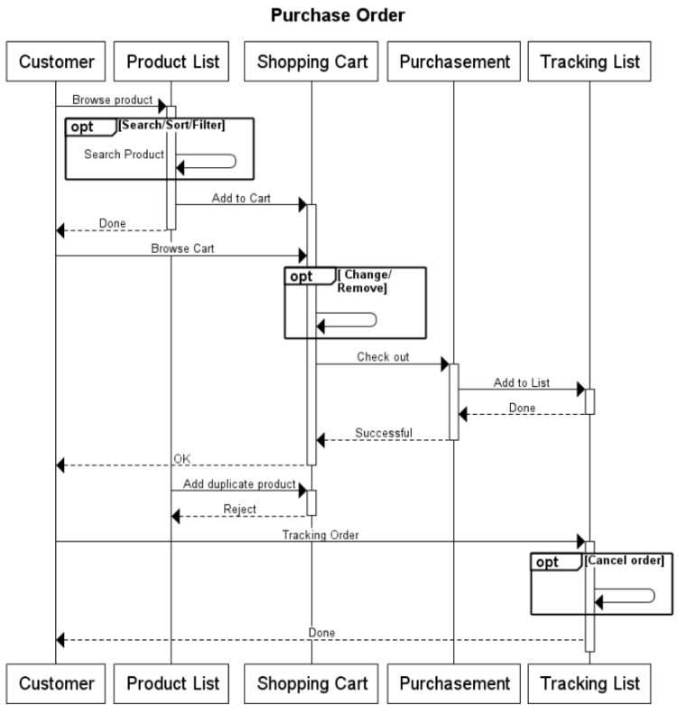

**Figure 4: Sequence Diagram for User Purchasing**

As first, customers can browse various products in product list page. Alternatively, they can filter by brand of product and sort by price and search name of product by using one or more keywords. Before customers chose the products they want, he/she can add them to shopping cart. However, a customer cannot add duplicate product to their shopping cart. Then, customer can check out, change quantity of product or remove products. When customers check out, our system will save all products in shopping cart. And message about purchased order will be displayed to the customer. Simultaneously, server will generate an order to customer's tracking order list. Therefore, customers can track their own order by checking the status. Customer can either wait for order to shipped or cancel the order.

# System Implementation

In this section, the information of constructing our online shopping mall is provided, such as the architecture and functions.

## Architecture

The online shopping mall is built up by two architectures: layered architecture and MVC model. The architectures are divided into the following two subsections.

### Layered Architecture

S-Mobile is used layered architecture pattern to separate the code of similar responsibilities that are being factored into layers. JQuery is dealt with the presentation of the content and interaction with the user; it gets the data from Apache. PHP and Bootstrap is used to receive data from upper level and transform it. The deepest level is MySQL server; it is used to retrieve data from sources.

As the following layered architecture diagram (figure) below:

Web Browser  
JQuery, Bootstrap

Web Server  
Apache

Application Server  
PHP

Database  
MySQL Server

**Figure 5: Layered Architecture Diagram**

### MVC Model

S-Mobile is also used MVC model to separate model, view and controller. To fast up our development process and provide an easy way of us to divide the work. The architecture is shown as the following figure.

**Controller**

Handling HTTP Requests

Processing PHP Requests

Data Validations

**View**

Generating Page

Using Templates

**Model**

Database Operation

Verification

Business Processes

HTTP Request

Return Display

Send Request

Return Response

Get Data

Send

**Figure 6: MVC Model Diagram**

## Product Search and Detail Display

There are two type of search function we implement for customer and vendor. Each user type can search the products by the keyword of product. If users used brand filter function, the search function would filter the product by the brand at first.

As the following code captures, the search function of customer and vendor are much look like each other. The only different of them is that vendor is able to search the product by the product ID. They are both using Laravel Eloquent ORM (Object Relational Mapping), which is an implementation of Active Record for converting data, to work with database. Also, we used regular expression to condition whether users used brand filter in before of not.

ORM is a programming technology for corresponding the complicate programming object to the table of related DBMS (Database Management System). By using ORM, we can implement CRUD (Create, Read, Update, and Delete) functions to database without SQL statement. The advantage is that it can reduce the related code of SQL statement. The below form would shows some example of corresponding SQL syntax in Laravel Eloquent ORM which are used in search function.

|  |  |
| --- | --- |
| **SQL Syntax** | **Laravel Eloquent ORM** |
| SELECT \*, SELECT columnName | /, select('columnName') |
| FROM tableName | ModelClassName:: |
| WHERE column = or != or > or < or >= or <= 'value' | where('column', '= or != or > or < or >= or <=', 'value') |
| AND/OR WHERE above conditional | andWhere(above conditional) / orWhere(above conditional) |
| DISTINCT columnName | distinct('columnName') |

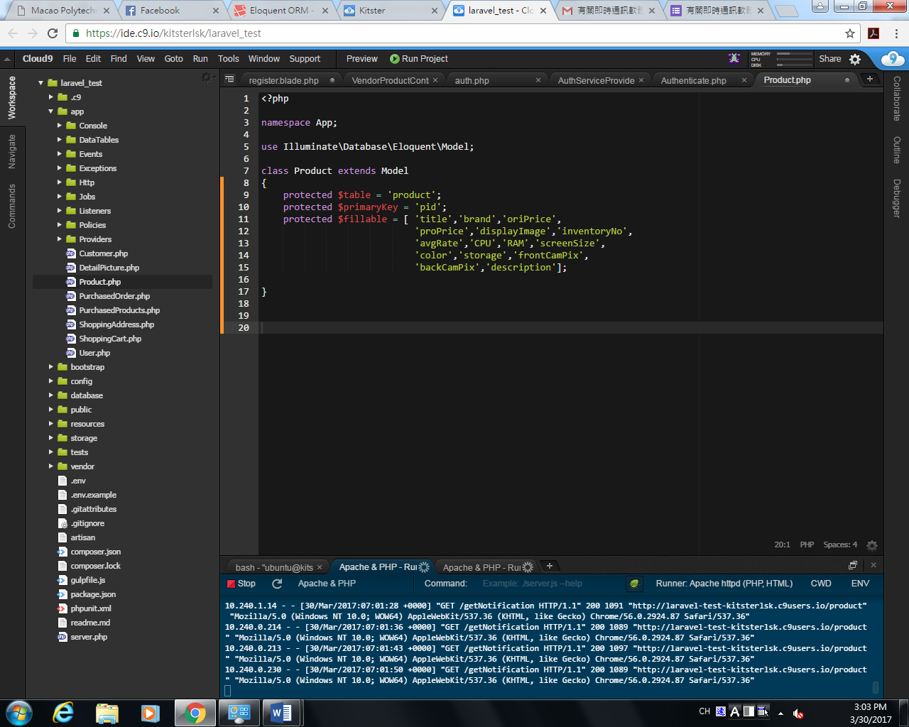

**Figure 7: Code of Search Function at Vendor Side**

Product class is an Active Record which is a model in MVC. It takes a responsibility to be done the function of CRUD with the table of product in DBMS by using ORM.

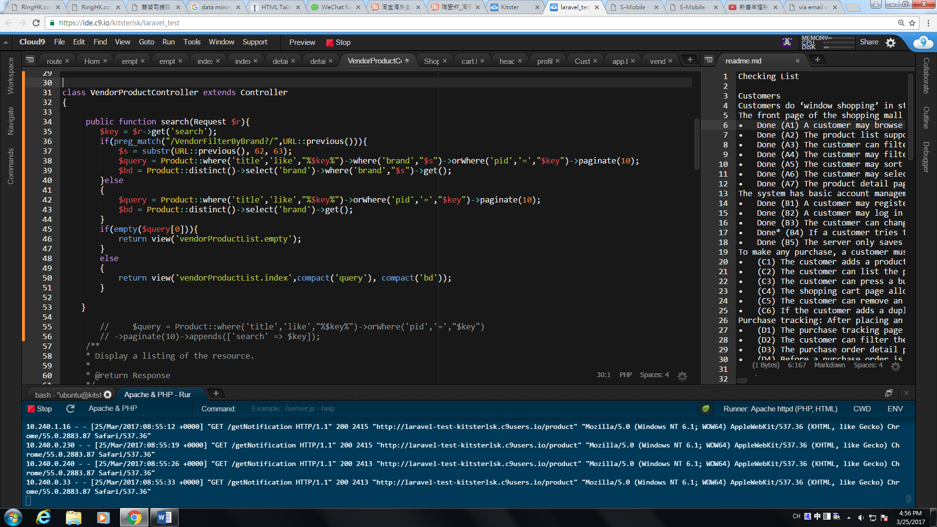

**Figure 8: Code of Search Function at Vendor Side**

The vendor’s search() function is able to search the product by either keyword of product or product ID. Also, it supports brand filter.

**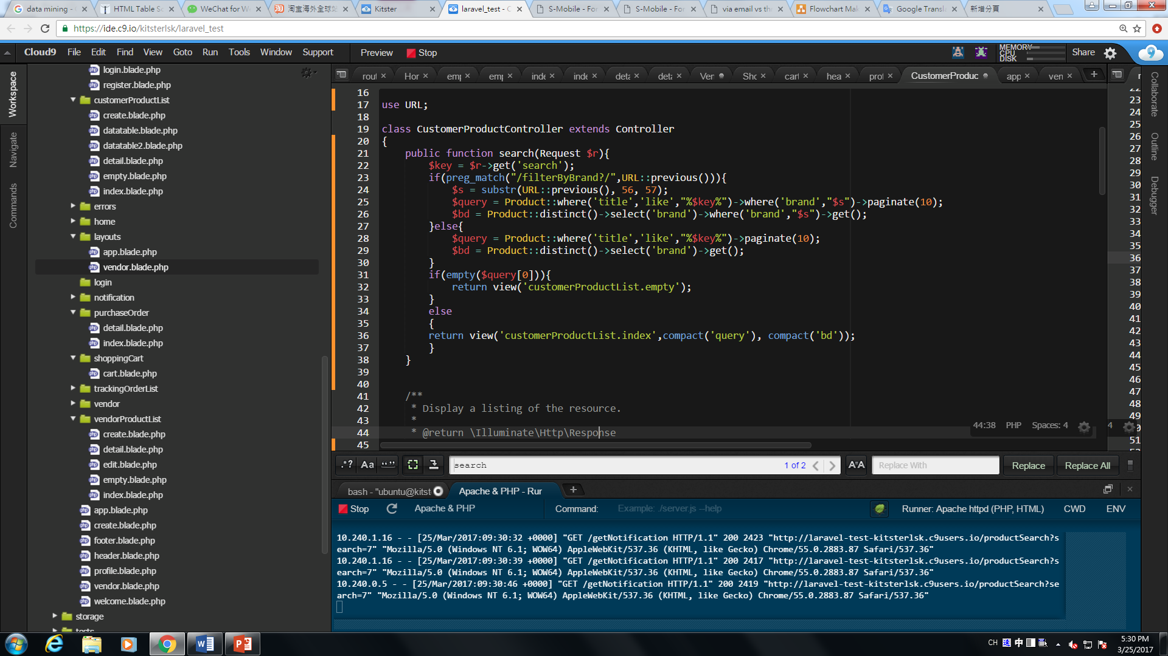**

**Figure 9: Code of Search Function at Customer Side**

The customer’s search() function is able to search the product by keyword of product. Furthermore, it supports brand filter.

## Image Storage and Handling

When vendor upload the image to the server, it would assign the unique name to the image before storing. After that, it would be stored in the storage/app/ folder which specific in config/filesystems.php (Figure 10). Afterward, insert the file path in the database.

For display images in client side, the server would transmit all the image path through retrieving it in the database. Server provides two type of users which are vendor and customer to view the product images and allows vendor to edit its. They are both able to view the product thumbnail image in the product list page or view the all of detail images in the product detail page. Furthermore, vendor can remove and re-upload the image in the edit page.

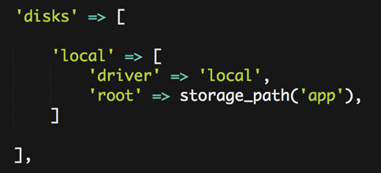

**Figure 10: Code of Search Function at Customer Side**

The above figure (Figure 10) specifics the storage location in Laravel. The local, which is the key in the disks array, is a parameter for disk() (Figure 11) and it mainly declare that the storage space and its folder location. The key driver means the space of storage (local, cloud… etc.). It is because all the file would be stored in local folder in our website, we assign the value ' local ' for the driver. The key root means the folder location path. In Laravel, it provides a method call storage\_path() for specific the storage path. If assign the parameter in that method, it would create a sub folder and save the file in there.

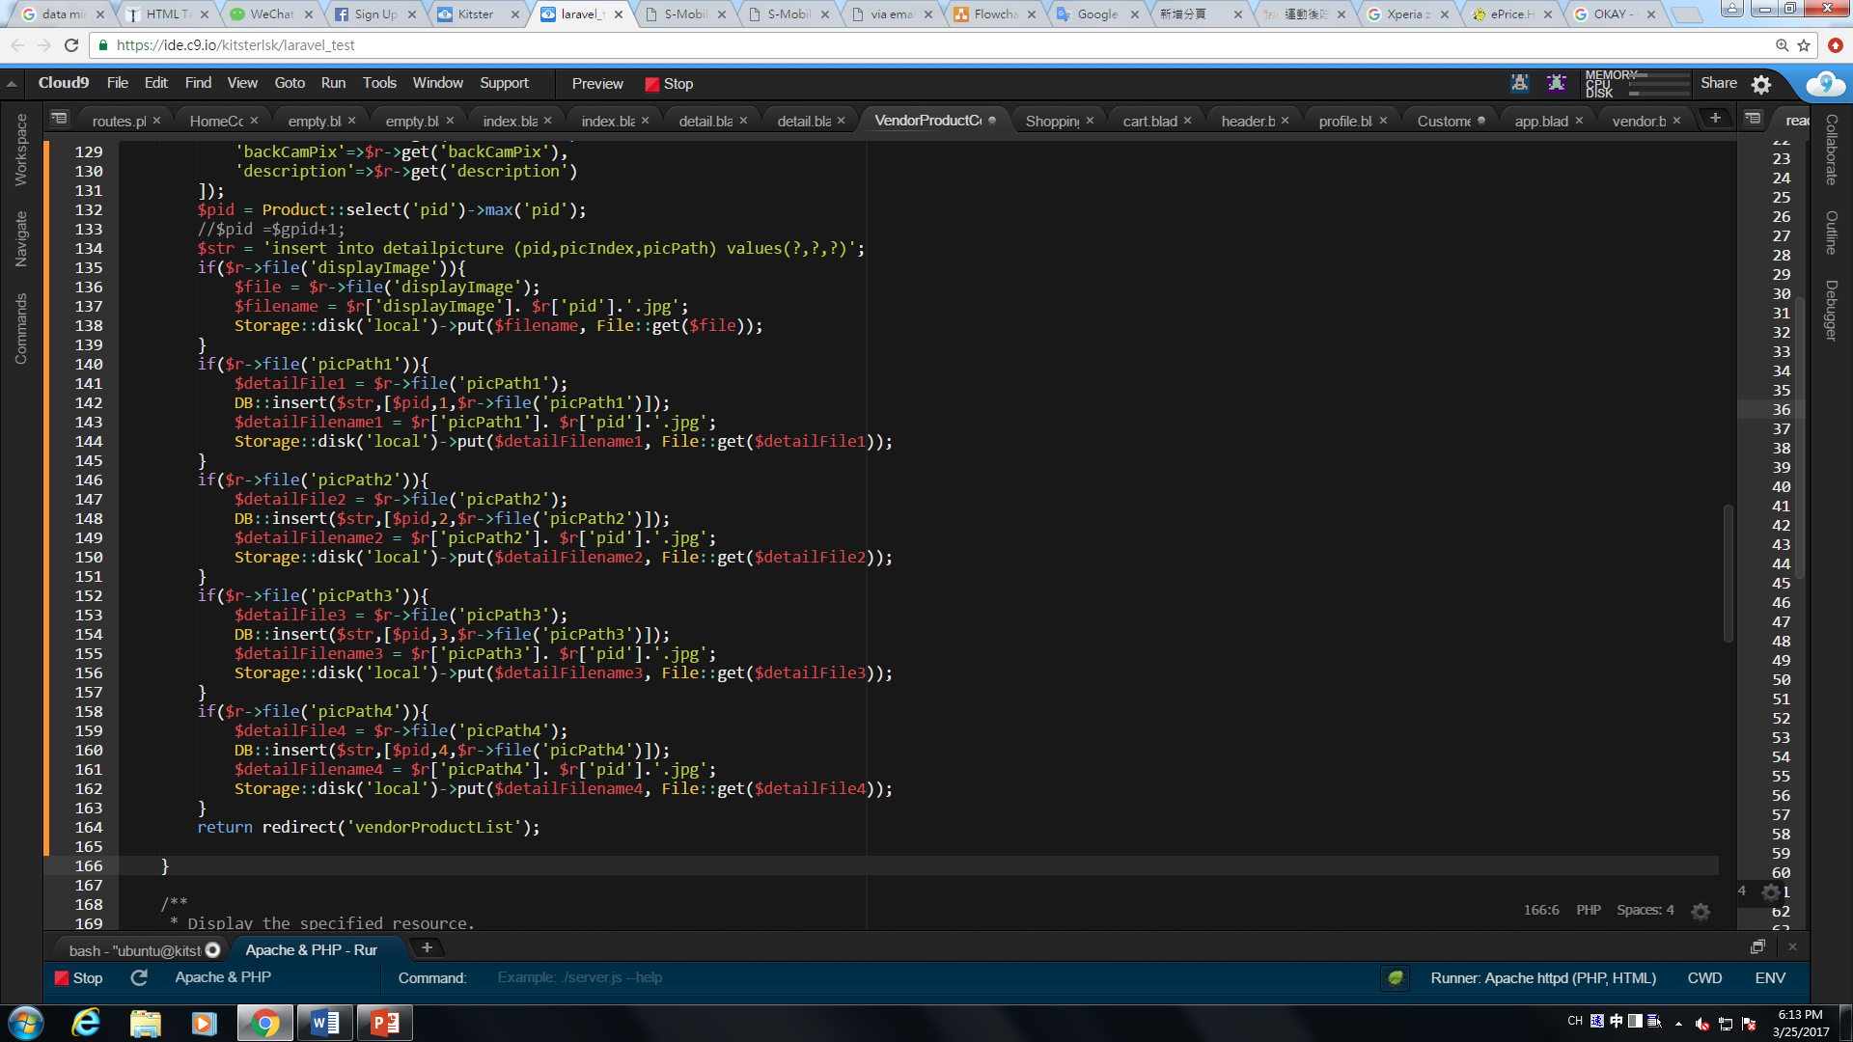

**Figure 11: Code of Image Storage**

Figure 11 shows that how to store the image in the server. The conditional means whether the file input boxes were used or not. If the conditional pass, the image would be uploaded to the server and insert the path in database. The specific image name decide through product ID and the picture name (E.g Figure 11 $filename).

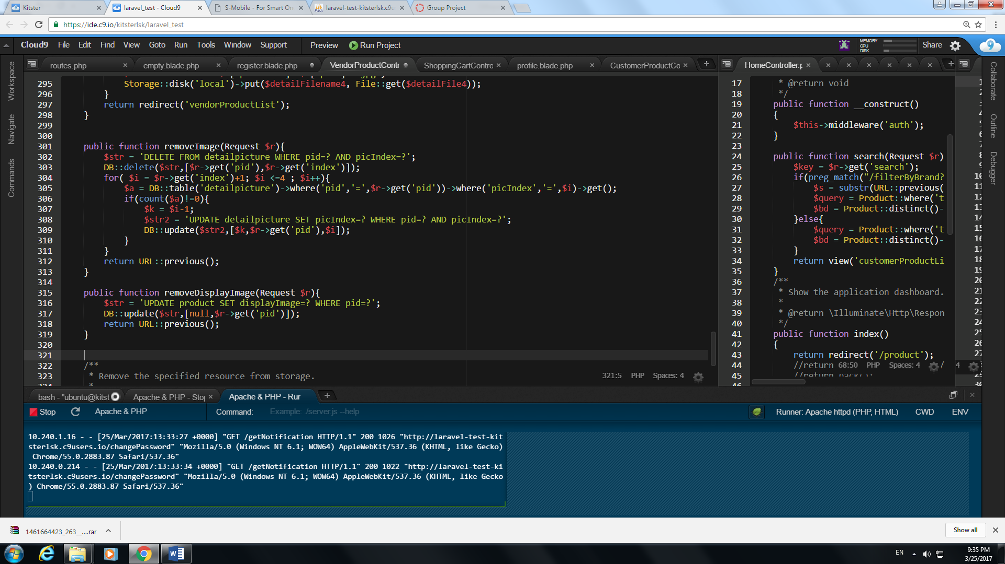

**Figure 12: Code of Image Removal**

Vendor can remove the thumbnail image and detail image through removeDisplayImage() and removeImage(). Also, the server support auto rearranges detail image order when vendor delete the detail image. For example, if vendor delete the product detail image 2 and it have 4 detail image, detail image 3 and 4 would be auto changed the order to 2 and 3.

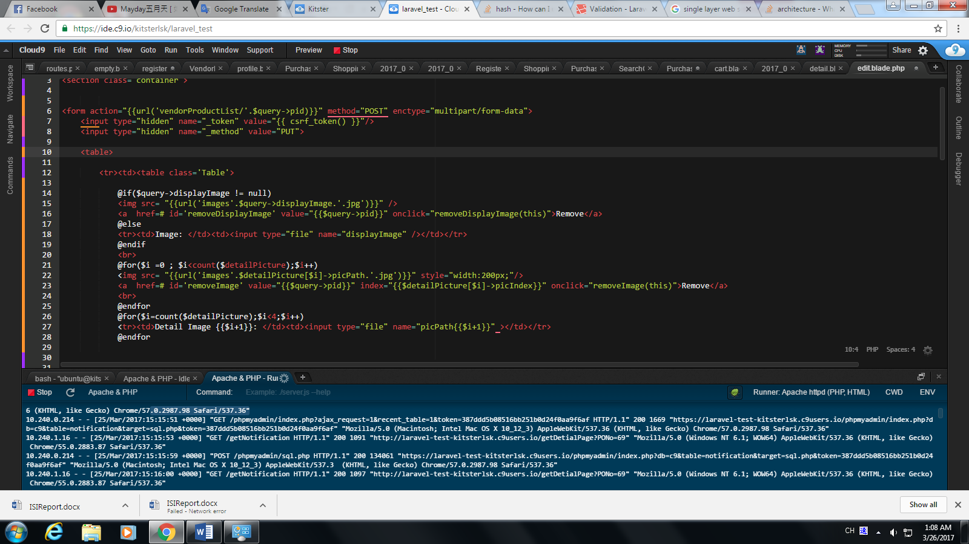

**Figure 13: Code of Image Retrieval**

In client side, image would be displayed if the server success to retrieve the path from the database.

## Password Security

Laravel provides Validator module to validate incoming data which was sent by client. The following codes show that password must be inputted with at least one capital letter and integer to satisfy the regular expression.

For security, the password cannot be stored in database simply. It’s very dangerous that the database is accessed by neither database administrator nor hacker probably. Therefore, the server has to hash the password before store it in the database. Because of Laravel provides password encrypt API bcrypt() for hashing the password, we implement hash function through using it.

Laravel provides Hash module for validating the user password. The check method would verify that a given plain-text string corresponds to a given hash. If checking pass, user would success to login or change the password.

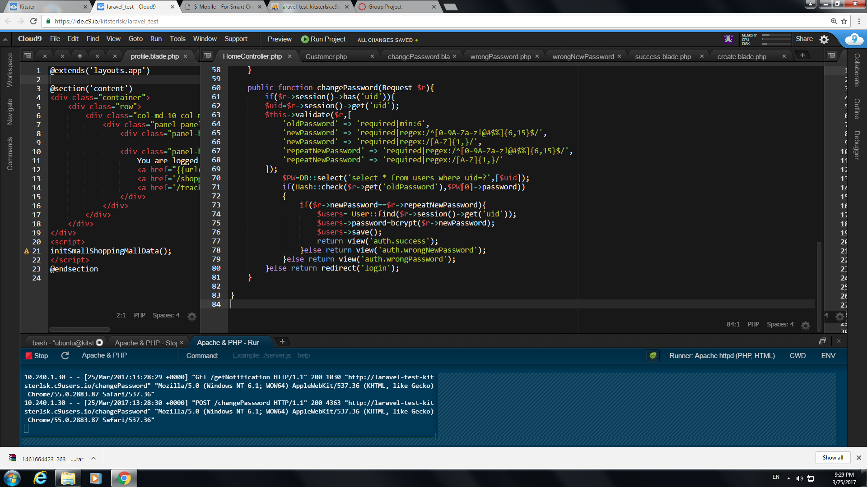

**Figure 14: Code of Changing Password**

In changePassword() function, server would execute the validator to validate all incoming data. After that, it would pass the data to Hash module and check the old password whether it is match or not. Furthermore, it would check the new password and the repeat new password is matching or not. If all of above condition pass, the password would be changed.

## Purchase Order Processing

There are 5 possible statuses of an order in the shopping mall system, pending, shipped, cancelled by vendor, cancelled by user, and hold. For easy management as well as saving the storage of database, 5 numbers are used to represent these 5 statuses. 1 to 5 are used to represent the pending, shipped, cancelled by vendor, cancelled by user, and hold 5 statues respectively. The section below will use a number in the brackets following status term to represent the status. (E.g. pending(1))

As the project specification requires, an order must start with the status pending(1). And then the order can be cancelled by customer or vendor before shipping, otherwise it can be shipped by vendor. There is a special status hold for vendor to use because some product may out of stock. The order in the hold status can still be cancelled by vendor or customer. If vendor unholds the order, the status of the order should change to shipped directly. The following Figure 13show the status change in this system.

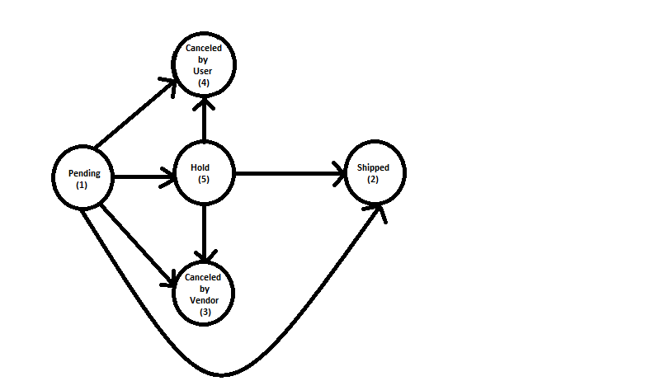

**Figure 15: Swap of Purchase Order Status**

There are 4 implemented functions for vendor to process the order status, checkOut(), cancelOrder(), holdOrder(), unholdOrder(), and shippingOrder(). And 1 function, which is also called cancelOrder(), for customer to cancel the order. In this system, there 5 functions are the only way to modify the status of order. According to thefigure13, there are limited statuses before any statuses of the order. Therefore, to ensure the validation of the statuses of product, those 5 functions only need to check if the current status of the order is the one of the possible previous statuses of the next status.

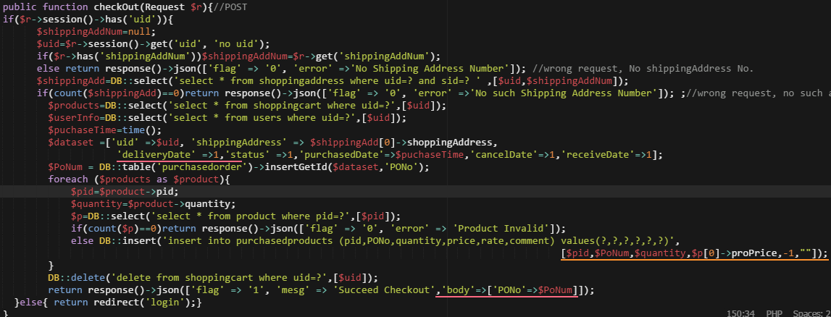

**Figure 16: Code of Check Out**

The checkOut() function create a new order, therefore it only need to store pending(1) in the order status.

**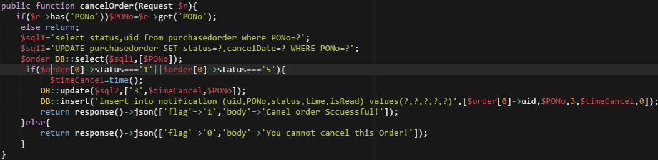**

**Figure 17: Code of Order Cancel**

The cancelOrder() for vendor using transfer an unshipped order to a canceled order. Therefore before update the status, the function will check if the status of order is pending(1) or hold(5).

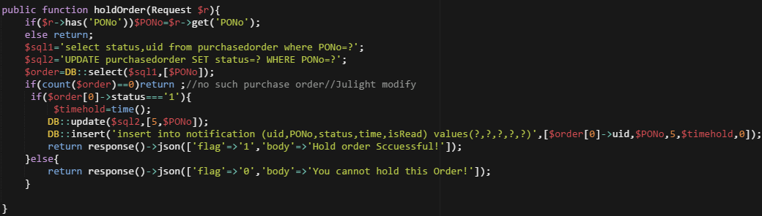

**Figure 18: Code of Order Hold**

The holdOrder function transfer the status from pending(1) to hold(5). A check for whether the status of order is pending(1) is designed in the code.

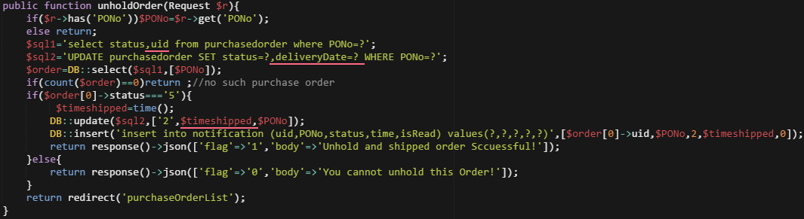

**Figure 19: Code of Order Unhold**

The unholdOrder function transfer the order from hold(5) to shipped(2). Therefore, the code checks if the status of order is hold(5) before shipping the order.

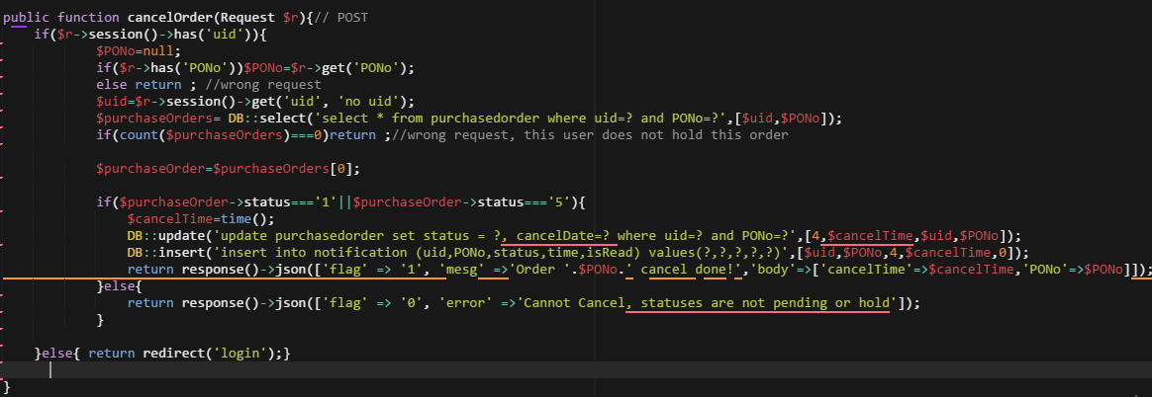

**Figure 20: Code of Customer Cancel Order**

The cancelOrder() for customer is designed to transfer the status of order from pending(1) or hold(5) to cancelled by user(4). Therefore, the function check if the status of order is pending(1) or hold(5) before cancelling the order.

## Customers’ Ratings and Reviews

The shopping mall system provides rating and comment functions for customer. The customer can submit new rating and comment with each product of their order after the vendor ship the customer's order. Each customer's rating and reviews would store in PurchasedProducts of database. The server would display the average rating and comment in each product. The average rating would store in Product of database. The reviews would store in PurchasedProducts of database. The average rating of product is the sum of each rating of product divided by the amount of customers had rated. Unfortunately, the system makes sure each customer only can submit in once. The customer only can view commentProduct page if he/she had submitted.

In client side, the customer must rate the product of their order. The review function is optional. The customer can review the product of their order by their own will.

The following codes describe that the server deal with be submitted rating and reviews. 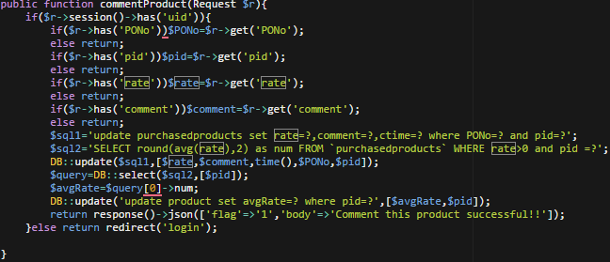

**Figure 21: Code of customers’ rating and reviews**

## Concurrency Control

The shopping mall system has concurrency control mechanism. The concurrency control mechanism is inventory checking. Before the vendor ship the customer's order, the system will check whether products have enough inventories for the quantity of product of the customer's order. If not, the system will ban the shipping order for vendor. The inventory of product in product of database will minus the quantity of product of the customer's order in PurchasedProducts of database, if vendor successfully ships the order. It is also update the inventory of product in Product of database.

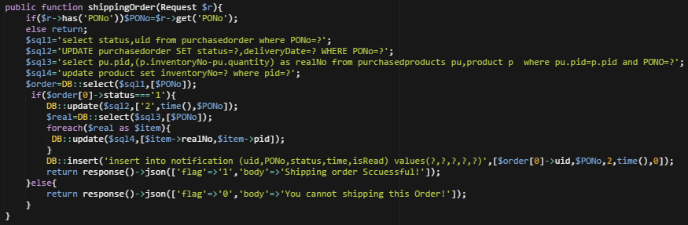

**Figure 22: Code of customers’ rating and reviews**

## Notification

Notification function is a very user-friendly function to customer. This function has been implemented in this system to support the customer to track the change of status of purchase orders. In this system, the function is a real-time notification, which means customer will receive the notification immediately as any of the status of purchase orders changes. The GUI of the notification function shows in the figure below.

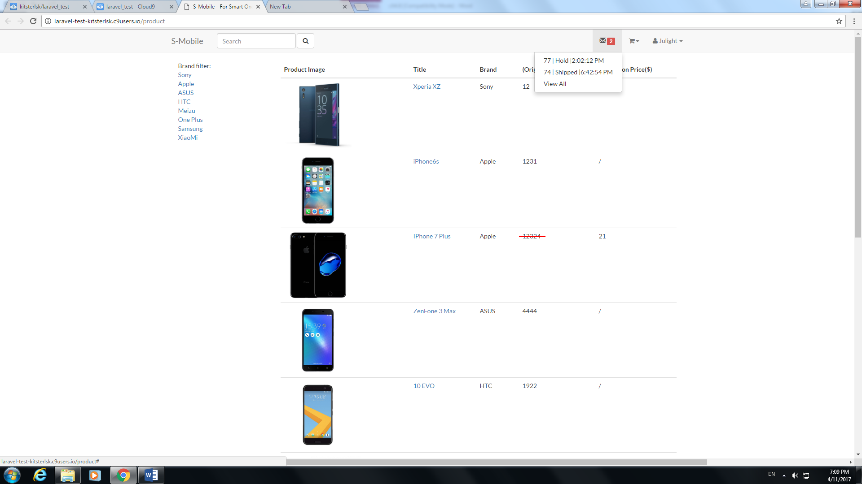

**Figure 23: Graphic User Interface of Notification**

The function is designed into two parts, client and server. The basic theory of this function is polling, which means client part will send request to server to the check the whether there are new notifications in some fixed time interval.

For the client part, the following figure 22 shows the code of client part in JavaScript. The major aim of this code is to request the server, every 7 seconds, to check whether there are new notifications. If the new notification exists the, the data will be updated in the client part and refresh the GUI. There are two reasons why requesting every 7 seconds. Firstly, if the request frequency is longer, the notification will have a long delay which affects the user experience of real-time notification. Secondly, it is not necessary to request server more frequent because the improvement of user-friendly experience is little and this action will add more stress to the server.

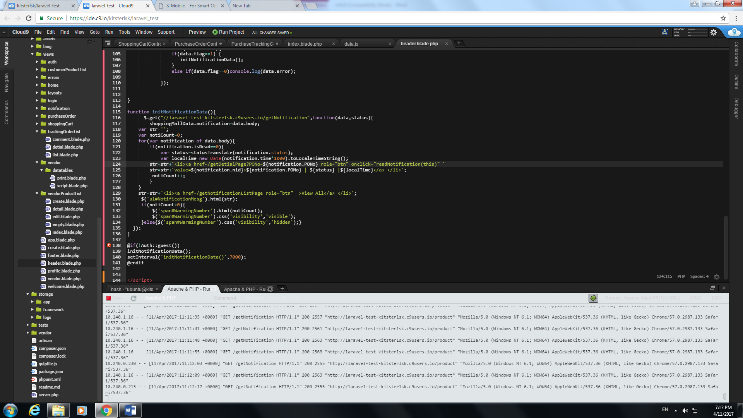

**Figure 24: Graphic User Interface of Notification**

For the server part, the following figure 23 shows the code of server part in PHP. The server returns the notification list to client after the request received.

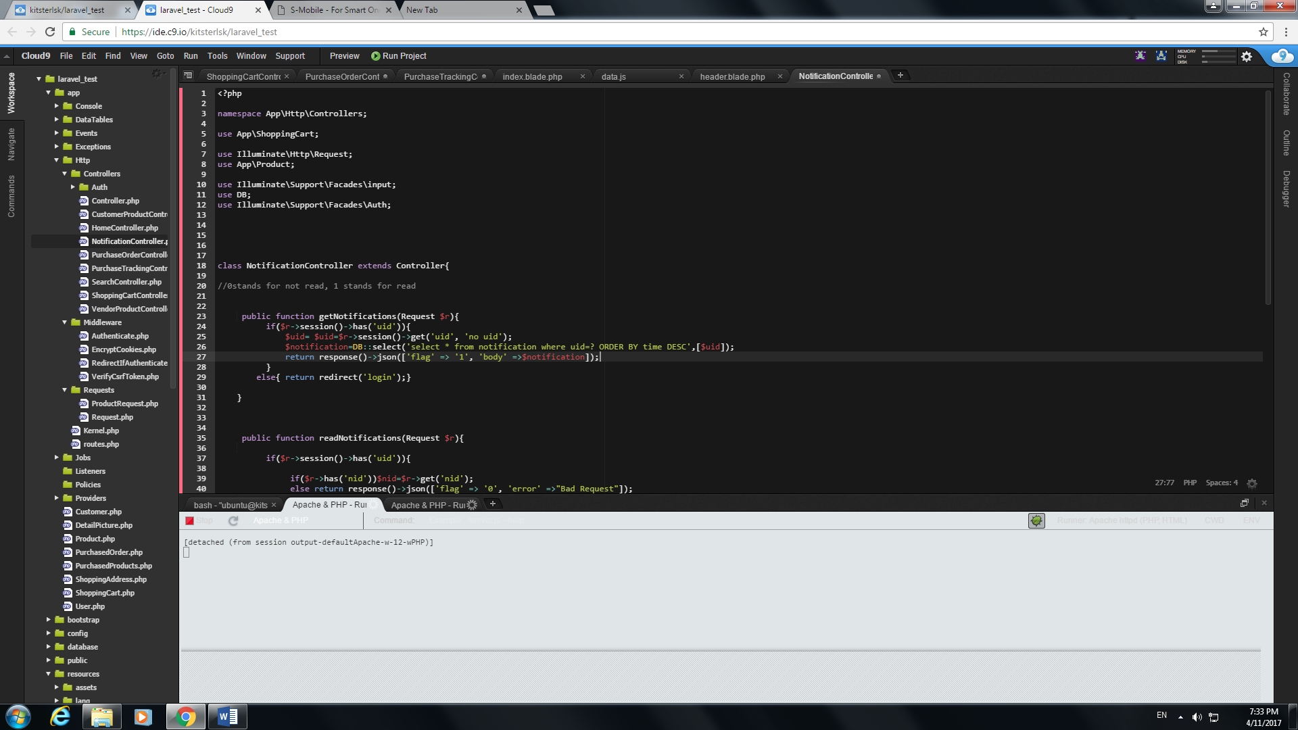

**Figure 25: Graphic User Interface of Notification**

# Results and Discussion

In this section, the results with some of our online shopping mall screen captures will be discussed.

## Project Outcome

An online shopping system has been fully implemented in this project. In this chapter, the whole system outcomes are illustrated via screen captures.

35 based functions with 5 advanced functions are covered in this project. These 40 functions are broken into 10 areas with number of functions in following bracket, namely: product list(5), product detail page(2), account management(5), shopping cart(6), purchase tracking(4), product catalog maintenance(6), purchase order processing(7), customer rating and review(2), notification(1), price and inventory control(2). By these 10 areas, the outcomes of this project will be shown below.

### Product List

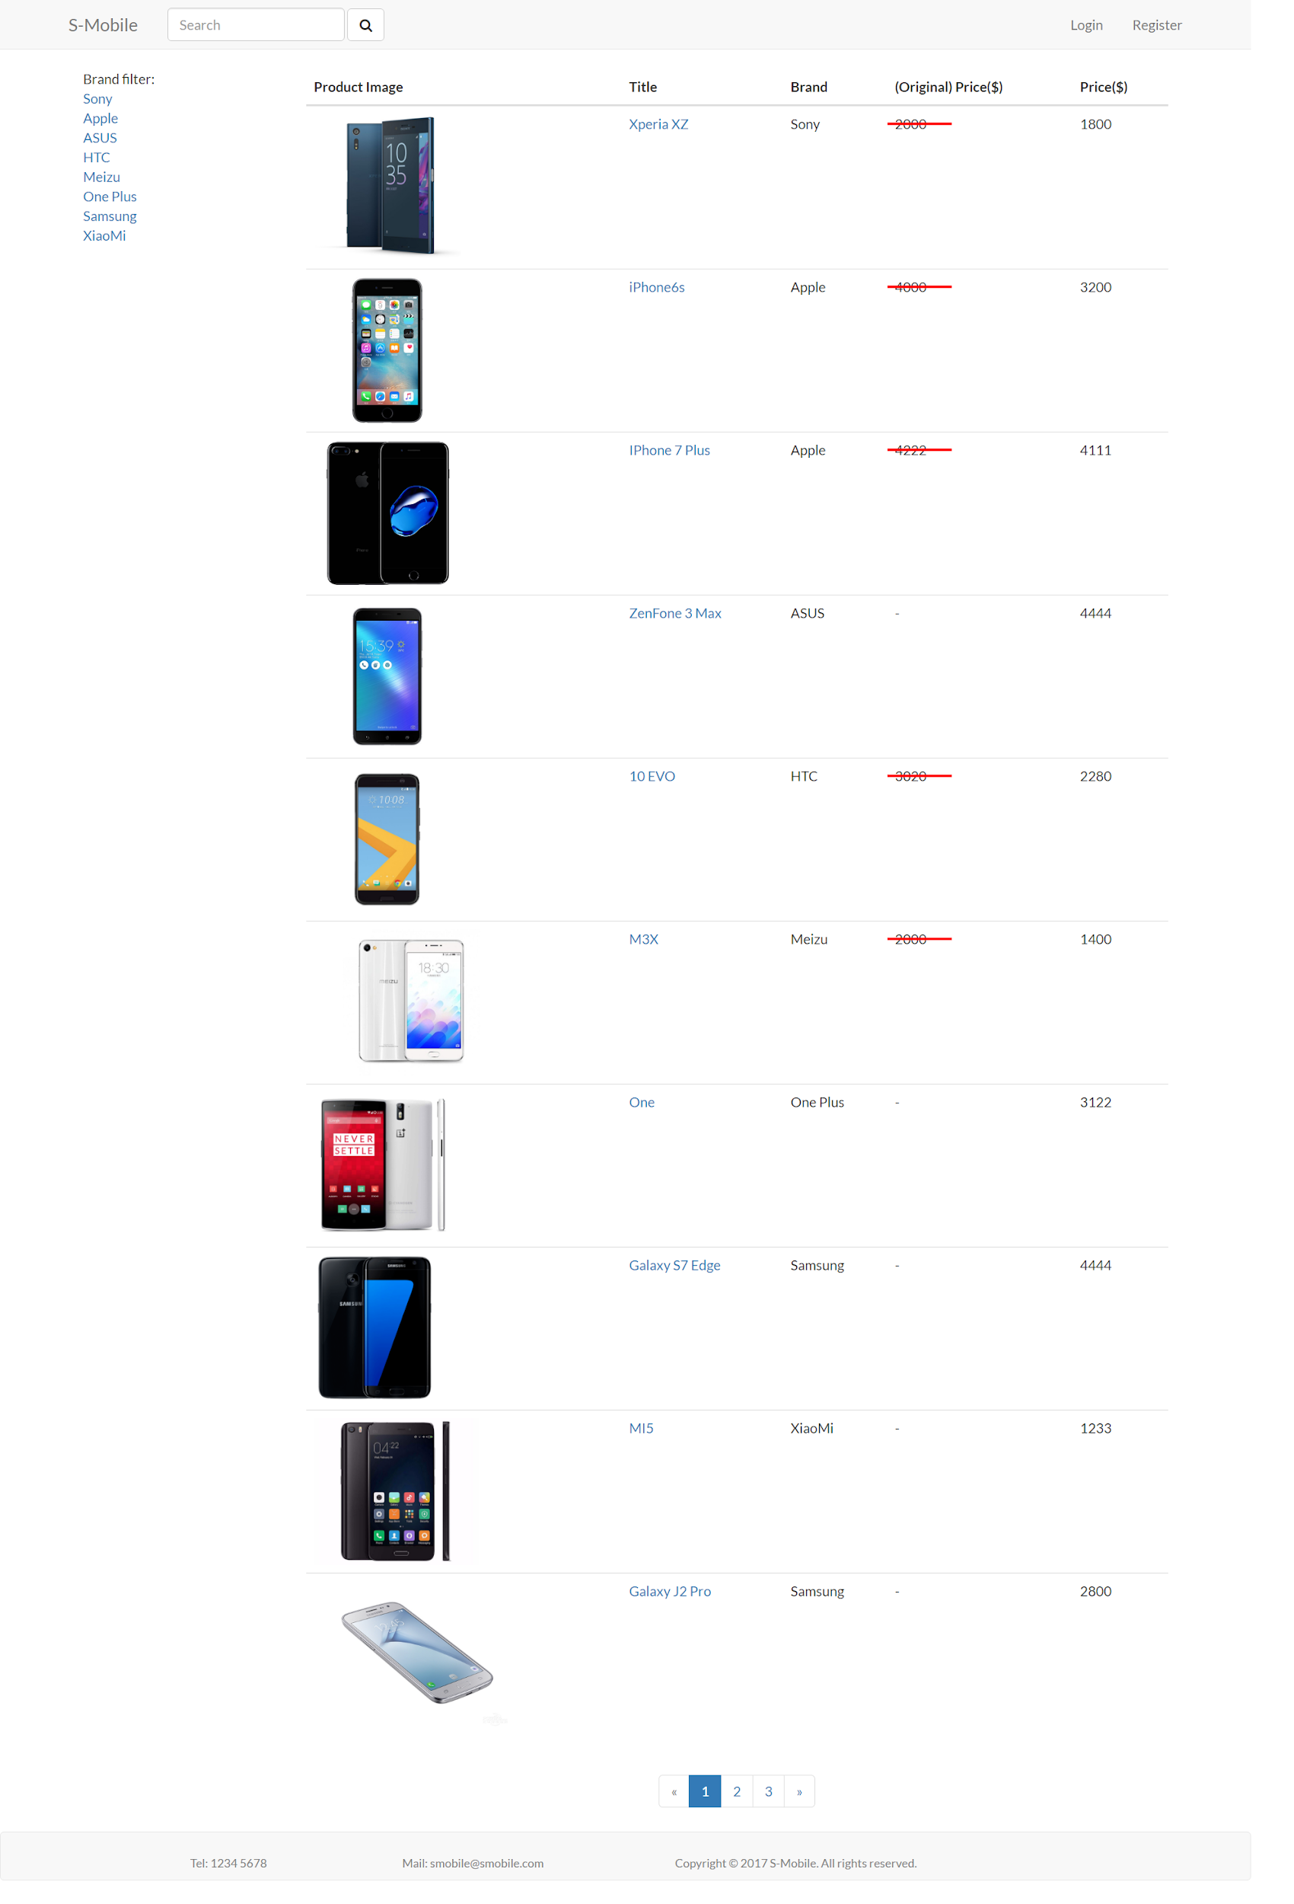

**Figure 26: Graphic User Interface of Product List**

In product list page, it not only allows users to view product list and some information of them, but also implement the filtering and searching functions. Users can filter by brand or search by keywords to find for what they are looking for. In addition, it supports an automatically pagination at the bottom of list and the sorting would not be lost till page changing.



**Figure 27: Pagination of Product List**

When users click the specific page number, the page would be got into that page. It also supports changing page through clicking page up (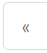) or page down () button.

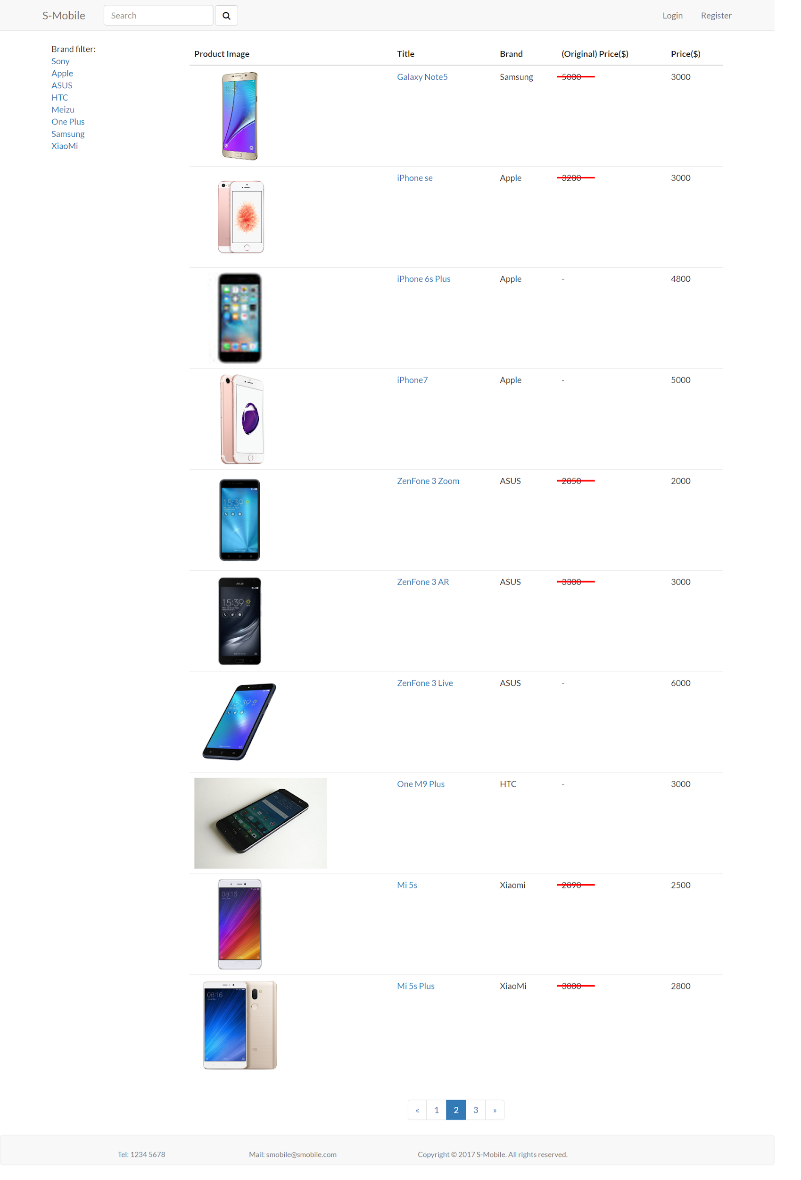

**Figure 28: Changing Pagination of Product List**

When users click the brand name in brand filter list, the product list content would show the products which match with the brand filter only.

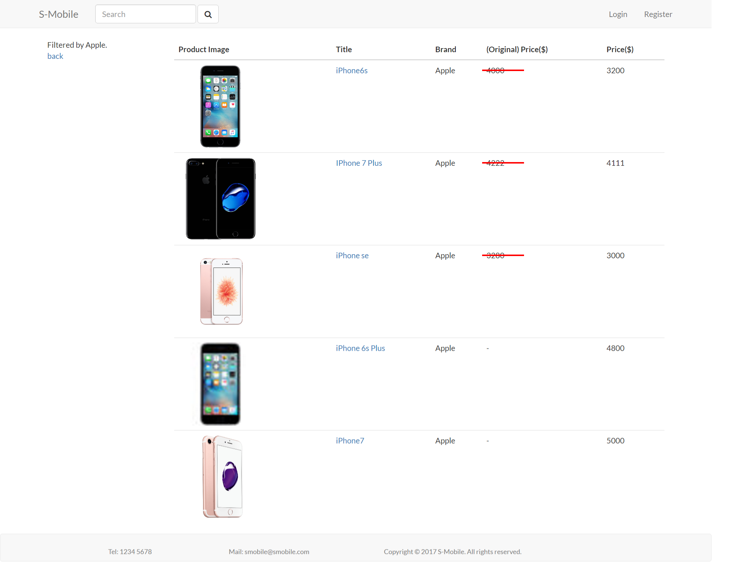

**Figure 29: The Comparison of Filtering the Product List**

Users are able to search the product by typing the partial products name (fizzy search). It also supports brand filter function.

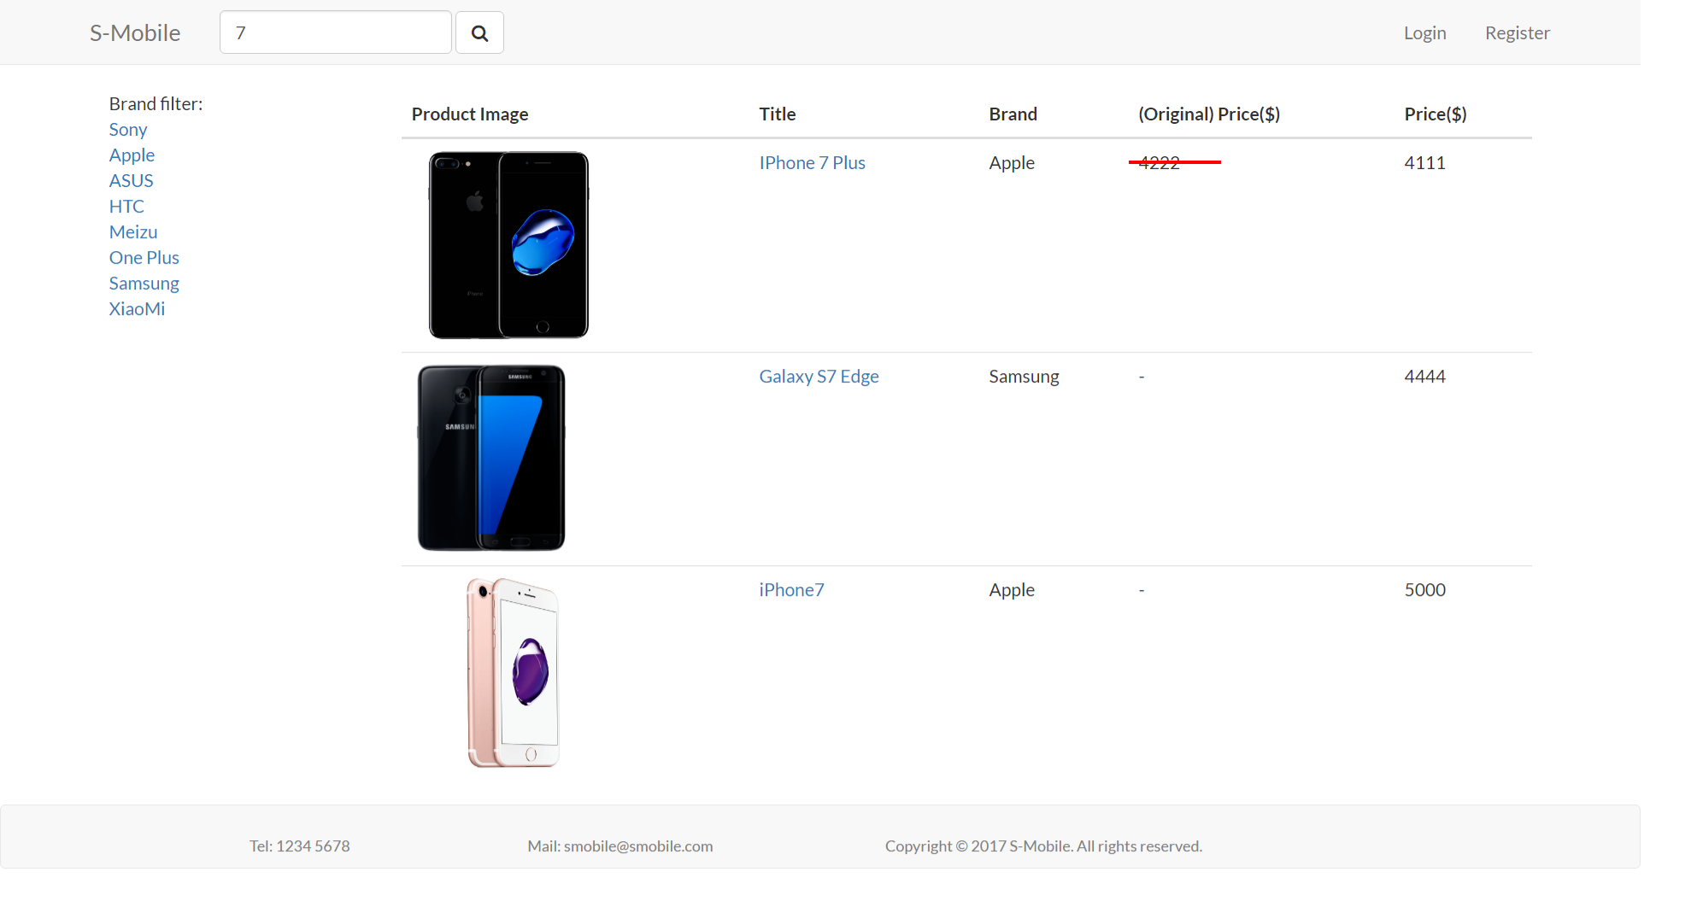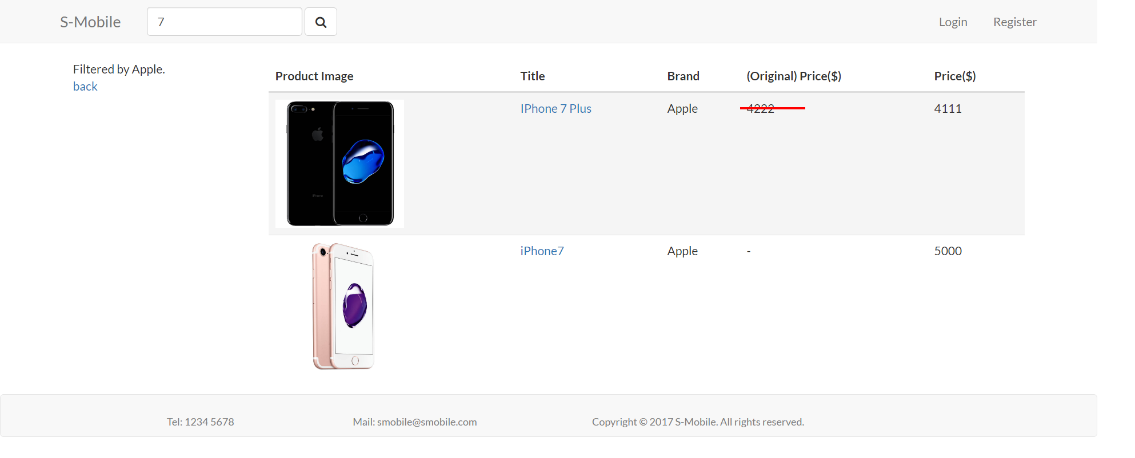

**Figure 30: Searching the Product List by Keywords and Brand Filter**

### Product Detail Page

When users click on the specific product name, the page would be redirected to the product’s detail page. This page shows the product information which users chosen, with a comment table which includes the personal buyer name, rating and comment, and the date of comments.

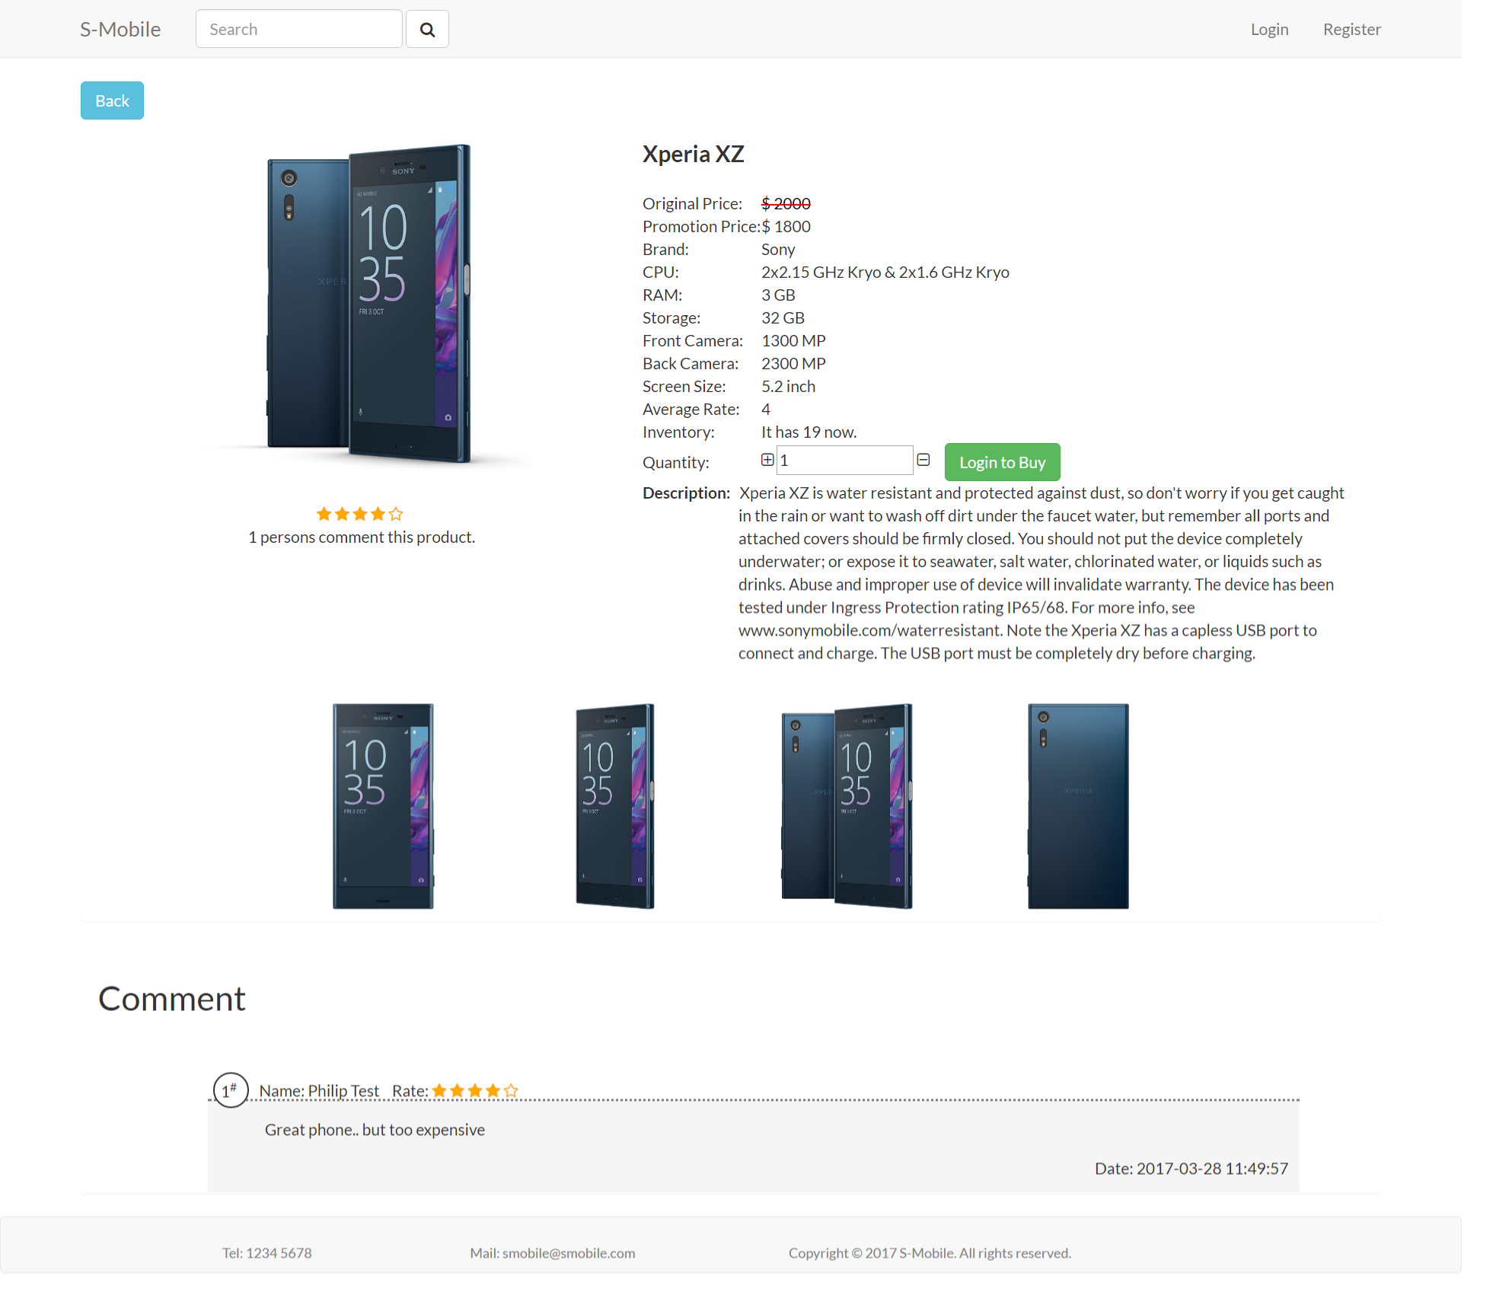

**Figure 31: Graphic User Interface of Product Detail Page**

### Account Management

Visitors are able to register the user account by clicking the “Register” button at the right side of the top bar, then he/she can register after input some personal information and password.

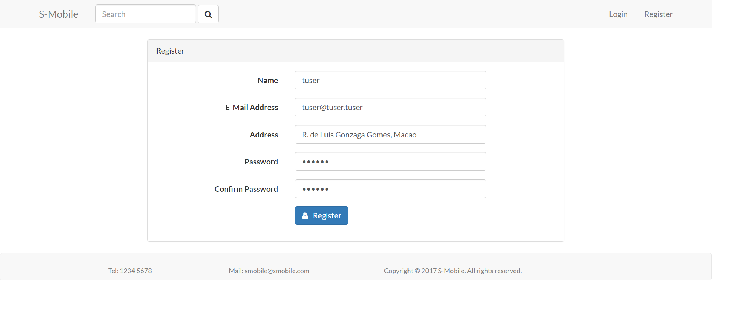

**Figure 32: Graphic User Interface of Registration Page**

Each information textbox have different validation to guarantee the input of visitors in right format.

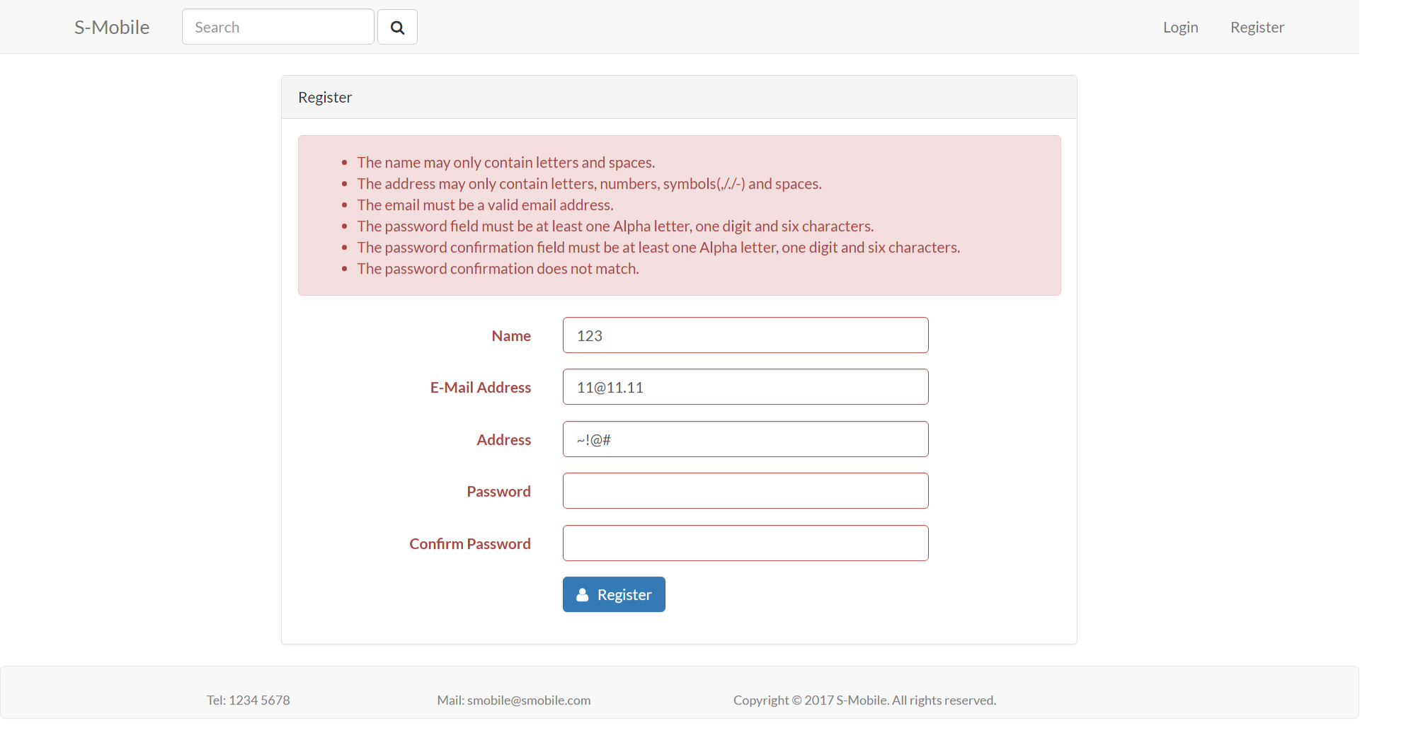

**Figure 33: Error Message of Registration**

If the information format is wrong, the server would return error messages to visitors.

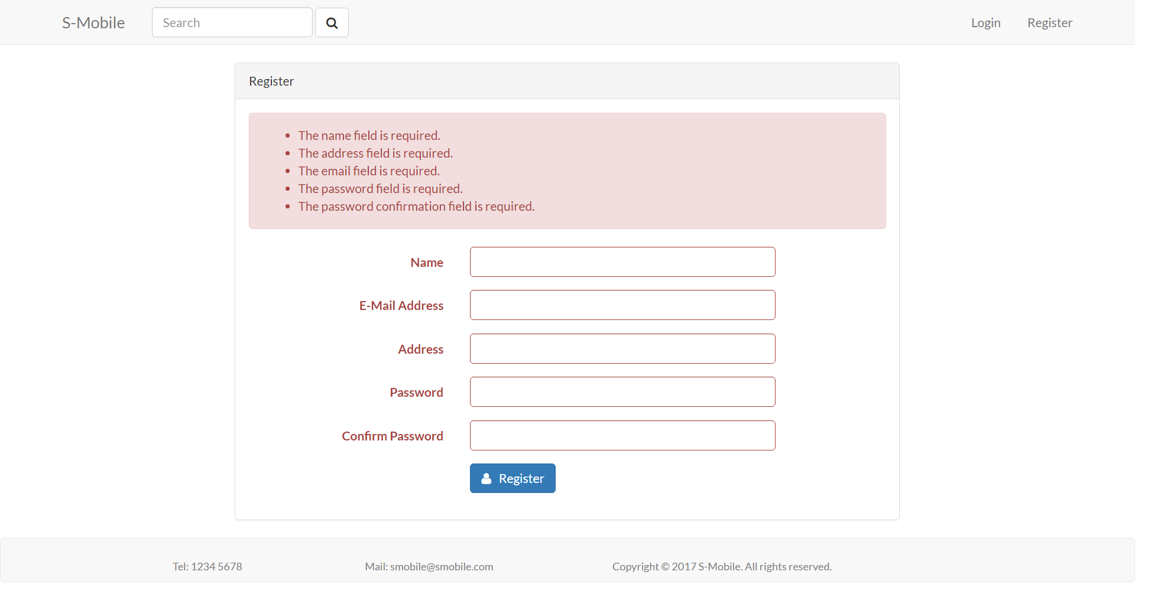

**Figure 34: Required Message of Registration**

Users are able to login through clicking “Login” button at the right side of top bar, then users can login by filling in the E-mail address and password, the validation of login is also workable. After login succeeds, the right side of top bar would shows three kinds of button, includes notification, shopping cart and account management.

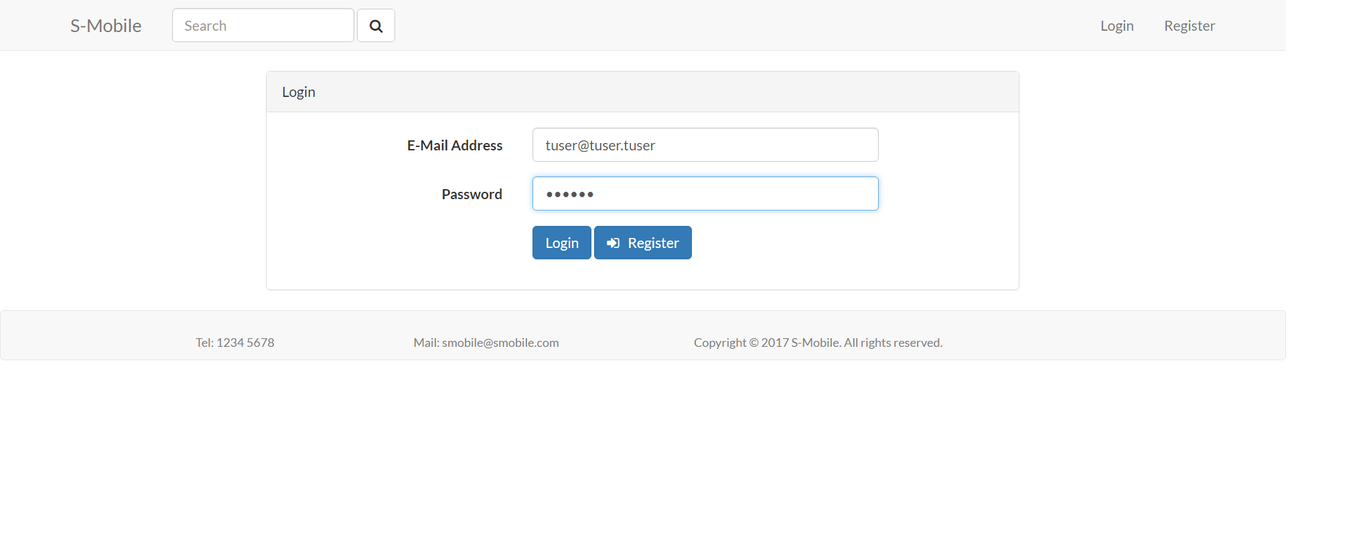

**Figure 35: Graphic User Interface of Registration**

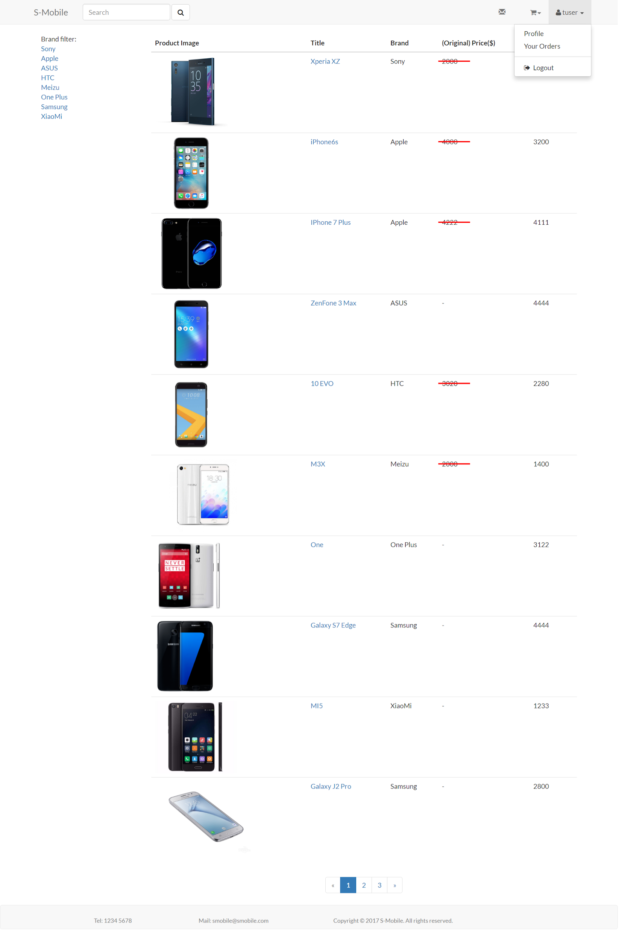

**Figure 36: Graphic User Interface after Login (Product List)**

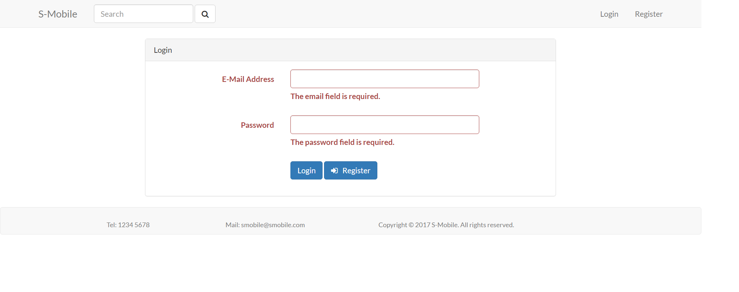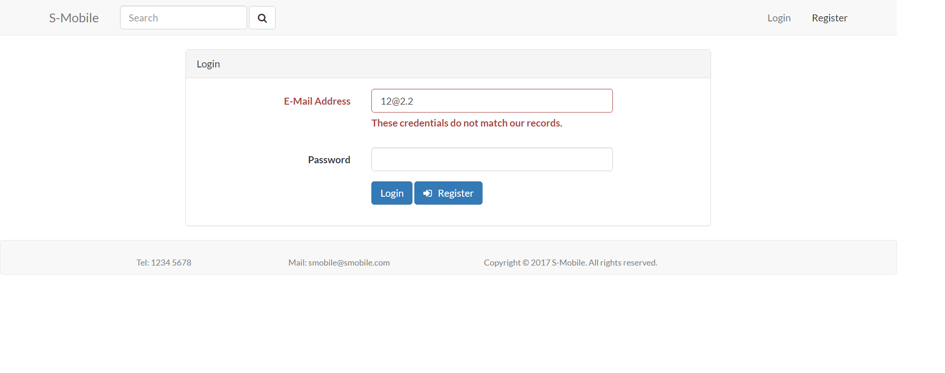

**Figure 37: The Validation of Registration**

Users are able to change password in their own profile.

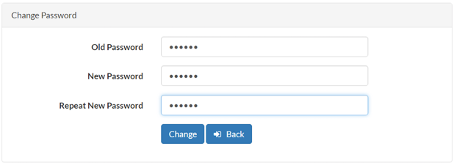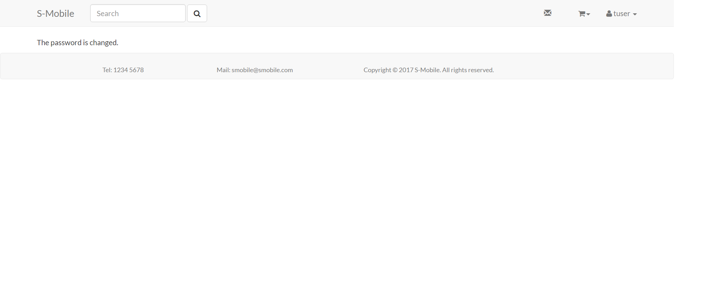

**Figure 38: Graphic User Interface of Changing Password**

There is validation for validating the users input the right format or not. If everything is correct, the website would be redirected and show the success sentence to users. (The specific coding shows in Ch. 4)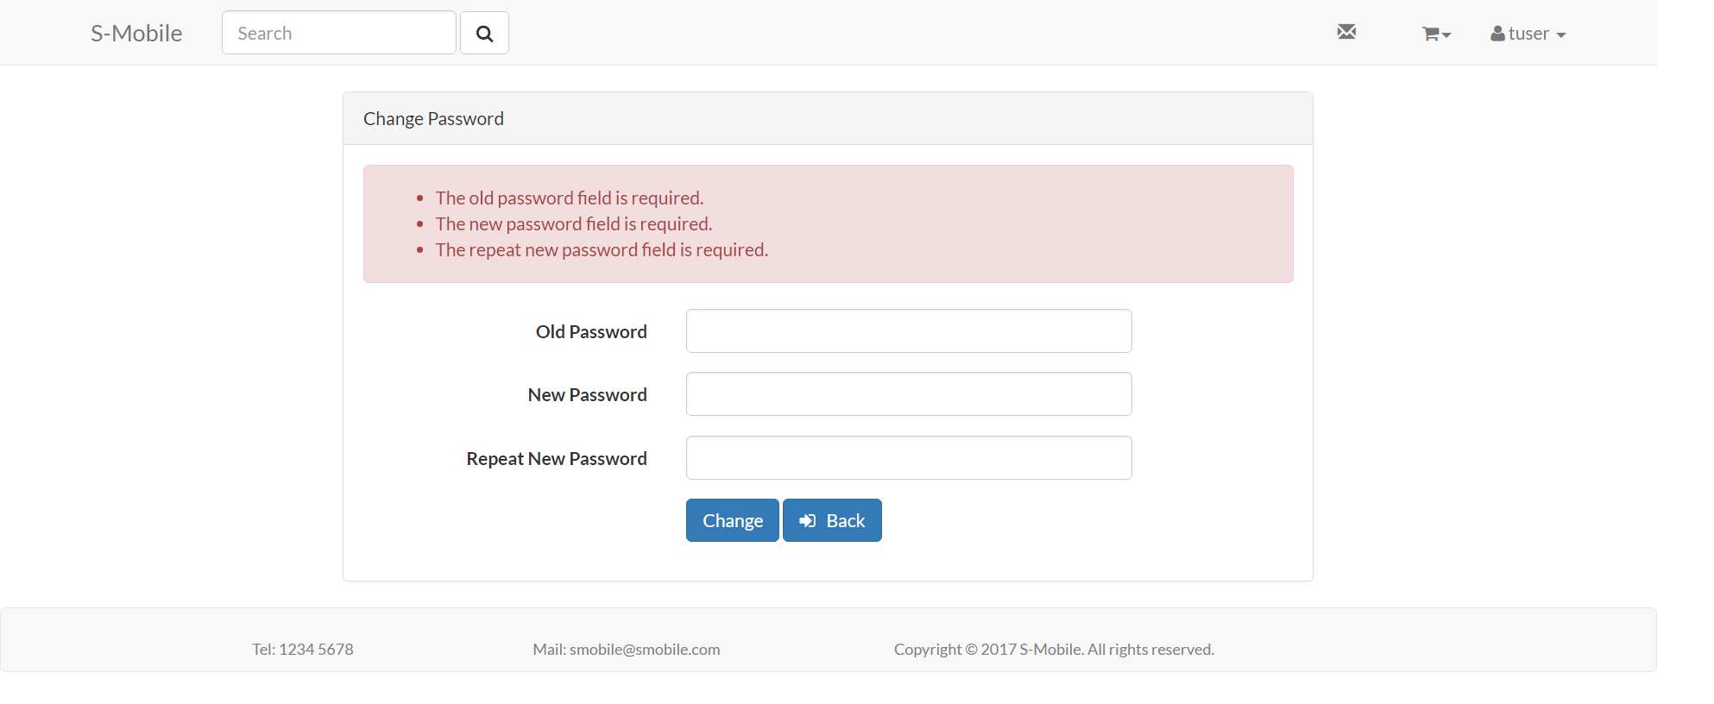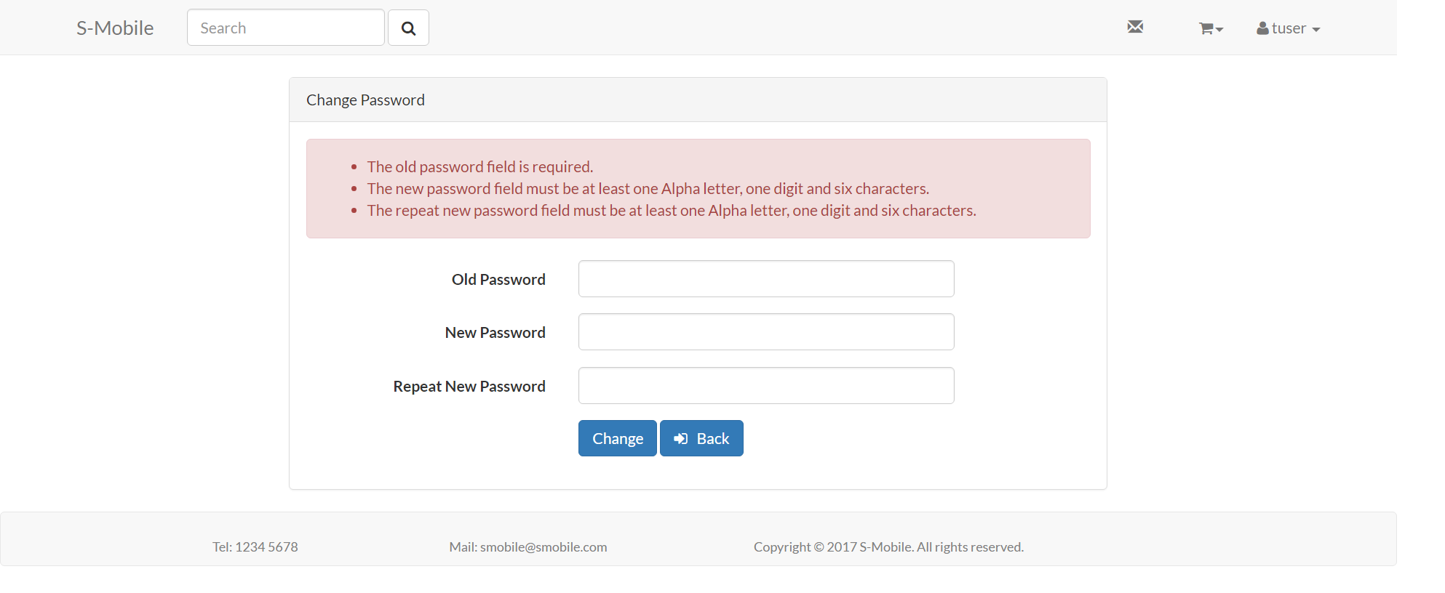

**Figure 39: Validation of Changing Password**

Since users without login cannot get connection to the shopping cart, the product detail page would show the “login to buy” button for user login. After login, users can make use of the shopping cart to add their wishing products.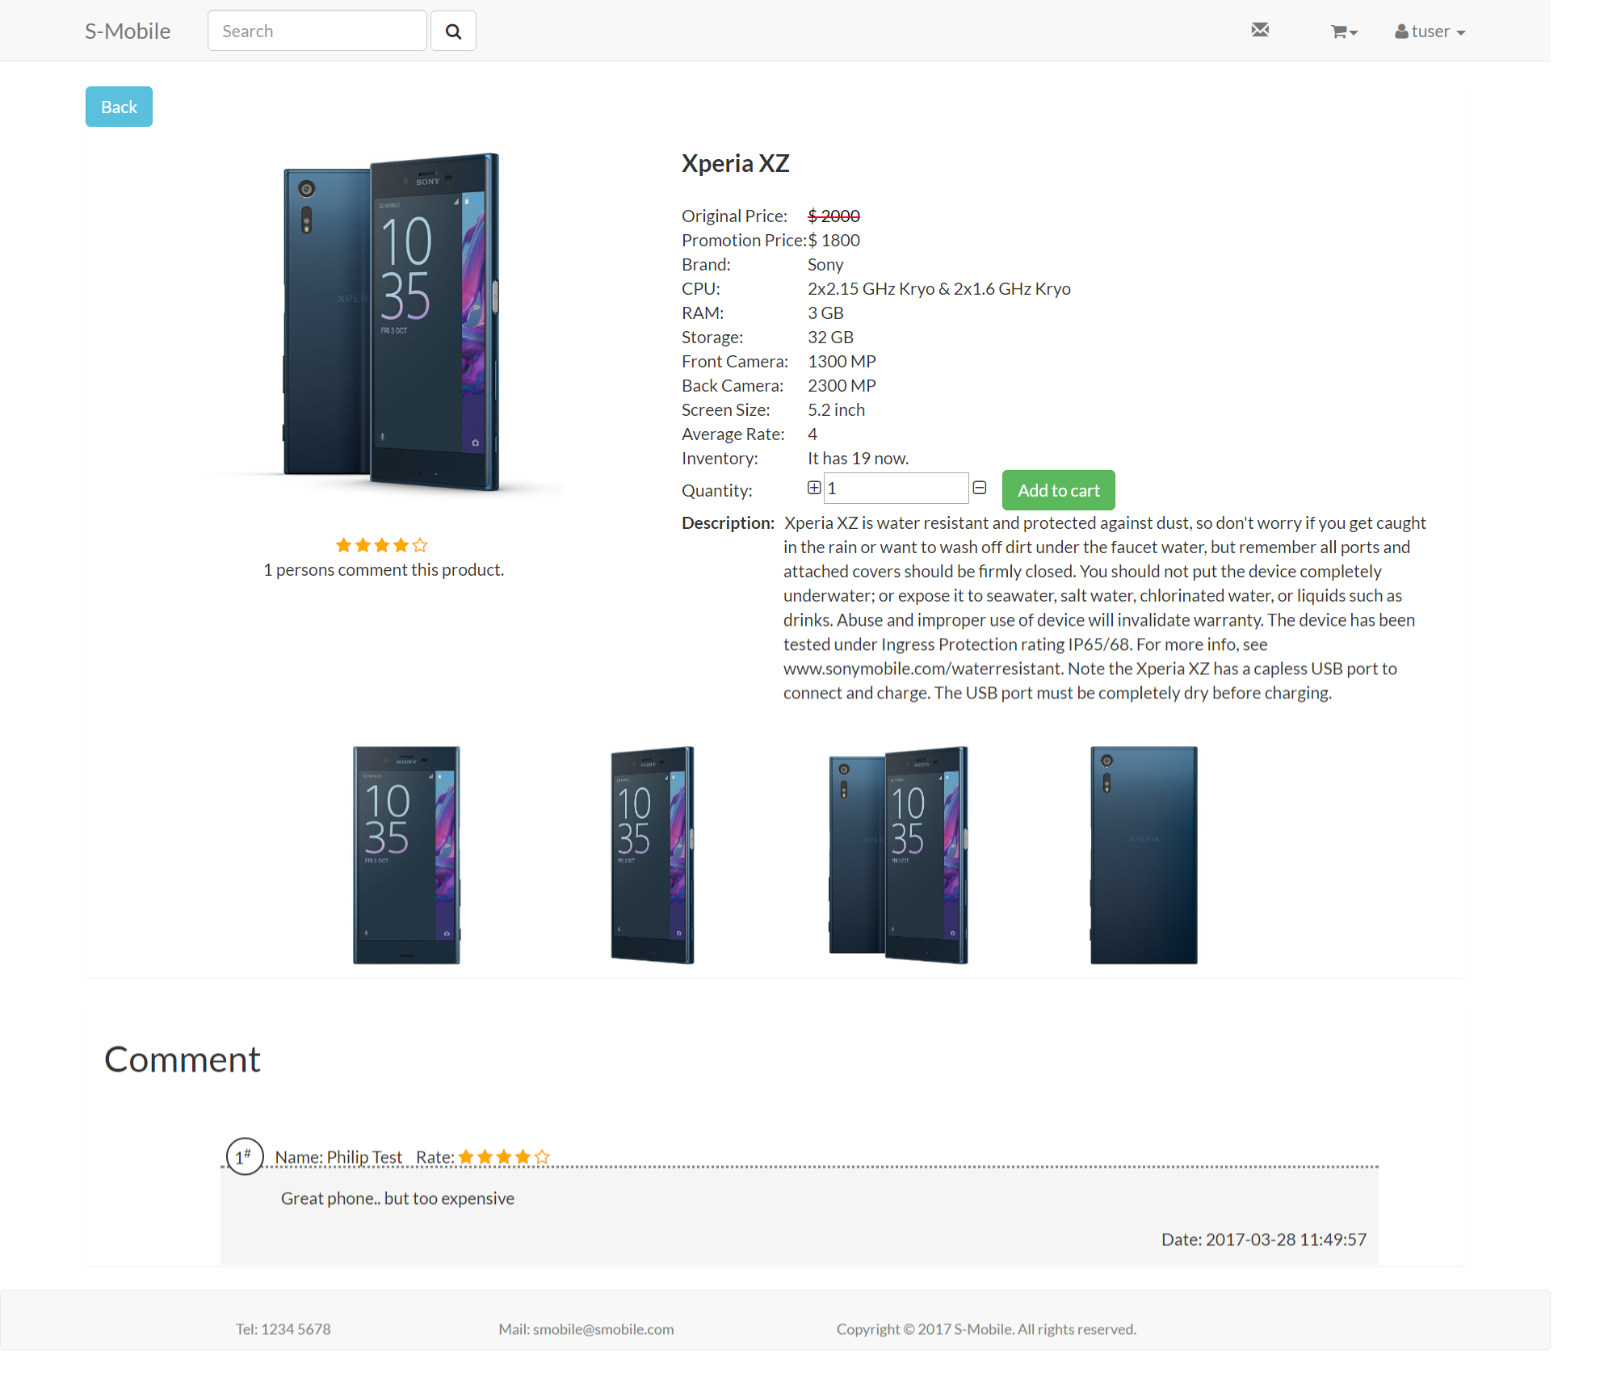

**Figure 40: Validation of Changing Password**

All passwords of users would hash before saved in database. (The specific code shows in Ch.4.)

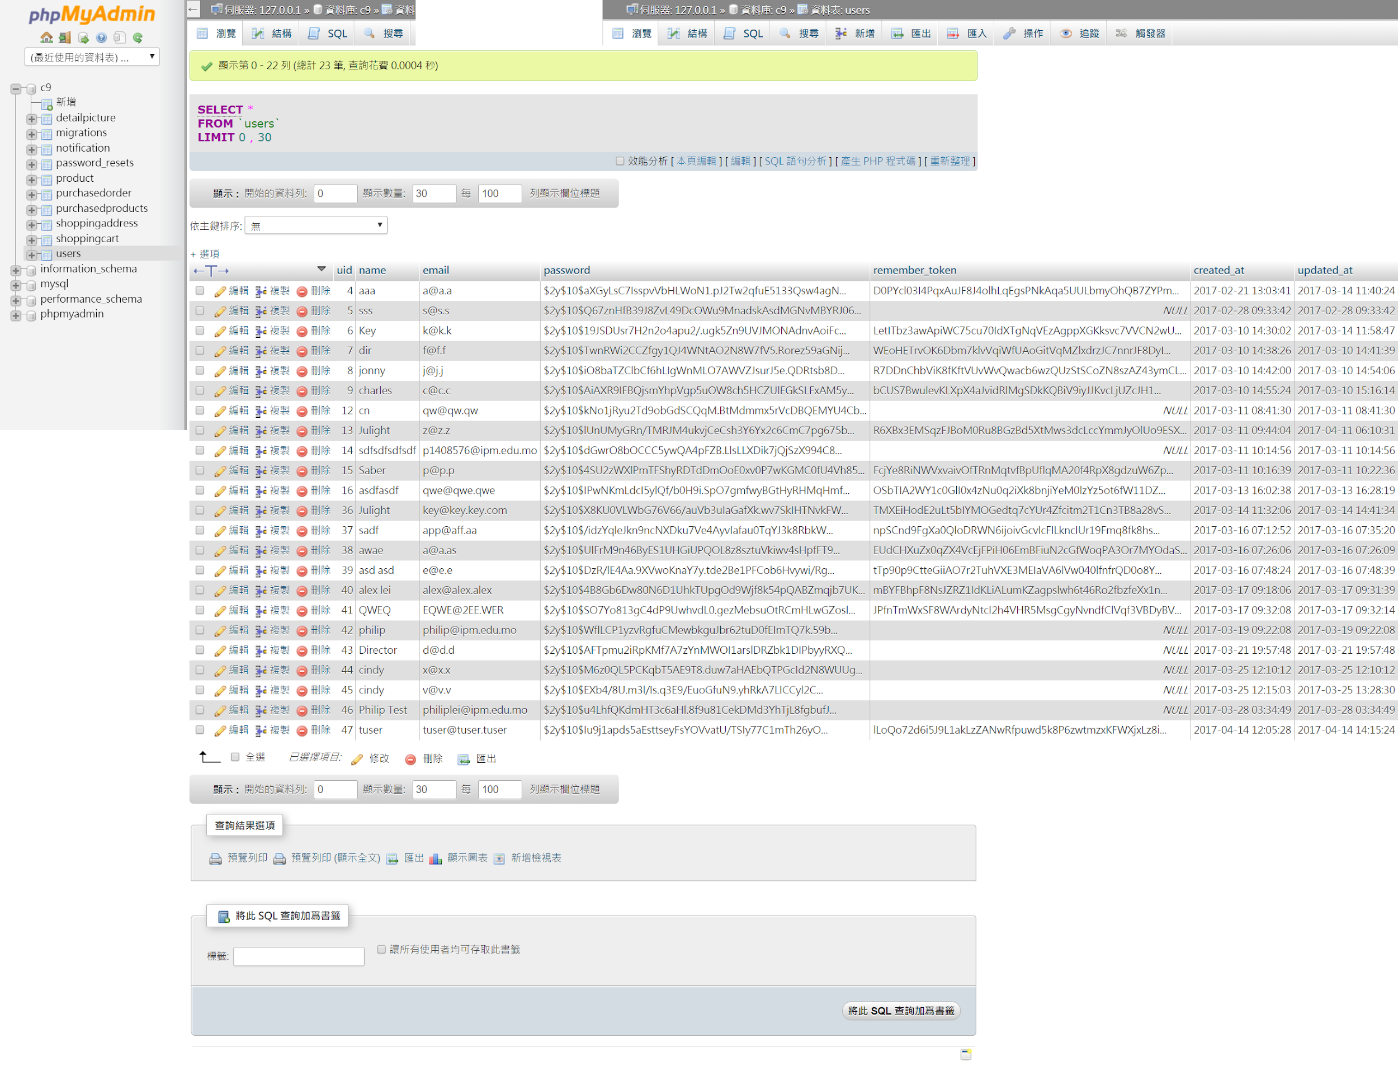

**Figure 41: The Database View of User Account**

### Shopping Cart

Users can add their wanted product into shopping cart in product detail page by clicking on the “Add to cart” button, then the system will show a successful message.

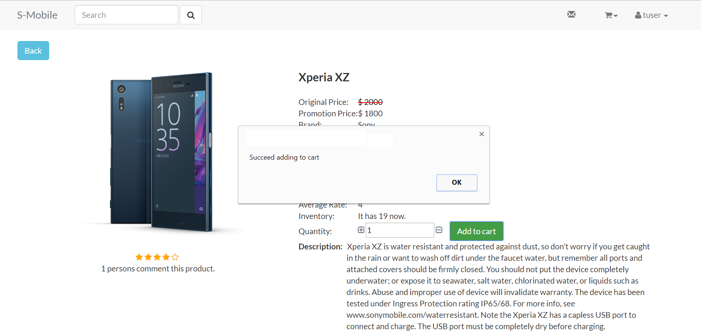

**Figure 42: Successful Message of Adding Product to Shopping Cart**

When users successfully add the product to shopping cart, he/she can have a quick view at the upper right corner “Shopping cart”.

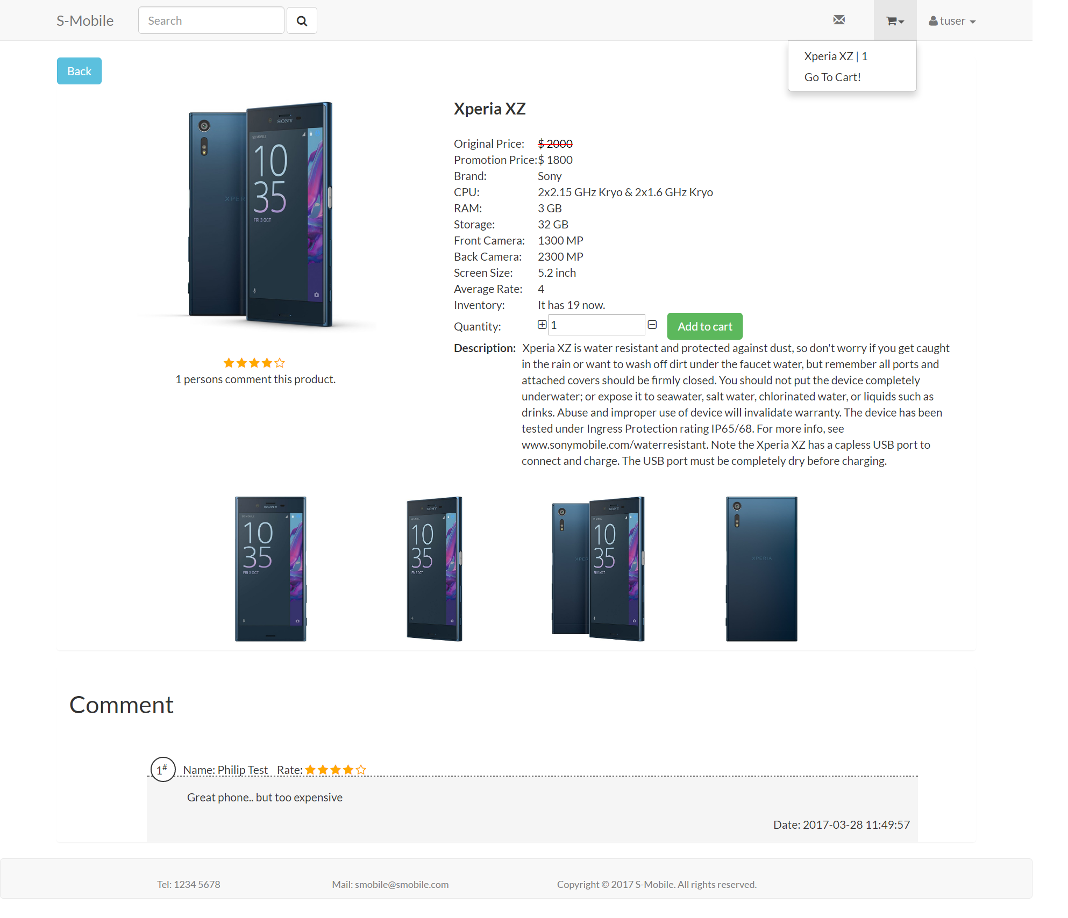

**Figure 43: Graphic User Interface of Shopping Cart**

### Purchase Tracking

Purchase tracking page (Figure 44) allows users to view their orders. The information includes order number, total amount, purchase date, and status. Users can also use the filter function to view the active orders or historical orders.

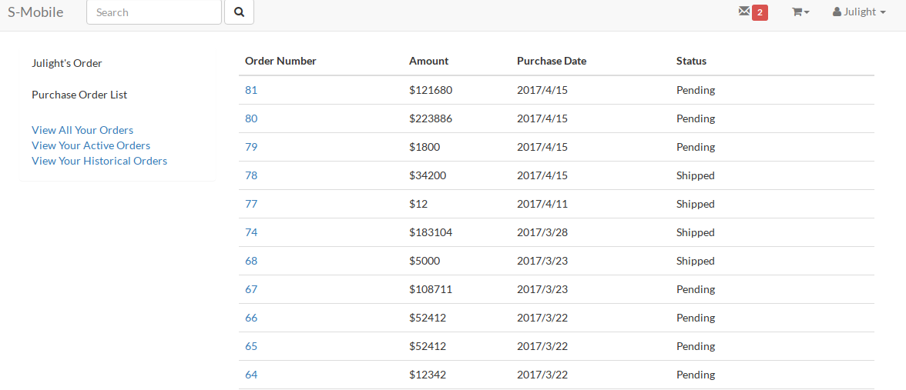

**Figure 44: Graphic User Interface of Purchase Tracking Page**

In purchase order detail page (Figure 45), users can view the detail of one specific order. The detail contains the information, subtotal, quantity, unit price of each product in the order. Also, the status, total amount, and date of the order are included in the page. If the order is shipped or cancelled, the date of shipping or cancel is also shown. Before the order is shipped, customer can also cancel the order through this page.

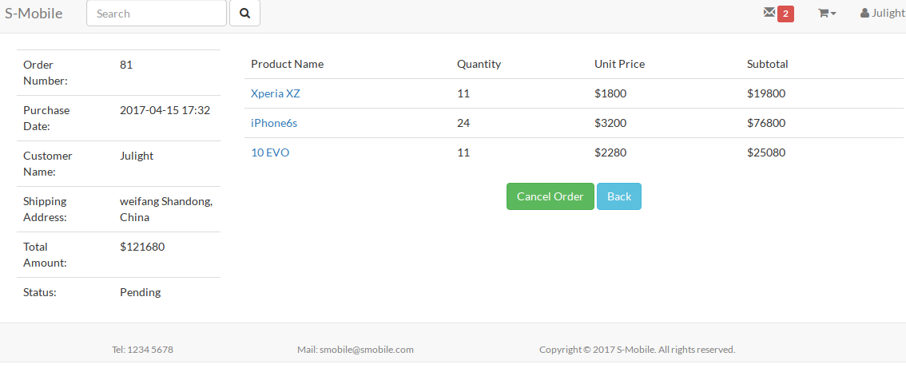

**Figure 45: Graphic User Interface of Order Detail**

### Product Catalog Maintenance

Product Catalog Maintenance provides vendor a view to add and edit products. The interface is shown at the following figure.

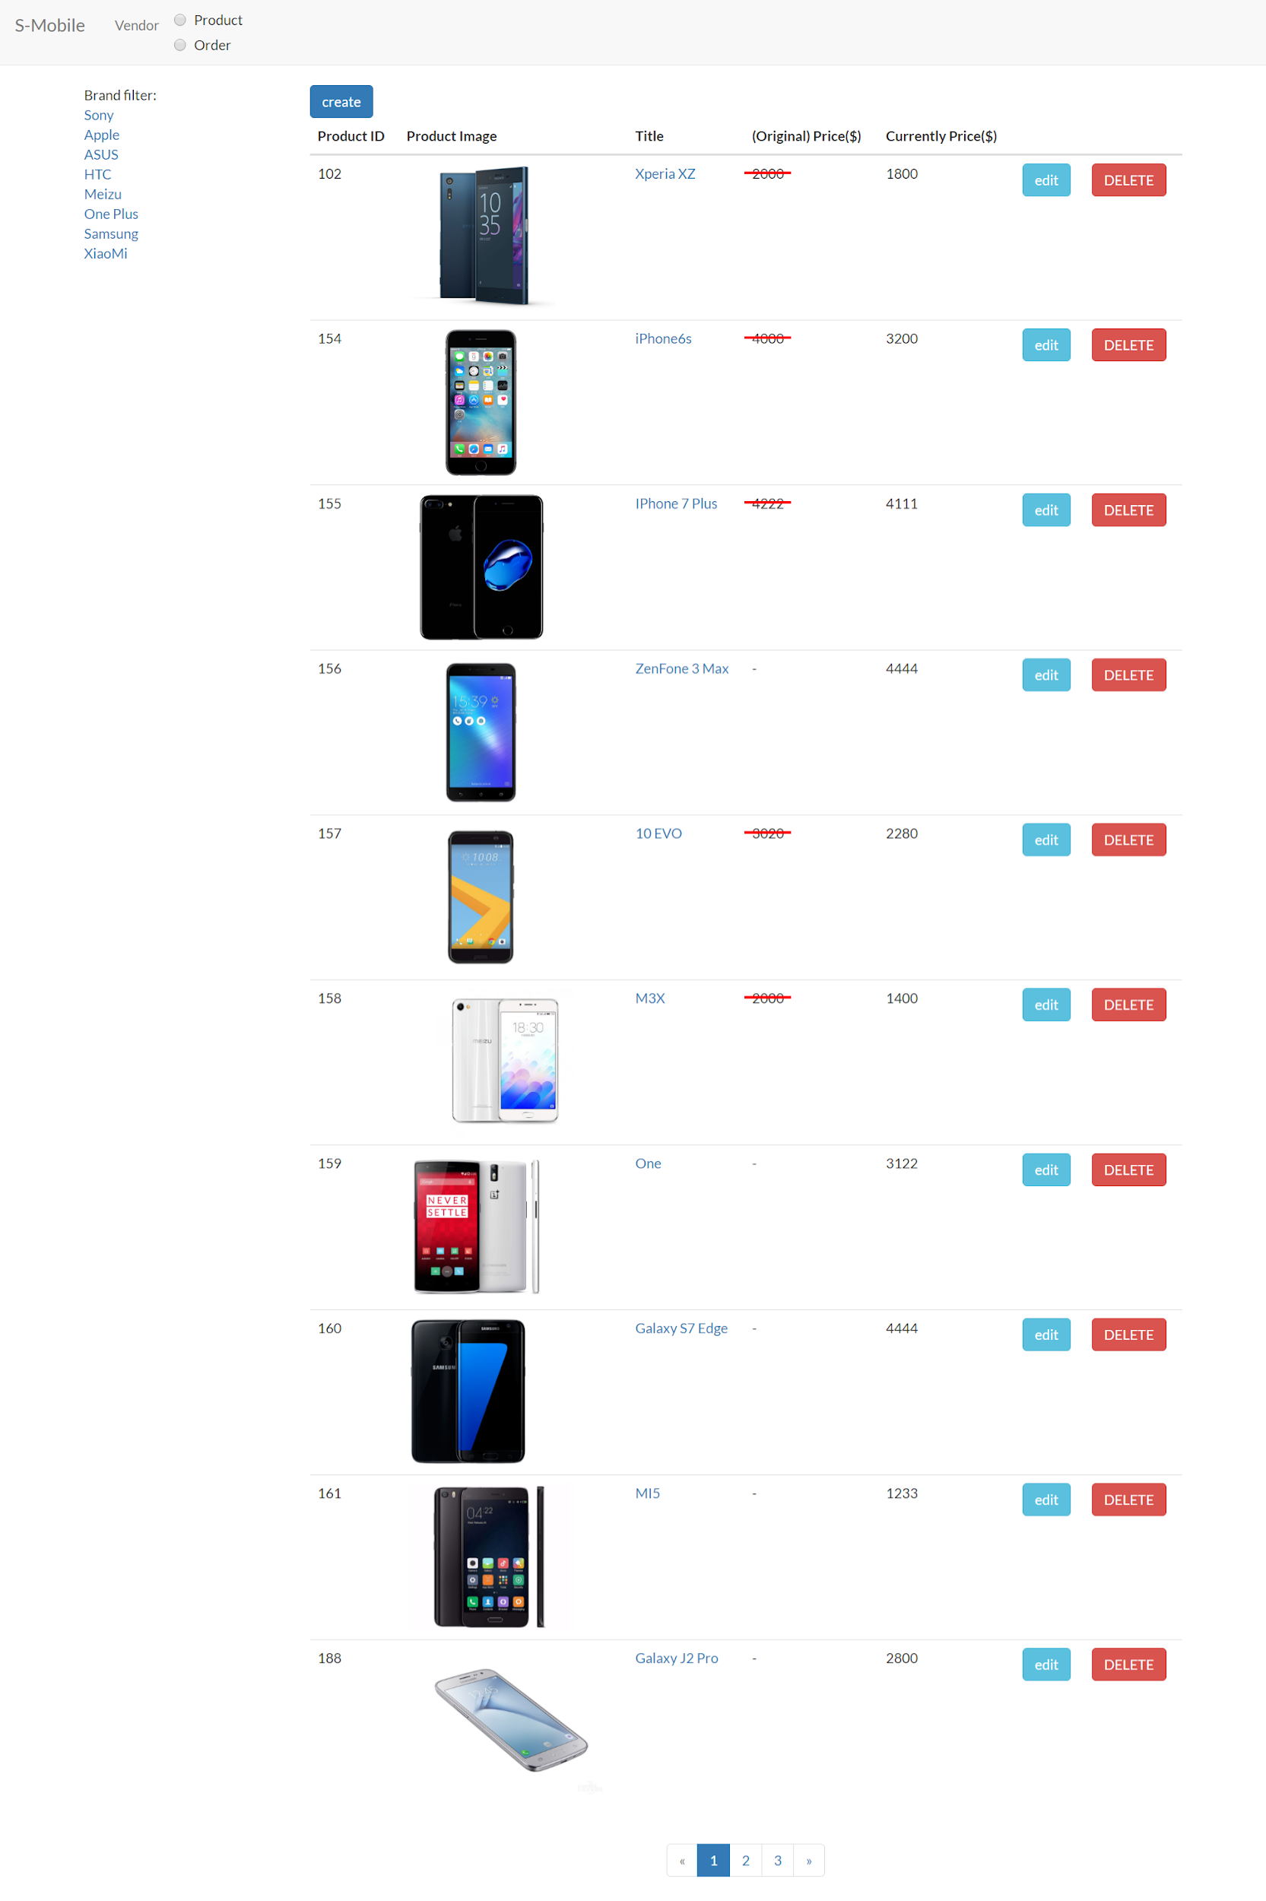

**Figure 46: Graphic User Interface of Product Catalog Maintenance**

Each page can show 10 products, the filtering and searching function still works at vendor side. More detailed functions are stated in the following screen captures.

Vendor can search a product by its product ID or title.

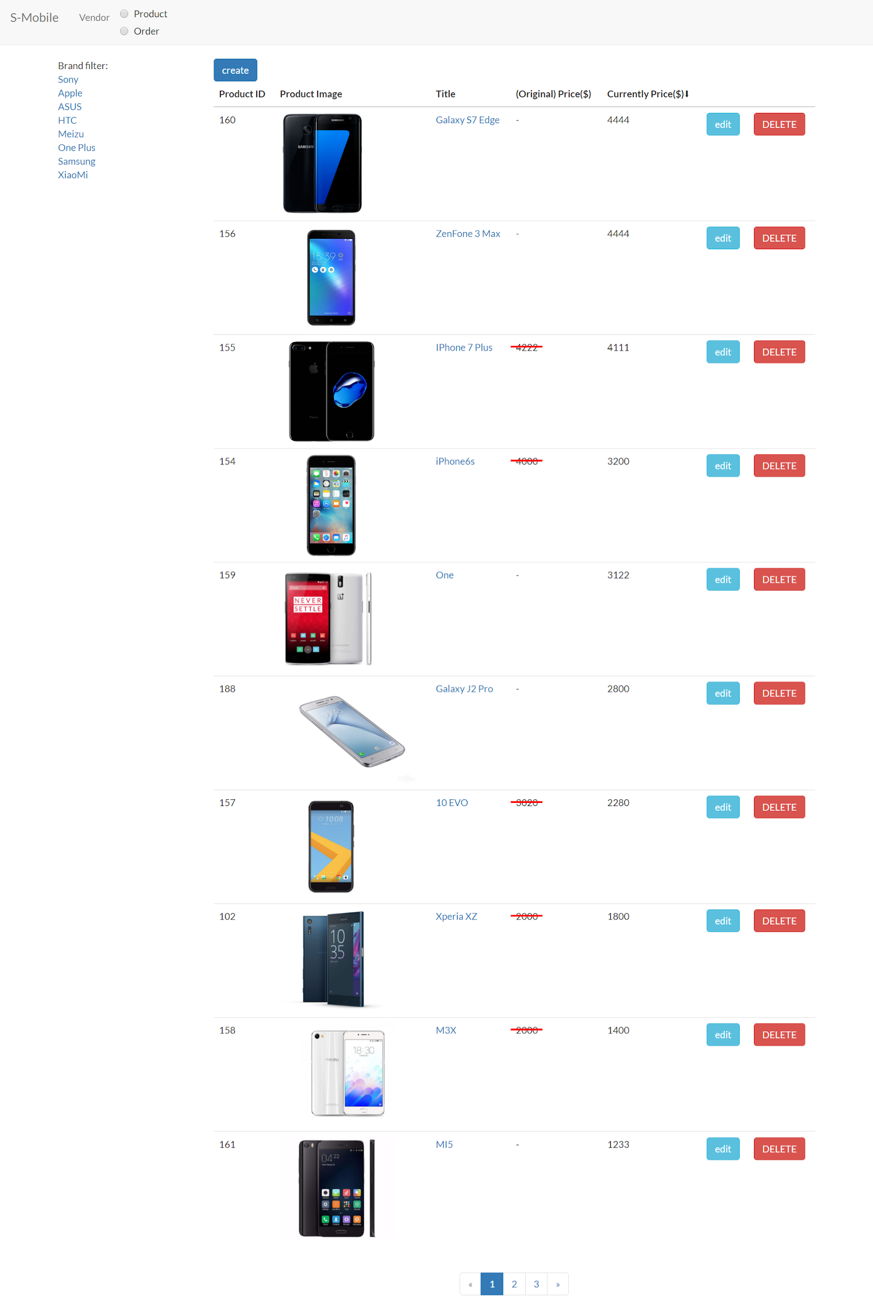

**Figure 47: Searching Function of Product Catalog Maintenance**

Select the radio button on main menu, a search bar will show.

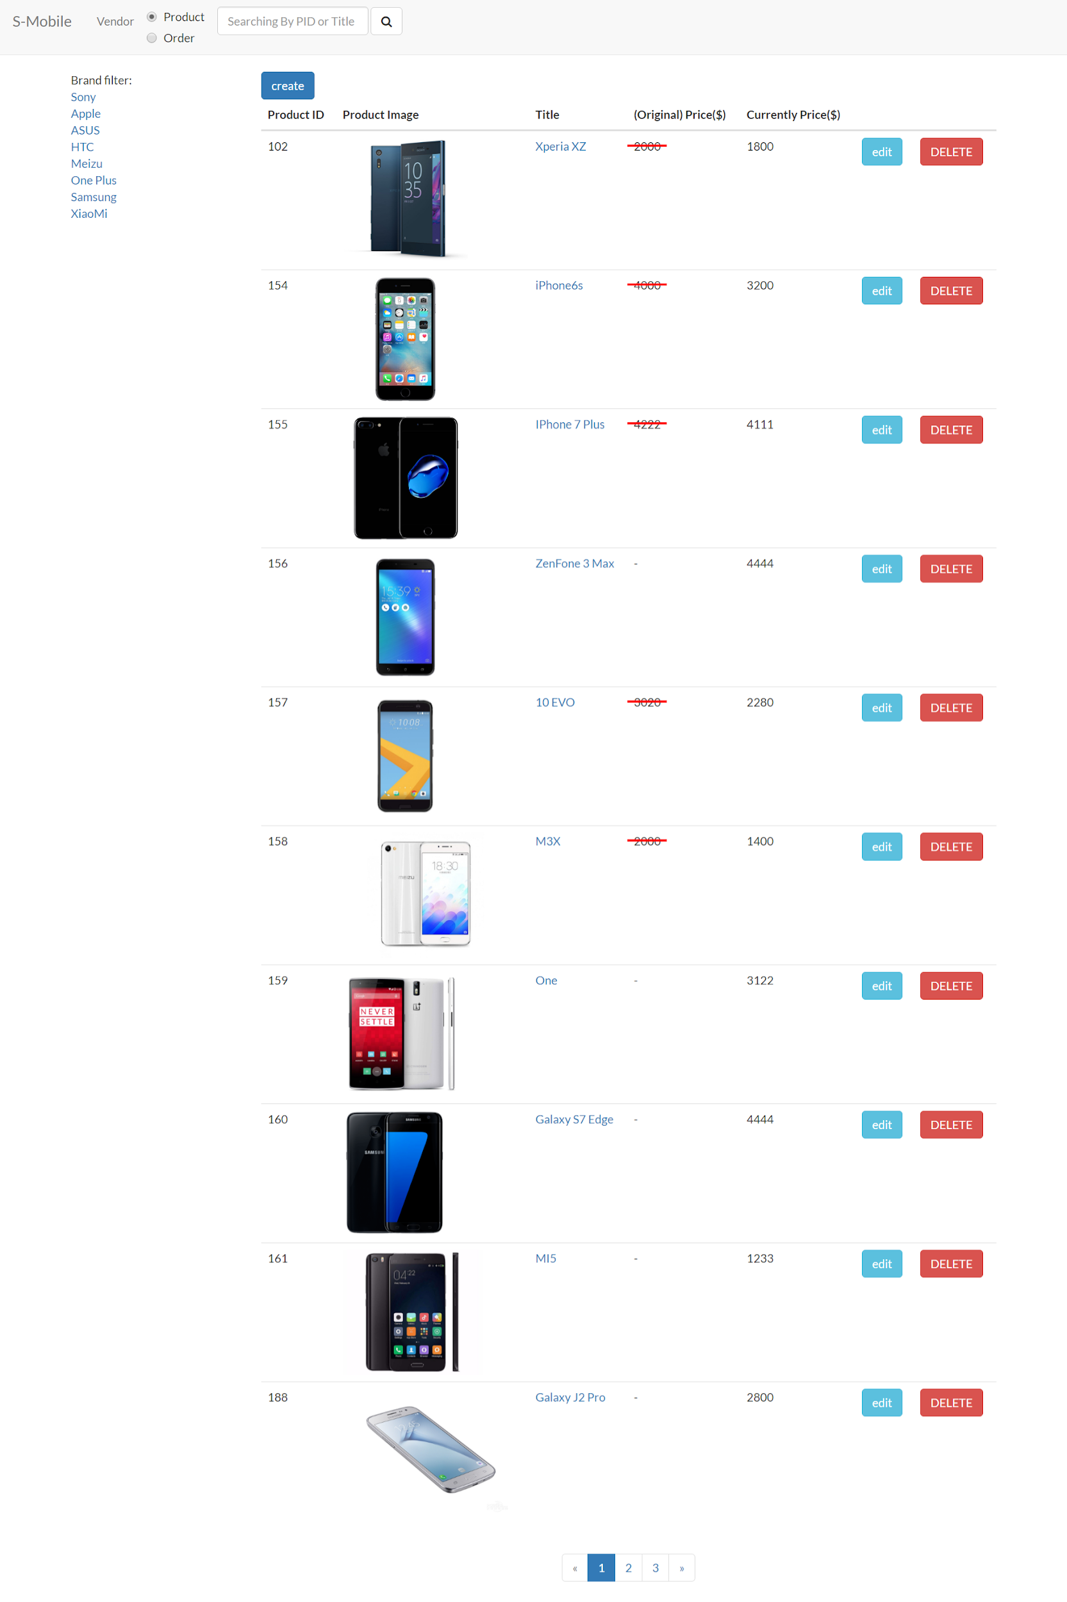

**Figure 48: Searching Function of Product Catalog Maintenance**

Type in the product ID 102 and search, the result was shown.

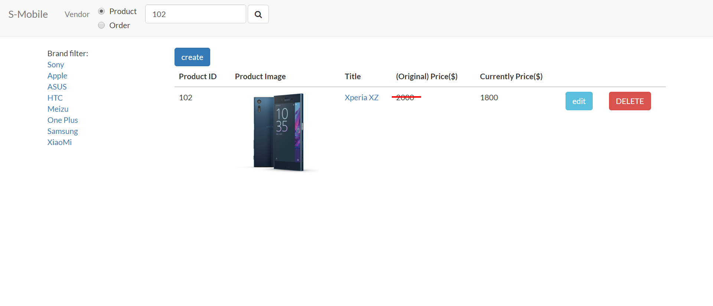

**Figure 49: The Result of Searching Function of Product Catalog Maintenance**

Type in the product keyword 7 and search, the result was shown.



**Figure 50: The Result of Searching Function in Product Catalog Maintenance**

Click on the left hand side filter list, the product content will change by the specific brand.

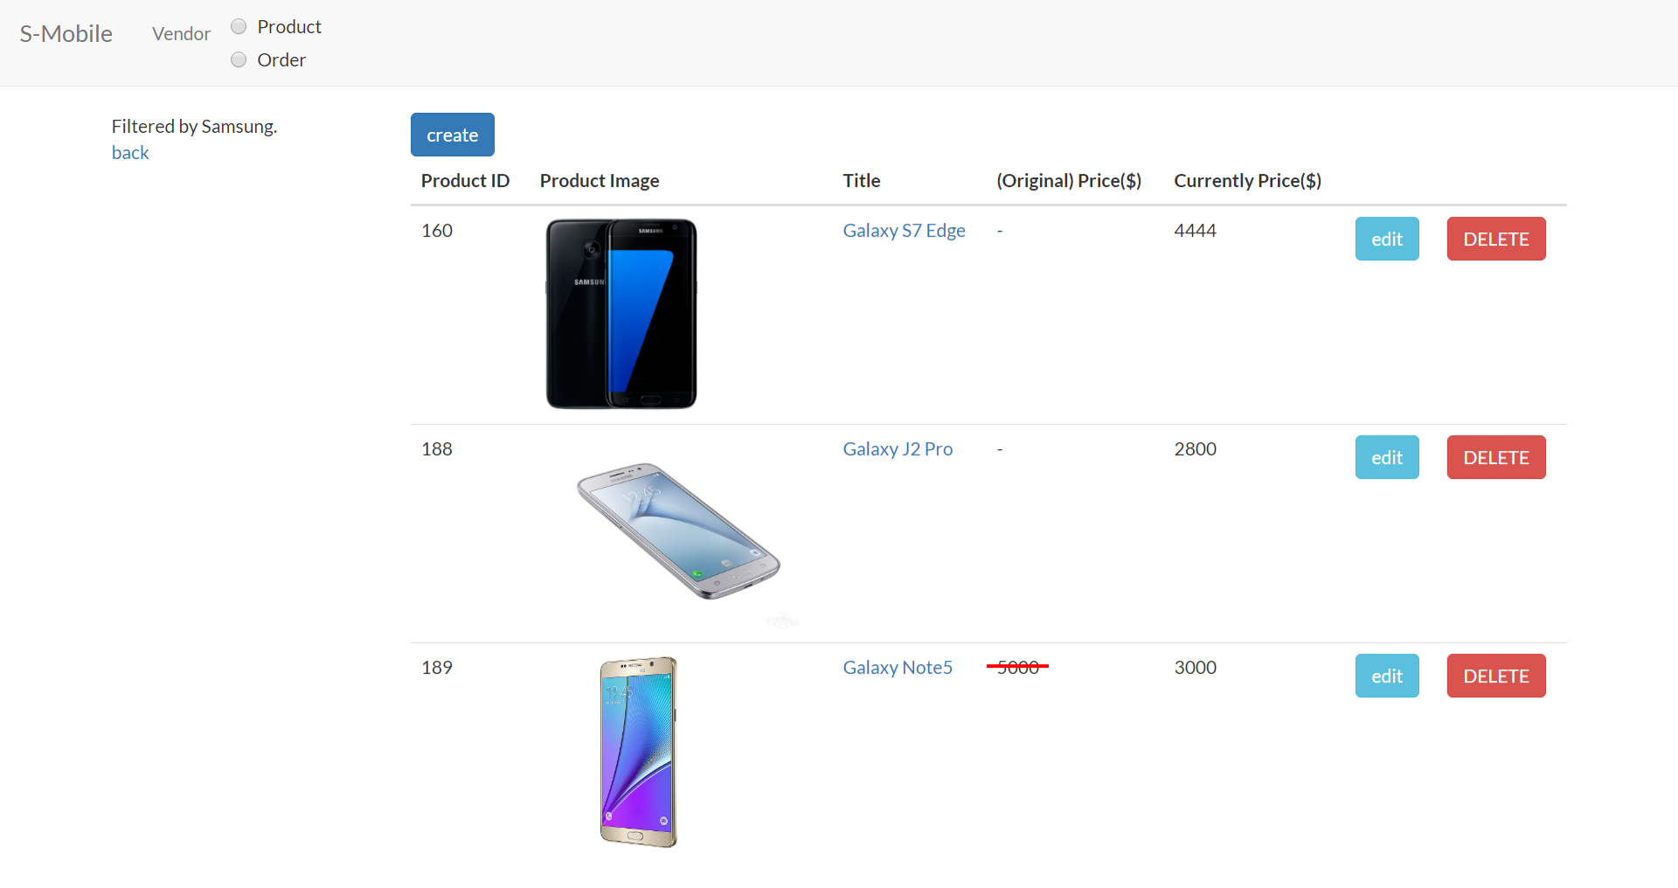

**Figure 51: The Result of Filtering Function in Product Catalog Maintenance**

The function of filtering and searching can do at the same time.

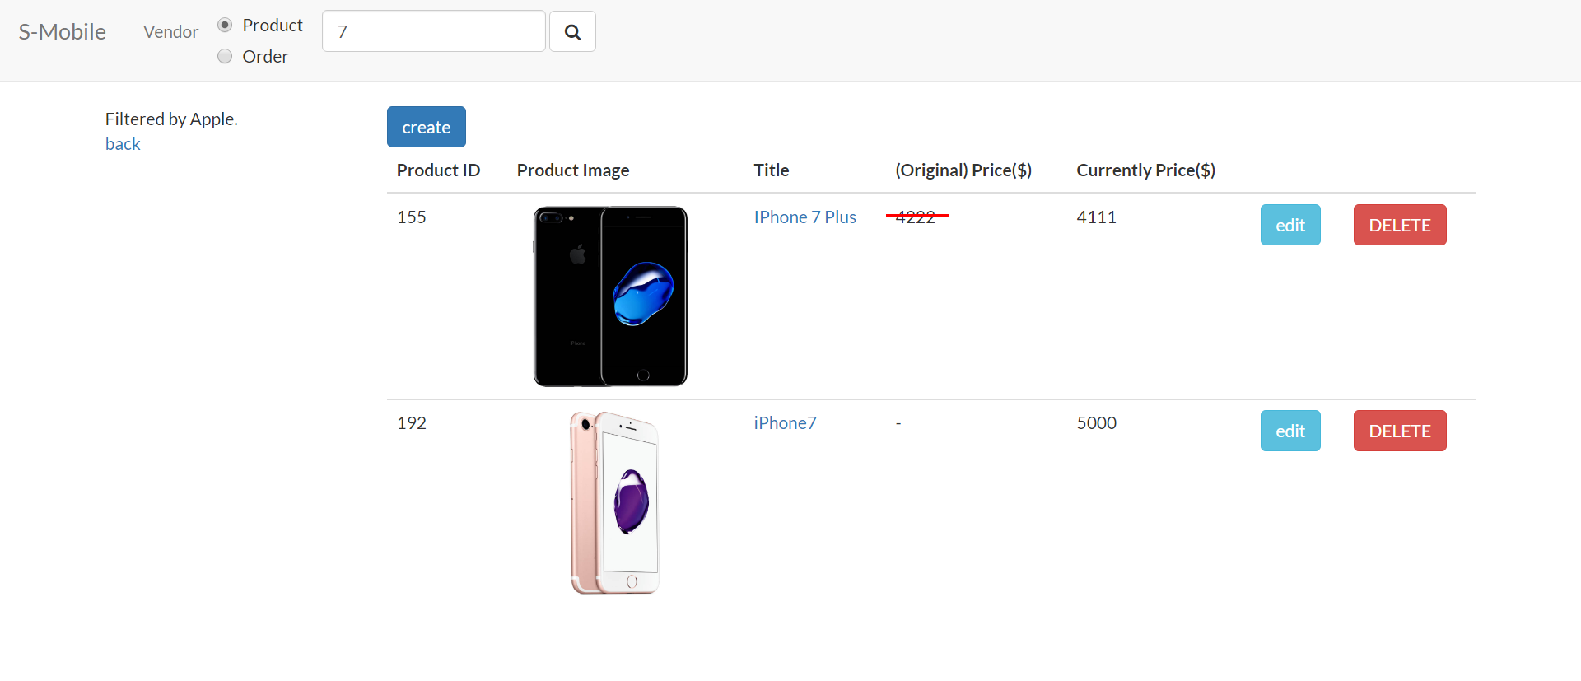

**Figure 52: The Result of Searching and Filtering Function in Product Catalog Maintenance**

After pressing on the “create” button, vendor can type in the information of product and upload the thumbnail, detailed picture of it.

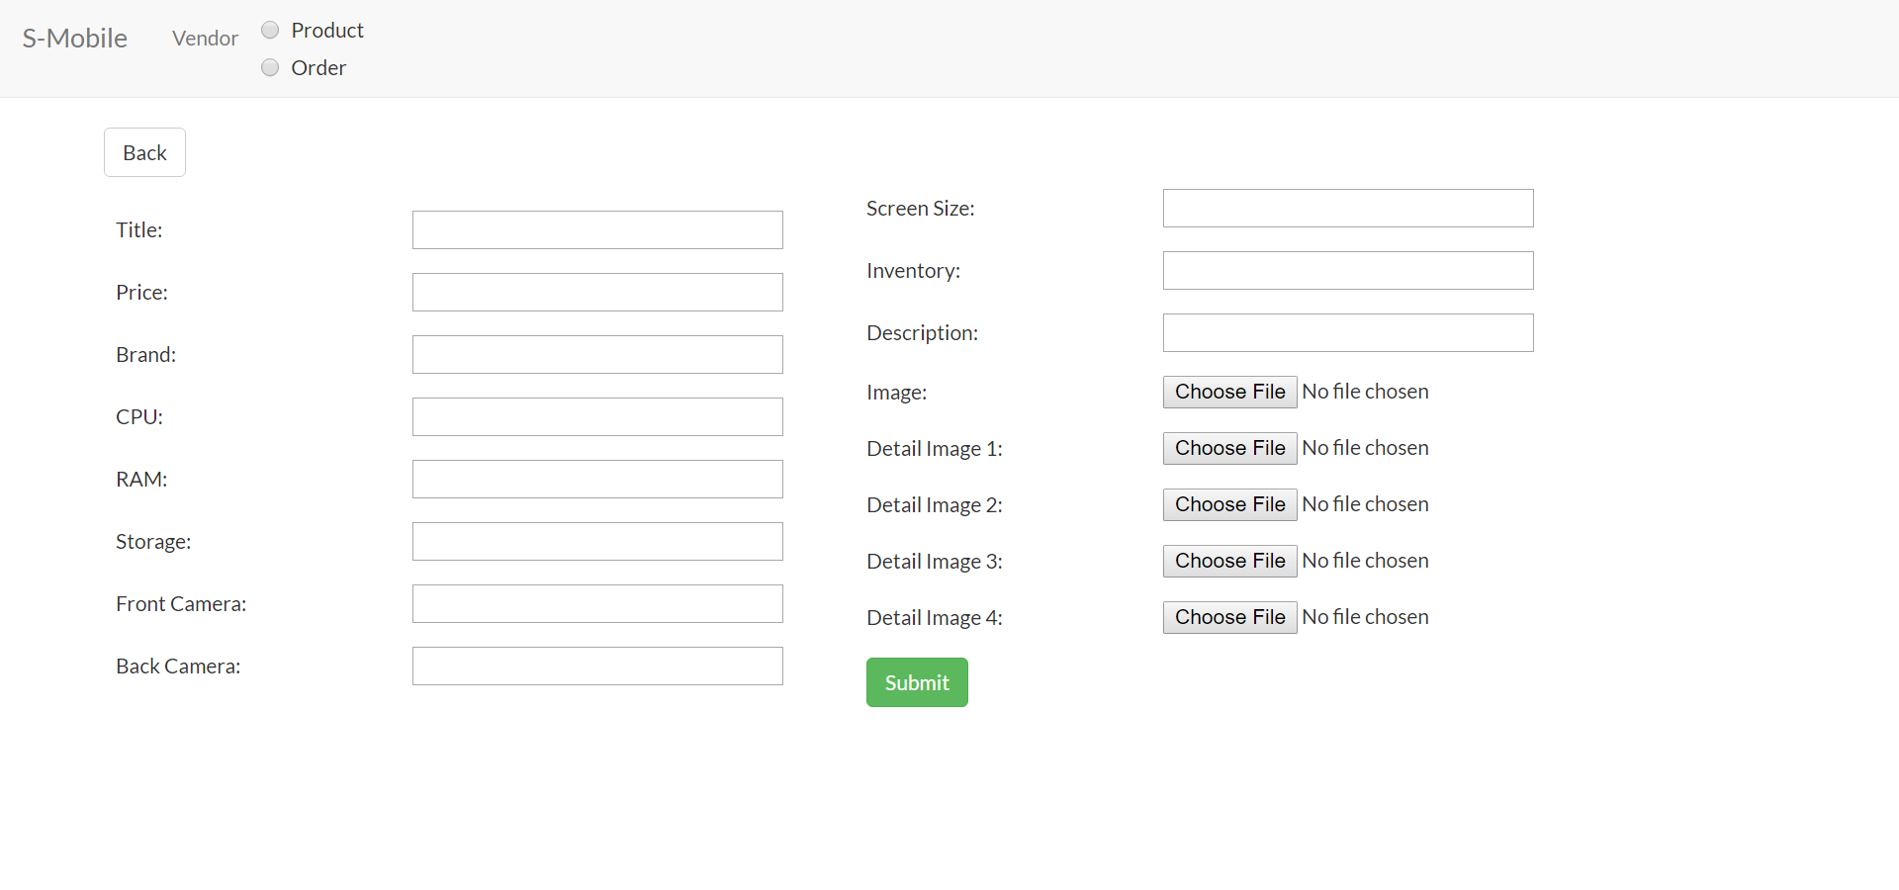

**Figure 53: New Product Creation in Product Catalog Maintenance**

The following image is the vendor view of product detail, vendor can browse, edit or delete the information of a uploaded product.

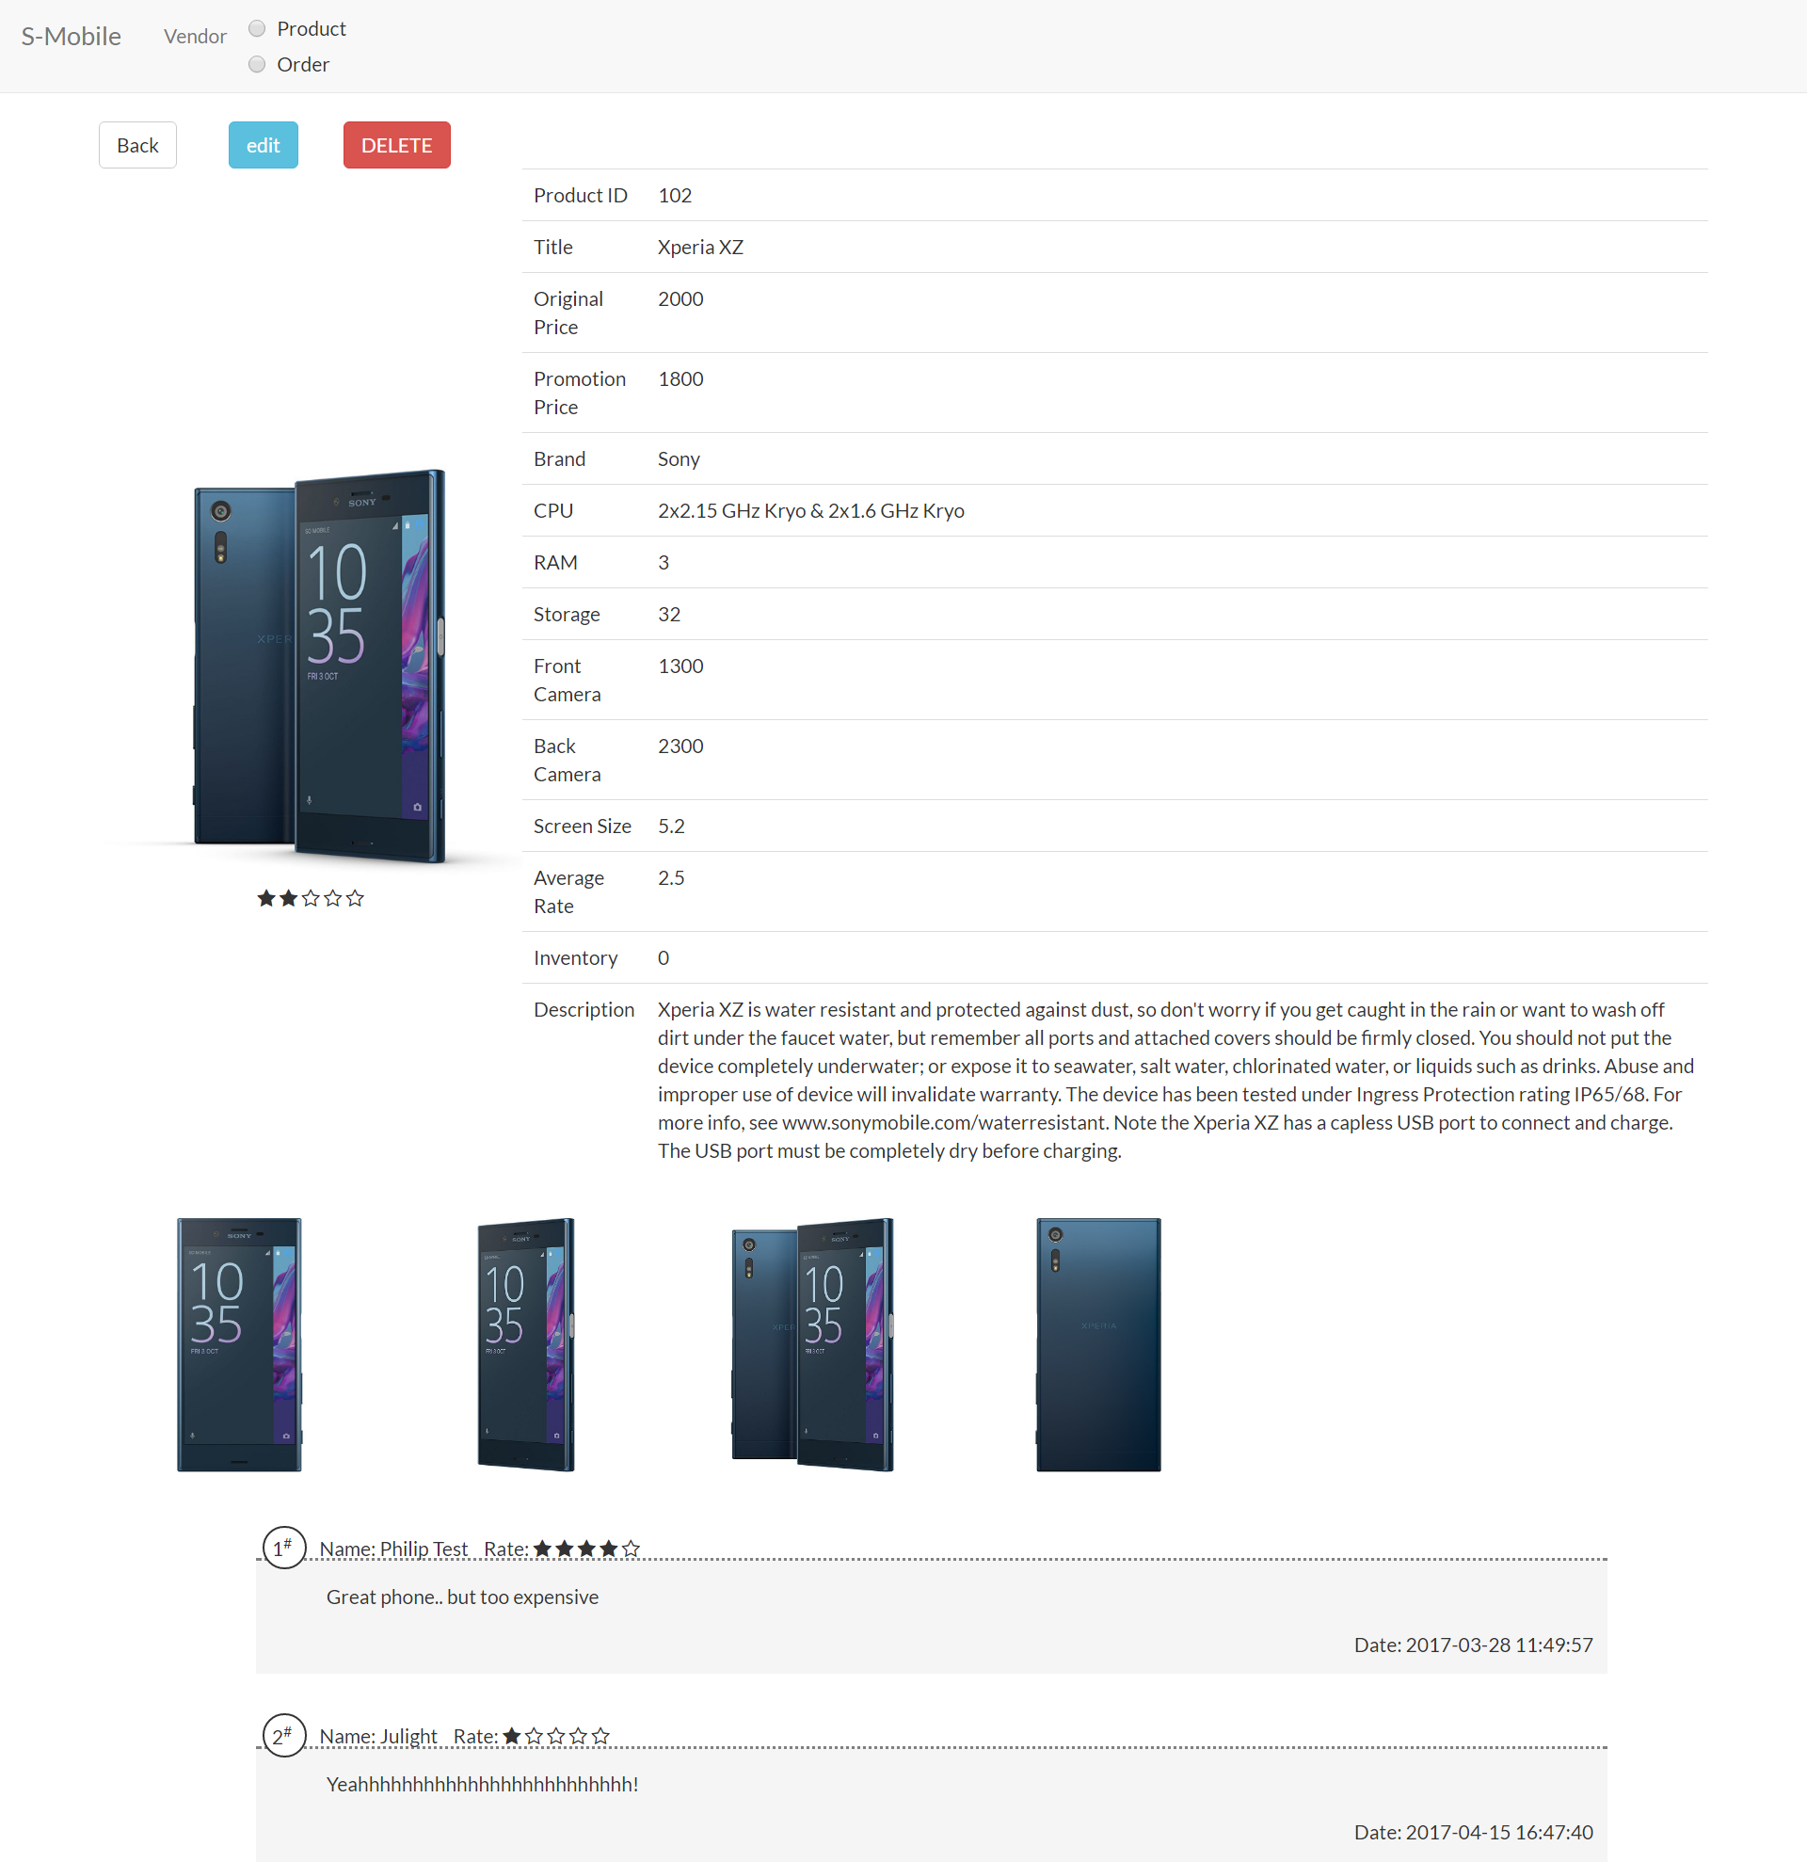

**Figure 54: Vendor View of Product Detail in Product Catalog Maintenance**

In edit mode, vendor can check on the checkbox next to “Promotion Price” to promote their product.

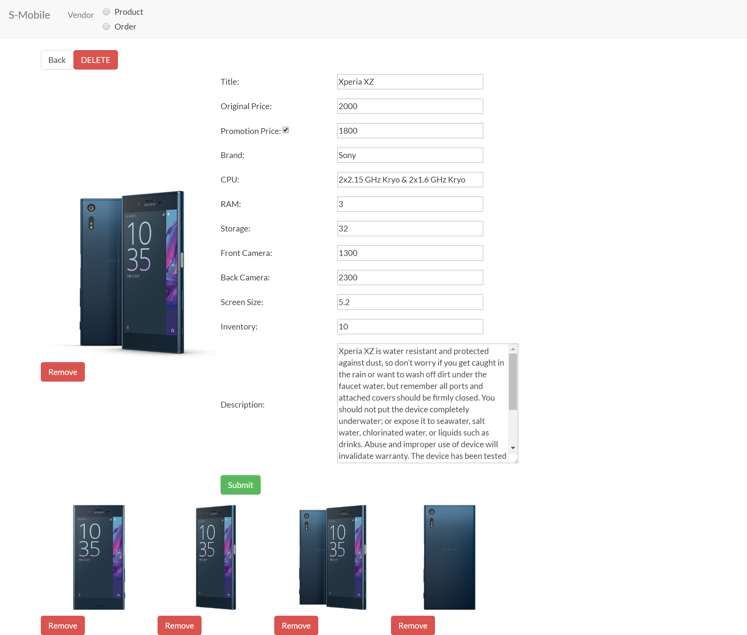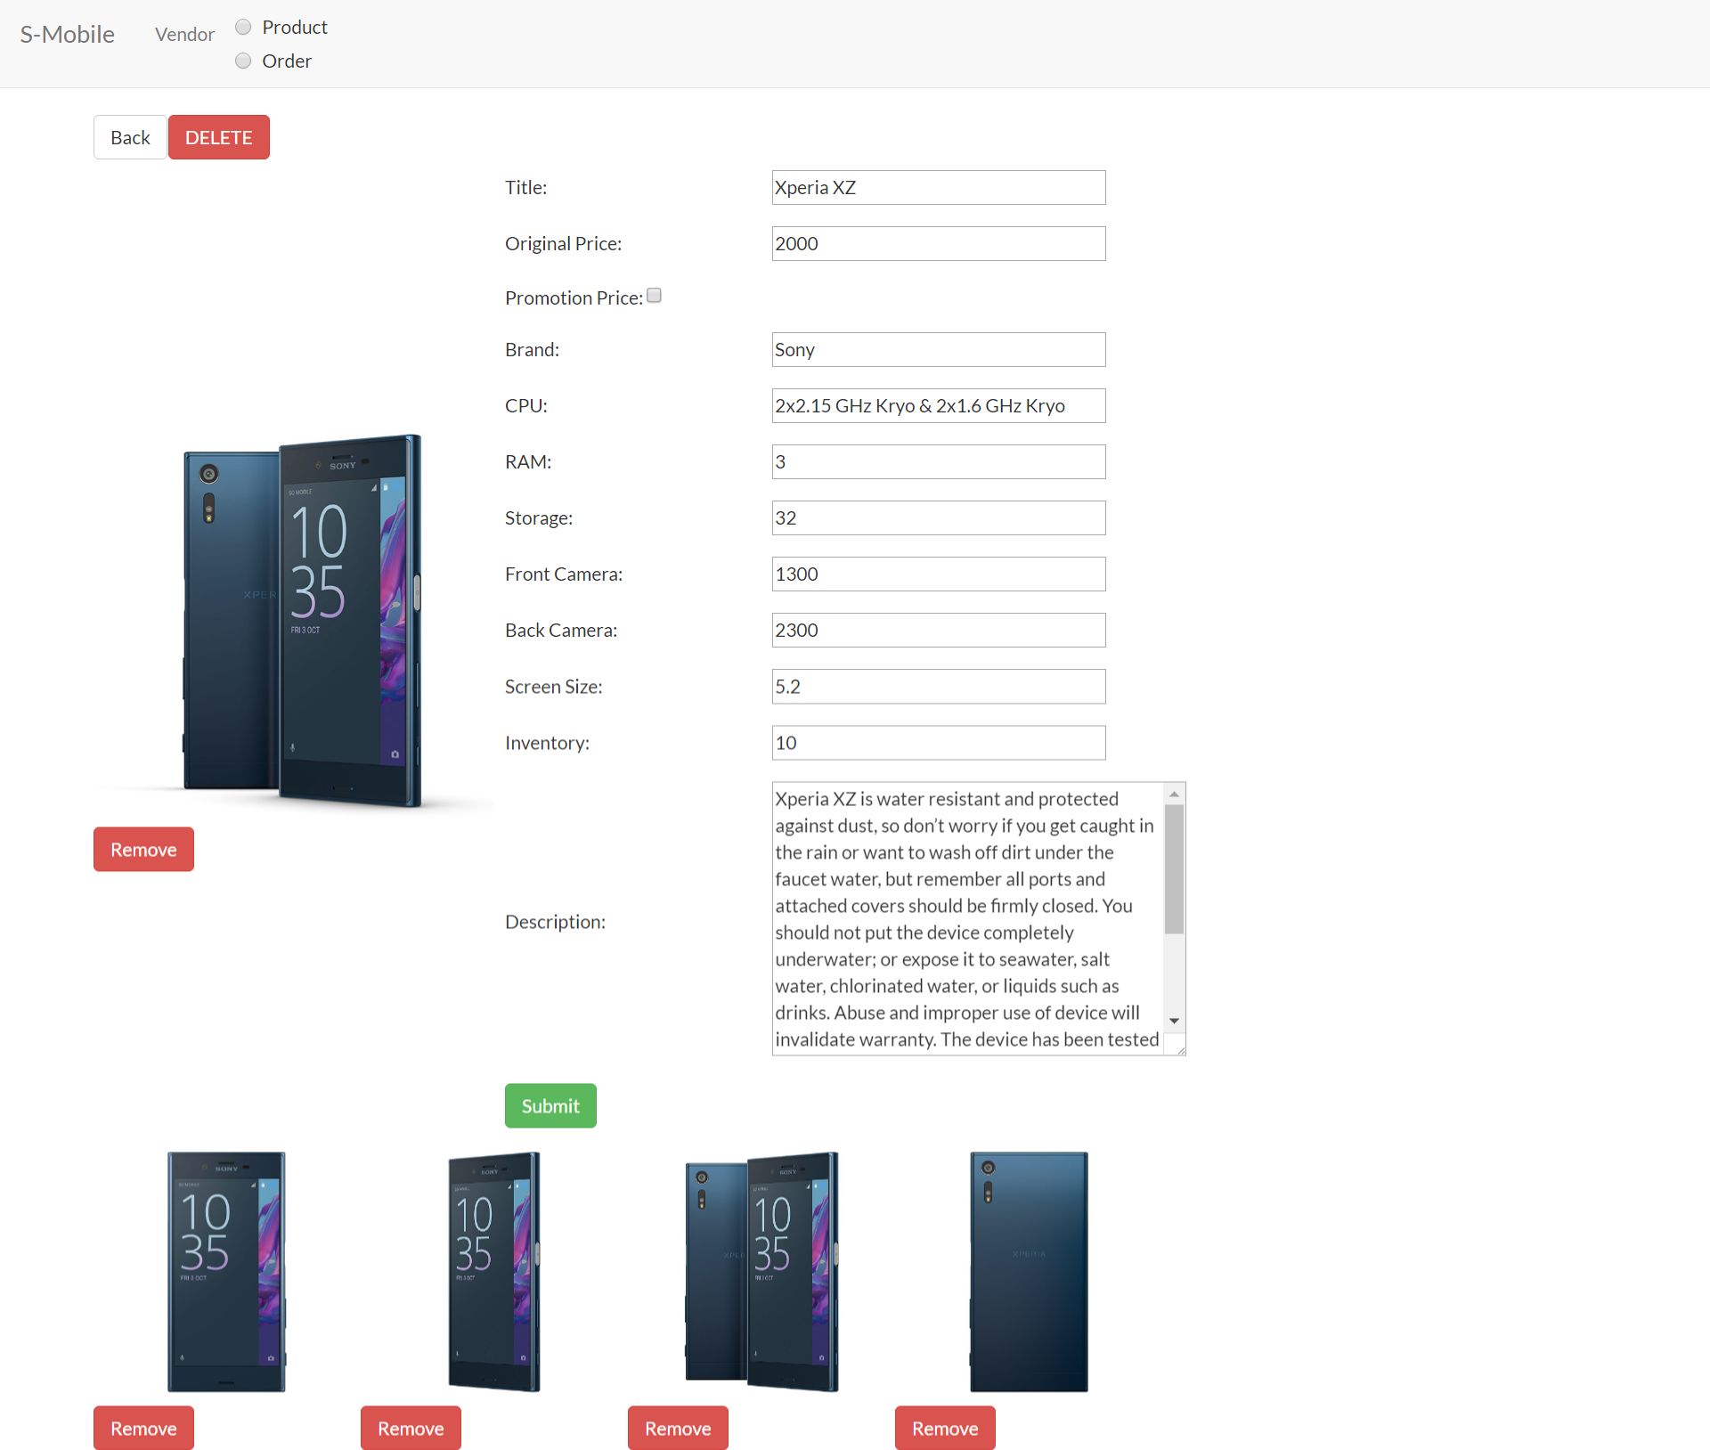

**Figure 55: The Promotion Price Changing in Product Catalog Maintenance**

### Purchase Order Processing

Purchase order processing helps vendor to view and manage the order. In purchase order list page (Figure 56), vendor may view the whole orders list. Vendor may also use the filter function to view orders in various statuses.

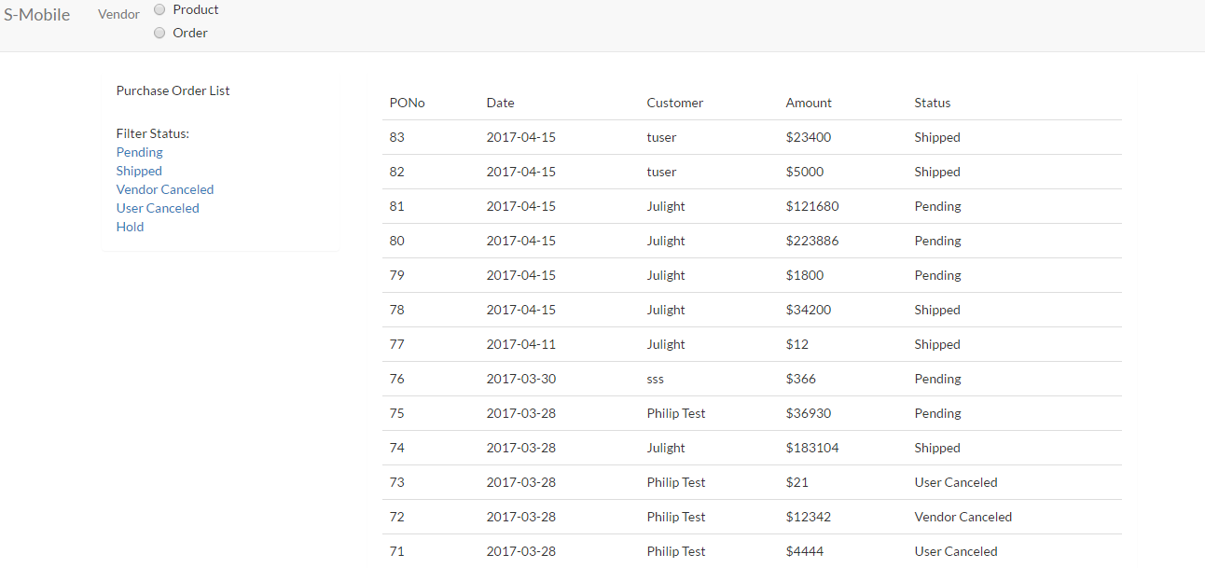

**Figure 56: Graphic User Interface of Product Order**

The screen capture of purchase order processing page (Figure 57) is shown below. By using this page, vendor can view the detail of one specific order. All products in this order plus the information of the order are listed in this page. Vendor may also use this page to hold, unhold, ship or cancel one specific order.

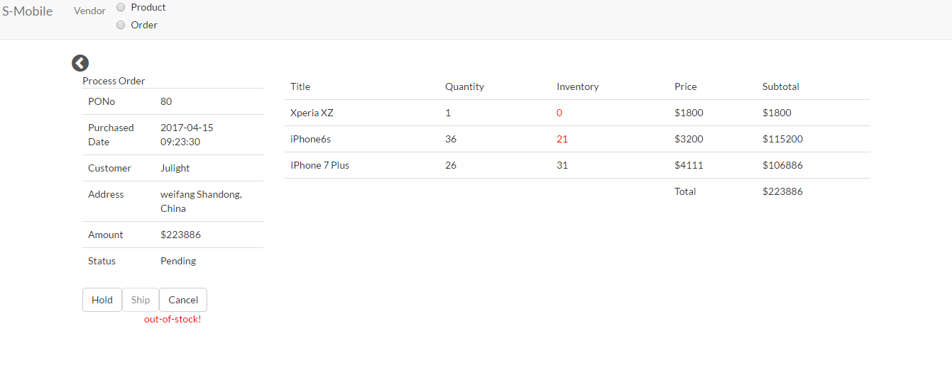

**Figure 57: Graphic User Interface of Product Detailed Order**

### Customer Rating and Review

Before customer gives out a rating and review, he/she should have ordered at least one of the products. When the order has shipped, customer can go to corresponsive product to rate and write a comment.

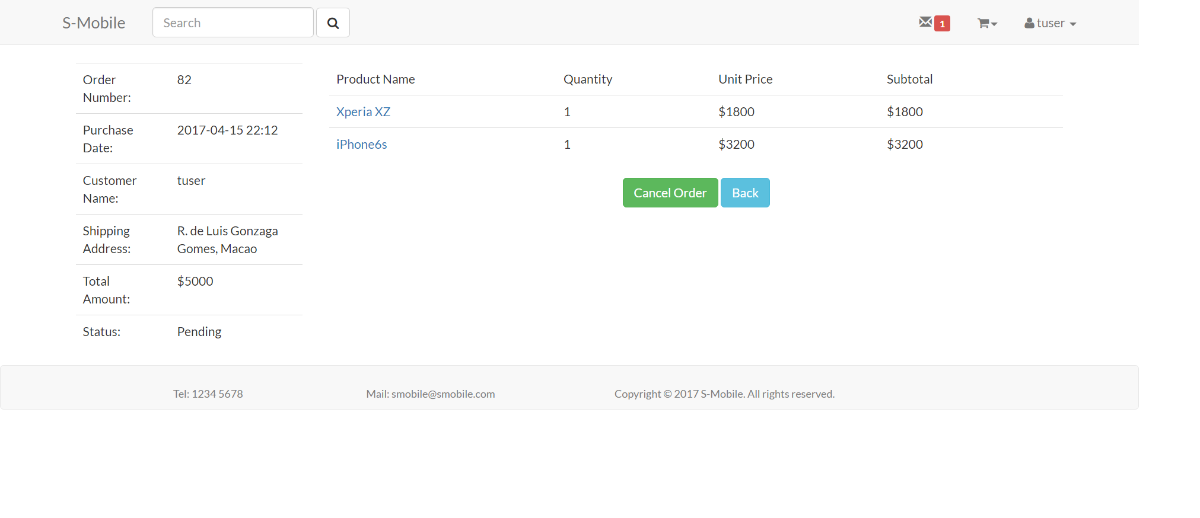

**Figure 58: Graphic User Interface of Product Detailed Order**

When an order has shipped, system will send a notification to remind customer. Customer will be redirected to a comment page by pressing on the product link.

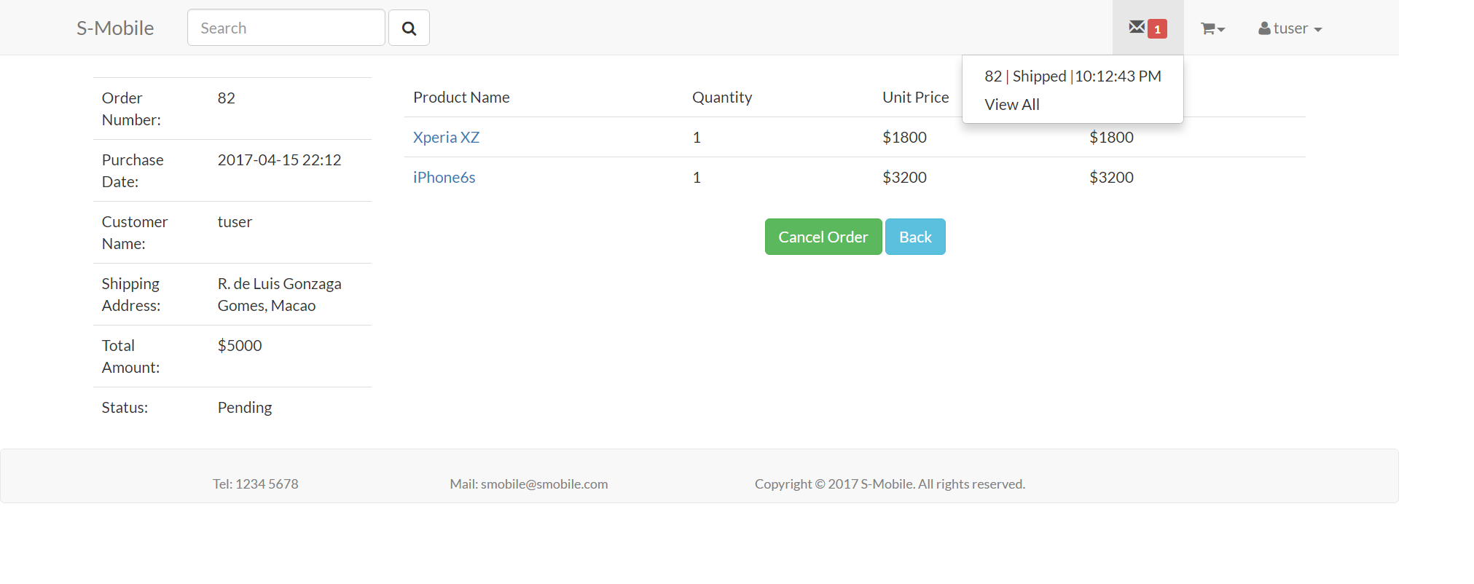

**Figure 59: Notification of Product Detailed Order**

The comment page shows the image and description of product, customer can give rating and comment in this page (Figure 60).

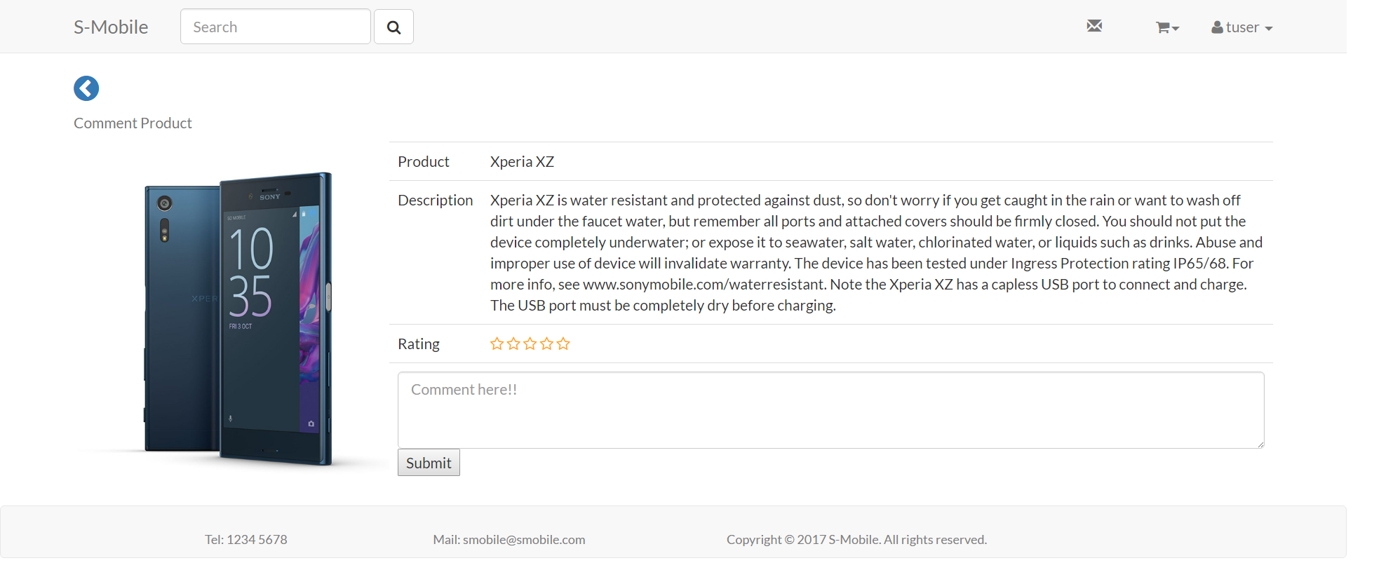

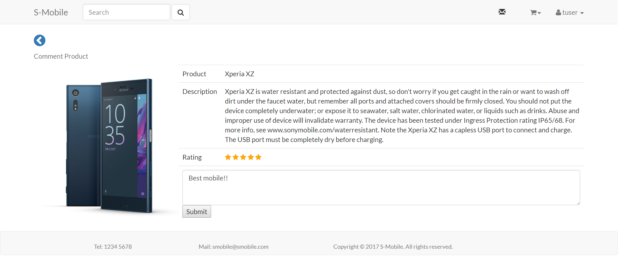

**Figure 60: Customer Rating and Review**

After submitting the comment, the data updates automatically.

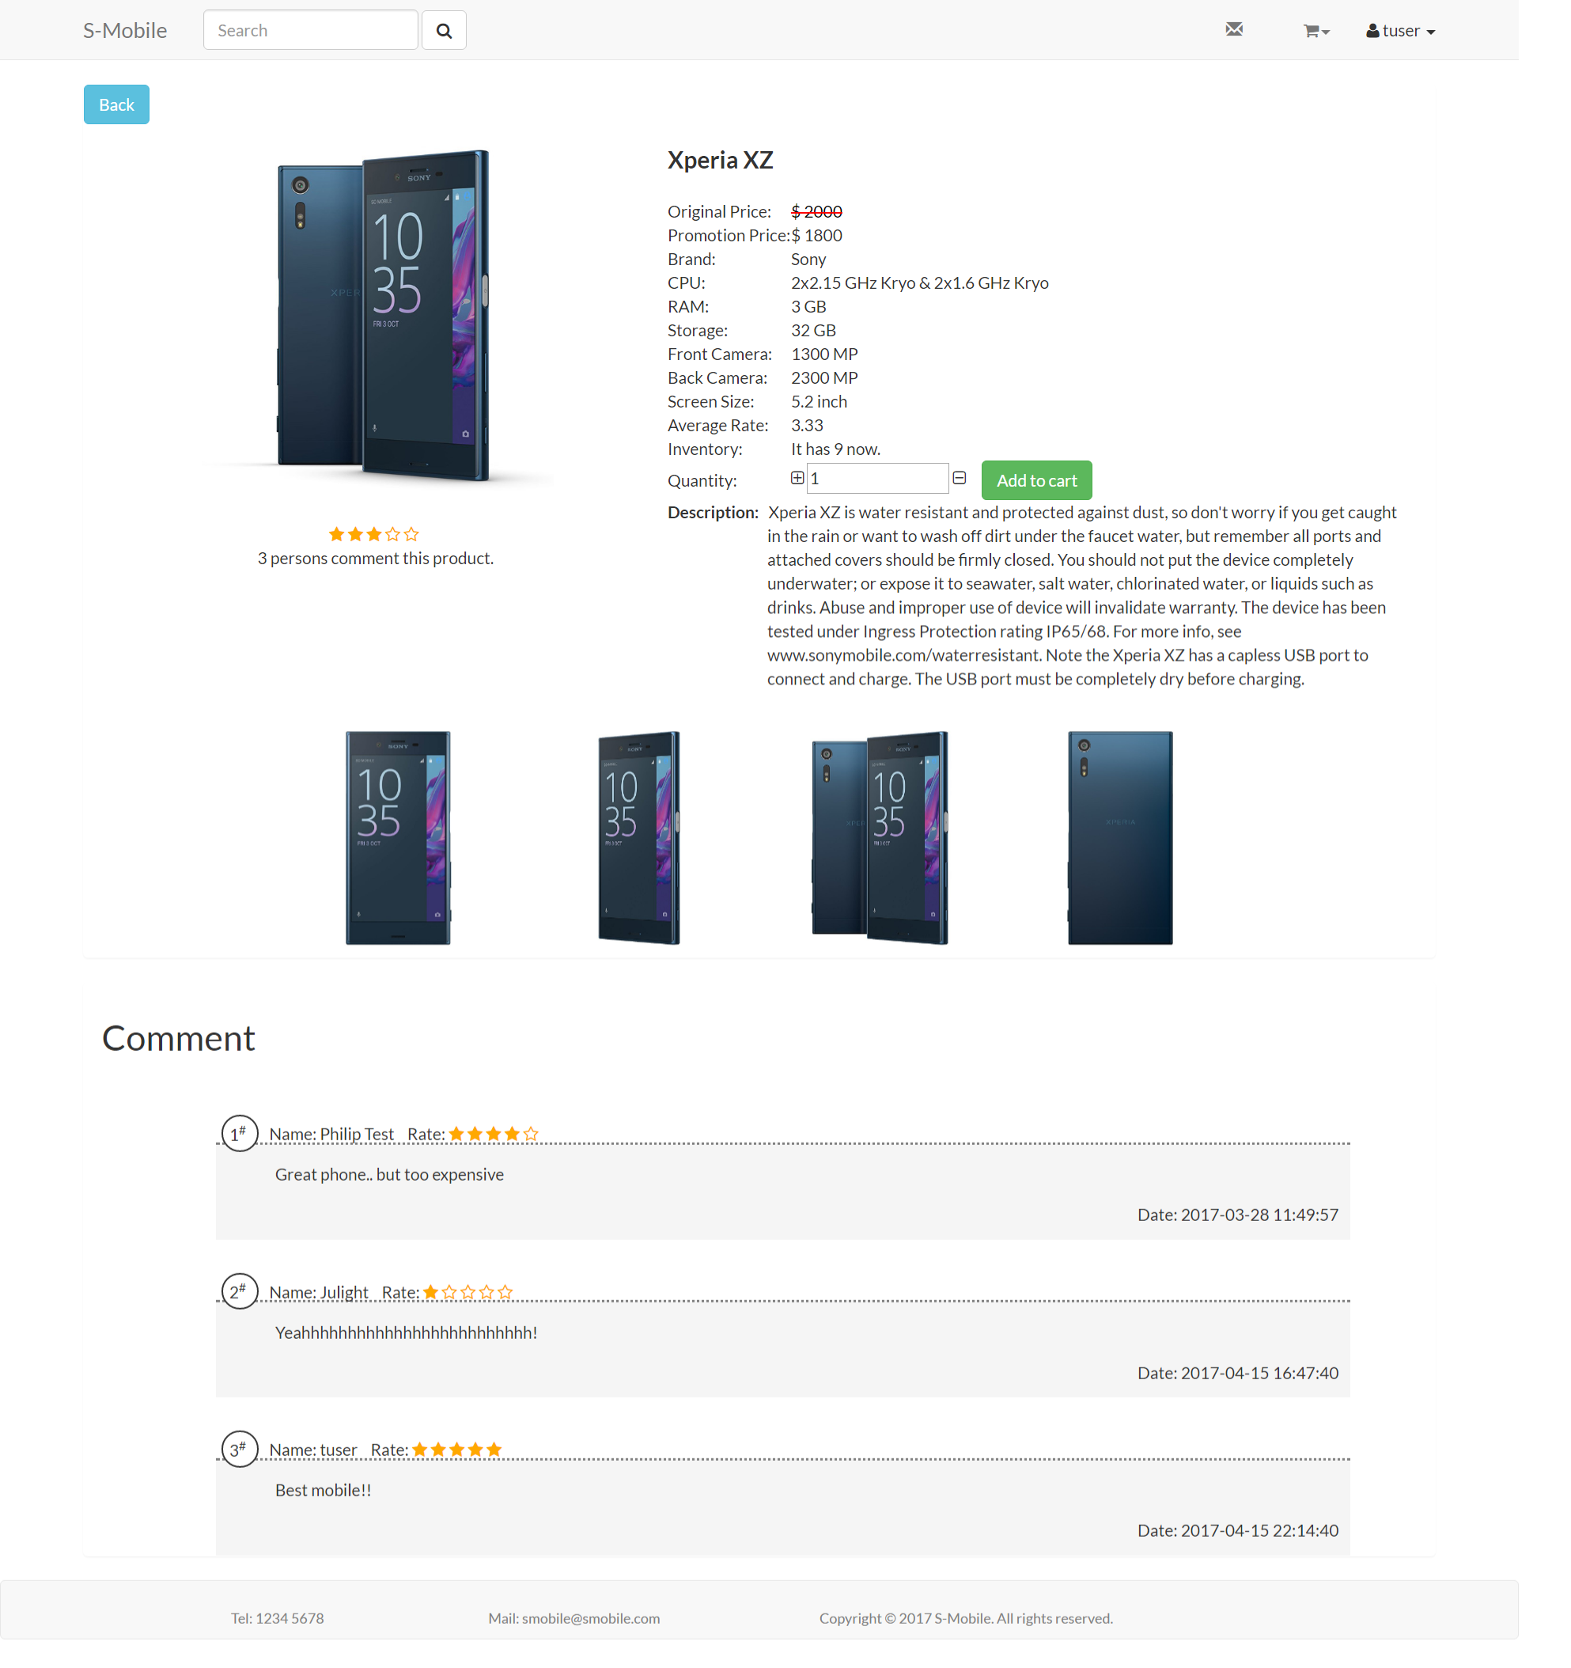

**Figure 61: The Update of Customer Rating and Review**

### Notification

Notification function enable user to track the status change of the order in real time. After login, user may view the message logo on screen, if there are any new messages, a red number will show on the left of the loge. User may also click the message logo to view the unread messages. User may click the message to read the message (jump to the detail page of the order) to change the status of the message to read. The GUI is shown in the figure 62.

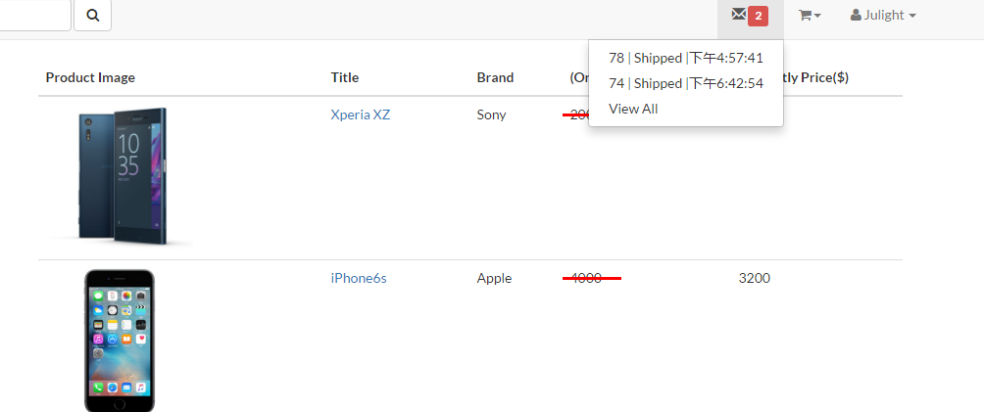

**Figure 62: Graphic User Interface of Notification**

By clicking the view all button, user may jump to the notification list page to view all historical notifications. Also, by clicking specific notification, user may jump to one specific order. The screen capture is showed in the figure 63.

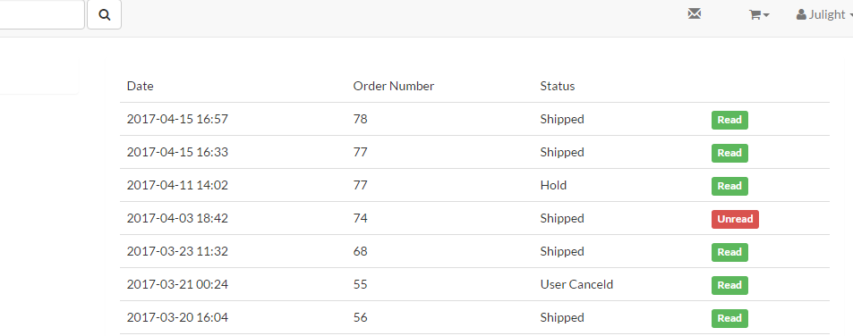

**Figure 63: Graphic User Interface of Notification**

### Price and Inventory Control

Some hot-selling product will be out-of-stock, therefore, the price and inventory control has been implemented.

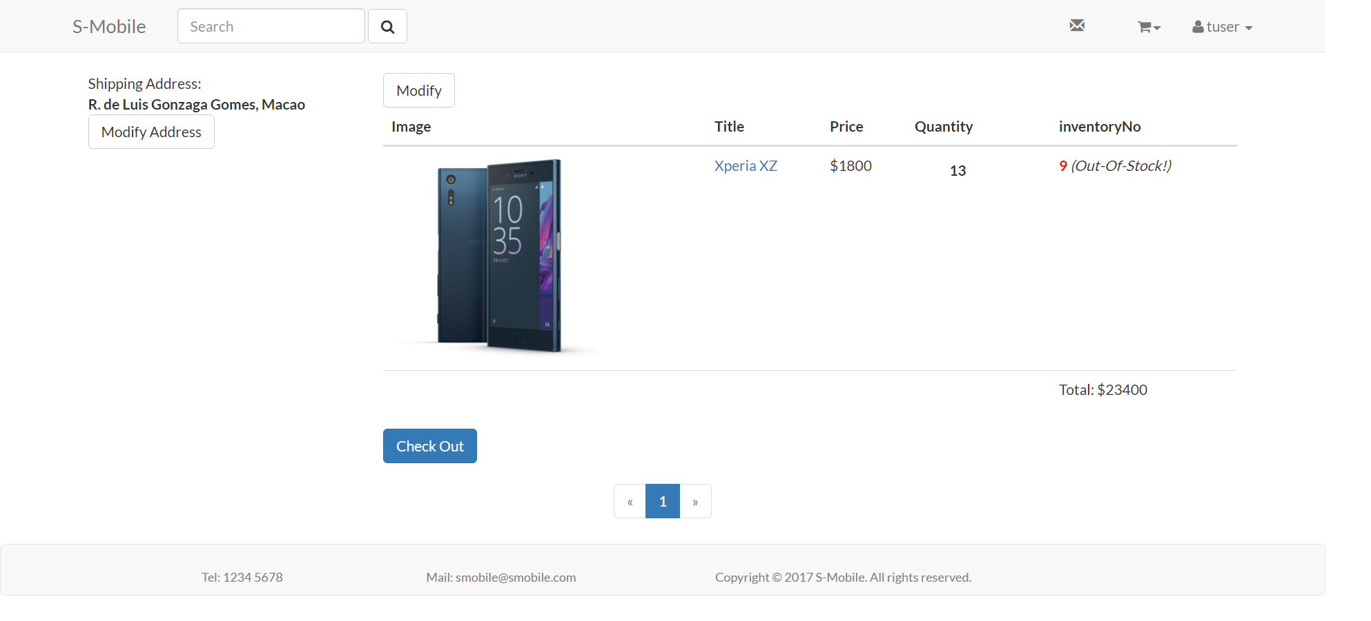

**Figure 64: Graphic User Interface of Price and Inventory Control**

When the inventory is less than the quantity of a product, system will remind the customer that the product may be held.

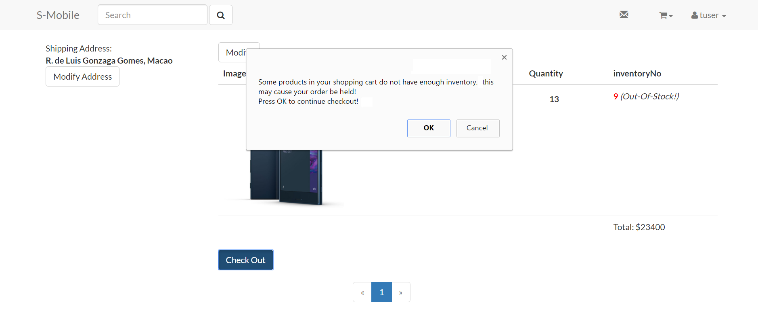

**Figure 65: Reminder of Price and Inventory Control**

When customer keeps check out the product, vendor would receive an order which cannot ship.

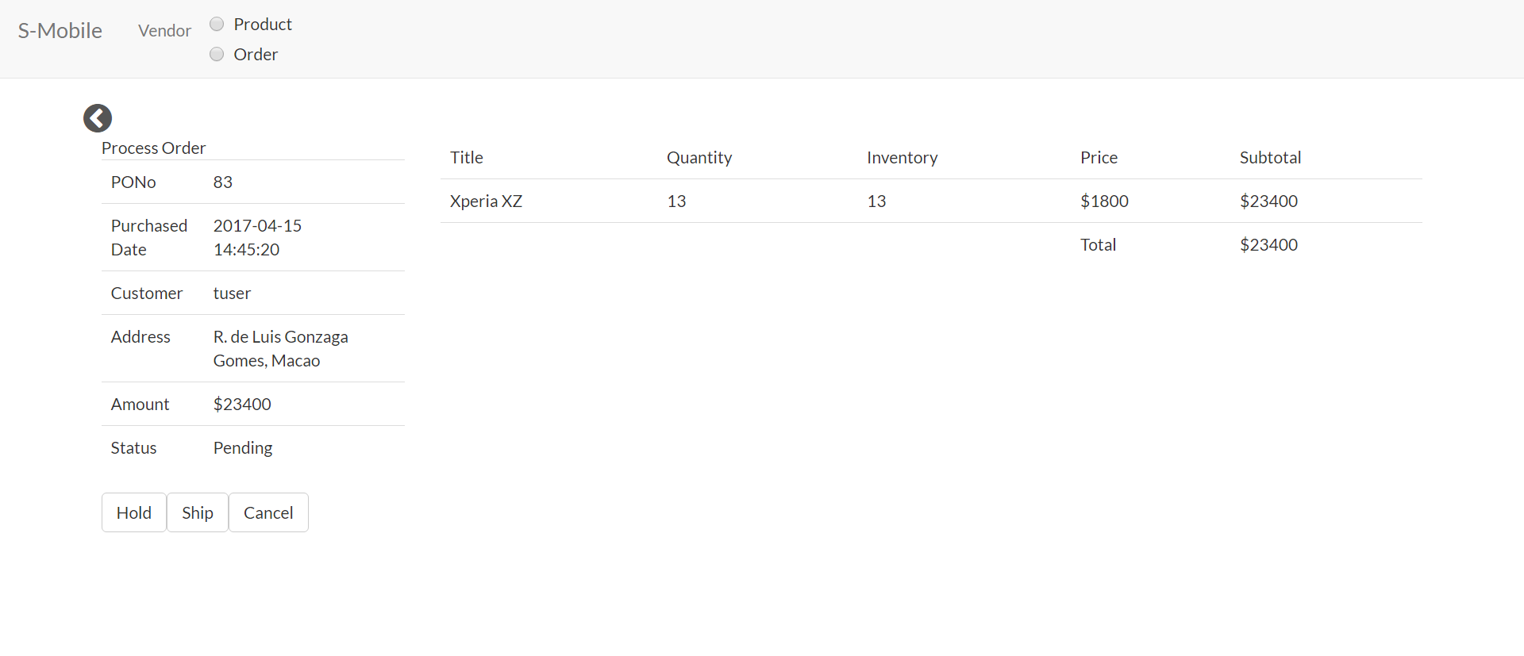

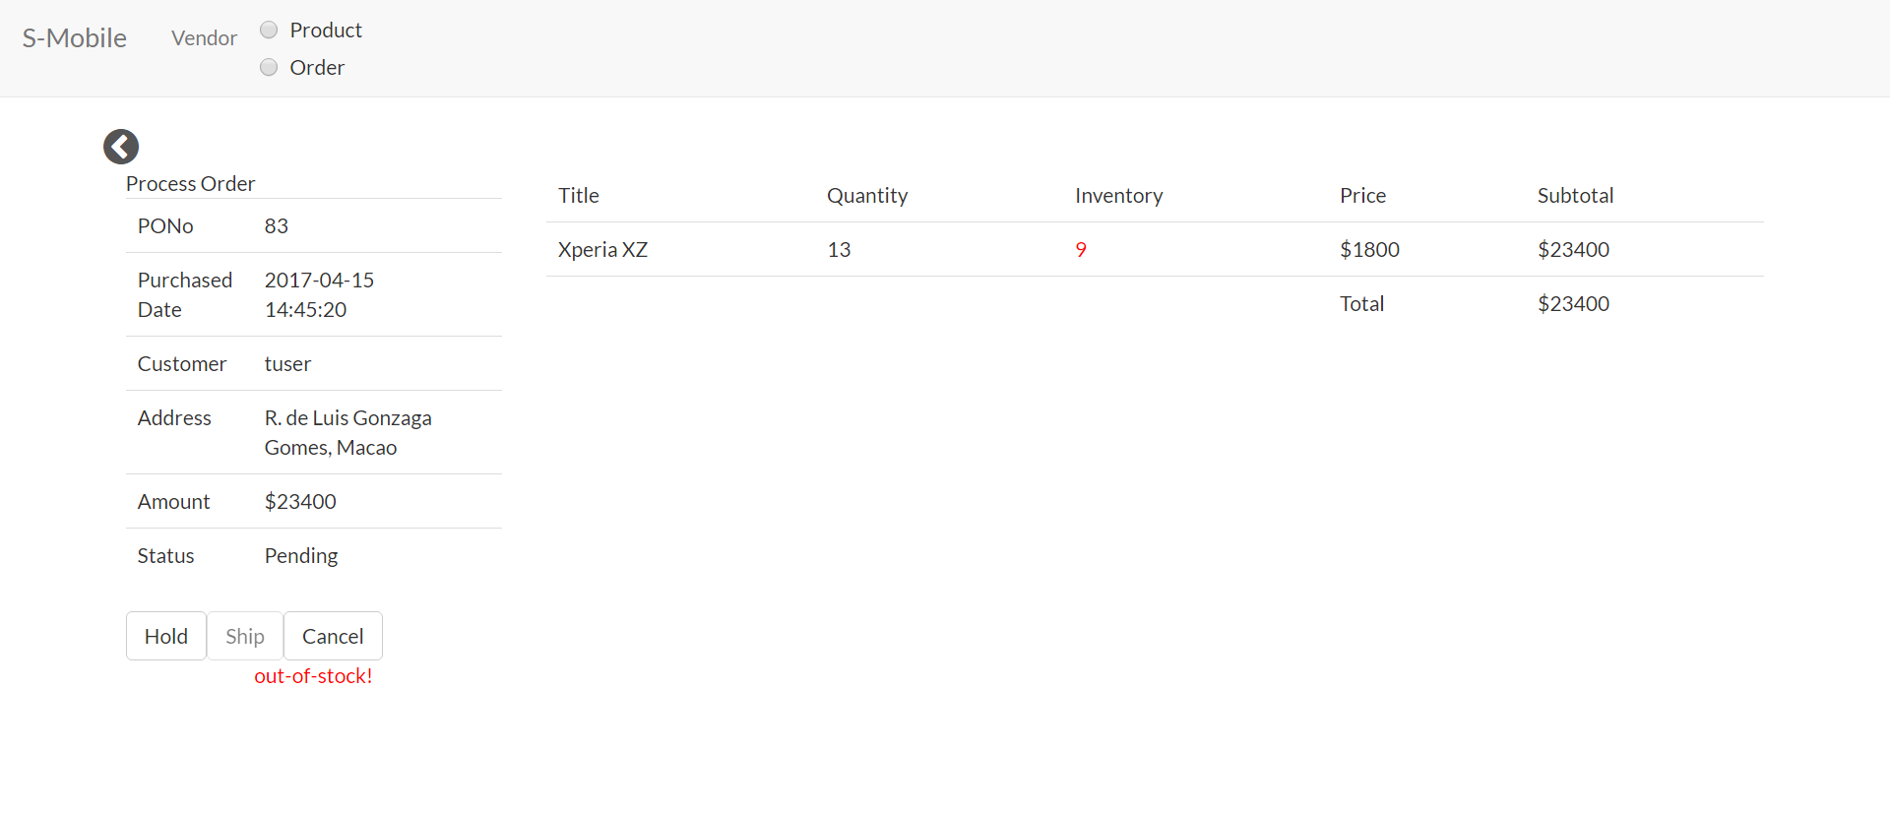

**Figure 66: Graphic User Interface of Price and Inventory Control**

## Testing and System Evaluations

|  |  |  |  |
| --- | --- | --- | --- |
| Test Case Number: | 1 | | |
| Test Case Name: | Product list | | |
| Requirements: | A1, A2, A3, A4, A5, A6, A7, C1, C6, B4 | | |
| Short Description: | A customer browses the list of product. By clicking the name of product, the customer could jump to the detail page of clicked product. In product list page, the customer can sort the product by price and filter the product by brand and searching keywords. In detail product page, the customer can view more information of product, such as product description, one or more photo, etc. Moreover, the customer can add product to cart after they login with their account. However, the customer cannot add duplicate product to shopping cart. | | |
| Module: | List | | |
| Pre-condition: |  | | |
| Function | Action | Expected System Response | Pass/Fail |
| 1 | Browsing the product list | All products will show on product list that works paging. | Pass |
| 2 | Filtering by brand | All products filtering by brand will show on product list. | Pass |
| 3 | Filtering by searching keywords | All products filtering by searching keywords will show on product list. | Pass |
| 4 | Sorting by price | All products sort by price will show on product list | Pass |
| 5 | Clicking the name of product | The system will direct the user to the product detail page. | Pass |
| 6 | Viewing the detail of product | The detail information of product will be shown here. | Pass |
| 7 | Adding product into cart | The system checks whether the user is logged in. If the user is already logged in to the system, the user can add this product to the shopping cart. | Pass |
| 8 | Adding duplicate product | The system will deny the product that is already store in shopping. | Pass |
| 9 | Redirect the login page | If user without account wants to add product to cart, the system will redirect to login page. | Pass |

**Table 1: Testing of requirements A1, A2, A3, A4, A5, A6, A7, C1, C6, B4**

|  |  |  |  |
| --- | --- | --- | --- |
| Test Case Number: | 2 | | |
| Test Case Name: | Account management | | |
| Requirements: | B1, B2, B3, B5 | | |
| Short Description: | The customer should have their own account before he/she buy the product. The customer can register a new account in register page. The customer login the system with their account in login page. In customer home page, he/she can change their passwords that contain at least 6 characters. | | |
| Module: | Management | | |
| Pre-condition: |  | | |
| Function | Action | Expected System Response | Pass/Fail |
| 1 | User sign in | Using registered account can successfully login the system. | Pass |
| 2 | User sign up | User use appropriate name and password with registration | Pass |
| 3 | Change password | User’s original password is same as its password in database. New password should contain at least 6 characters (at least 1 digit and 1 capital letter). | Pass |
| 4 | Storing hash value in database | User’s password stored in database of server using hash value. | Pass |

**Table 2: Testing of requirements B1, B2, B3, B5**

|  |  |  |  |
| --- | --- | --- | --- |
| Test Case Number: | 3 | | |
| Test Case Name: | Shopping cart | | |
| Requirements: | C2, C3, C4, C5 | | |
| Short Description: | After the customer adds product to cart, he/she can go shopping cart to browse be added product. In shopping cart page, the customer can modify own added products, such as change the quantity of an item and remove an item. Furthermore, the customer can check out all items in shopping cart. | | |
| Module: | Cart | | |
| Pre-condition: |  | | |
| Function | Action | Expected System Response | Pass/Fail |
| 1 | Browsing the shopping cart | All added products will display on shopping cart. | Pass |
| 2 | Check out | The shopping cart will clear all items. The system will generate a purchase order message to user. | Pass |
| 3 | Changing the quantity of an item | The database successfully changes quantity of an item. | Pass |
| 4 | Removing an item | The database successfully remove an item | Pass |

**Table 3: Testing of requirements C2, C3, C4, C5**

|  |  |  |  |
| --- | --- | --- | --- |
| Test Case Number: | 4 | | |
| Test Case Name: | Purchase tracking list | | |
| Requirements: | D1, D2, D3, D4, Z3, Z4 | | |
| Short Description: | The customer can view all of own orders in purchase tracking page. The customer can click the button which filtering by current and past. By clicking order number, the page will jump to purchase order detail page. The customer can click the cancel order button to cancel order before a purchase order is shipped. If an order is shipped, the customer can comment and rate each product in this purchase order. | | |
| Module: | List | | |
| Pre-condition: |  | | |
| Function | Action | Expected System Response | Pass/Fail |
| 1 | Browse purchase tracking list | The all of user’s own purchase order will display on user's purchase tracking list. | Pass |
| 2 | Clicking button of the current order | The purchase order with status 'pending' and 'hold' will display on user's purchase tracking list. | Pass |
| 3 | Clicking button of the past order | The purchase order with status 'shipped' and 'cancelled' will display on user's purchase tracking list. | Pass |
| 4 | Clicking order number | The system will direct the user to the purchase order detail page. | Pass |
| 5 | Viewing the detail of purchase order | The detail information of purchase order will be shown here. | Pass |
| 6 | Cancel order | User cancels the order before it is shipped. | Pass |
| 7 | Commenting the product | User comments the product after the order is shipped. | Pass |
| 8 | Rating the product | User rates the product after the order is shipped. | Pass |

**Table 4: Testing of requirements** D1, D2, D3, D4, Z3, Z4

|  |  |  |  |
| --- | --- | --- | --- |
| Test Case Number: | 5 | | |
| Test Case Name: | Product catalog | | |
| Requirements: | E1, E2, E3, E4, E5, E6, Z5 | | |
| Short Description: | In vendor product list page, the vendor can browse product catalog. The vendor can find the products by searching some keywords in product name in search bar. By clicking remove button, the vendor can remove selected product. By clicking create button, the vendor can add a new product. By clicking edit button, the vendor can edit select product. When the vendor edit information of product, the original price will keep in the database. The product will use new price to selling. By clicking name of product, the vendor can view the detail information of selected product. In detail page, vendor can also click the edit and remove button. | | |
| Module: | List | | |
| Pre-condition: |  | | |
| Function | Action | Expected System Response | Pass/Fail |
| 1 | Browsing the product list | All products will show on product list that works paging. | Pass |
| 2 | Searching product | All products filtering by searching keywords will show on product list. | Pass |
| 3 | Adding new product | The vendor can add a new product. | Pass |
| 4 | Editing information of product | The vendor updates the product successfully. | Pass |
| 5 | Removing existing product | The vendor removes the product successfully. | Pass |
| 6 | Viewing detail information of product | The vendor view detail information of product | Pass |
| 7 | Uploading photos | The vendor can upload one to four photos in each product. | Pass |
| 8 | Change photos | The photos can be added and removed in each product. | Pass |
| 9 | Changing price | The original price will keep on the database. The system will using new price to selling | Pass |

**Table 5: Testing of requirements E1, E2, E3, E4, E5, E6, Z5**

|  |  |  |  |
| --- | --- | --- | --- |
| Test Case Number: | 6 | | |
| Test Case Name: | Purchase order list | | |
| Requirements: | F1, F2, F3, F4, F5, F6, F7, Z6 | | |
| Short Description: | The vendor can browse the list in purchase order list page. The order list can be filtered by each status, such as pending, hold, shipped and cancelled. The vendor can enter the existing order number in search bar. By clicking an entry of the order, the system can jump to purchase order processing page. In purchase order processing page, the vendor can view all products with each order. The vendor can cancel, hold, unhold and ship a purchase order. If the quantity of product more than inventory of product, the vendor cannot ship and hold this order. | | |
| Module: | List | | |
| Pre-condition: |  | | |
| Function | Action | Expected System Response | Pass/Fail |
| 1 | Browse the purchase order list | All purchase orders will display on purchase order list. | Pass |
| 2 | Filtering by status | All purchase orders filtering by brand will show on product list. | Pass |
| 3 | Enter the order number | The system will direct the vendor to that purchase order processing page after entering the order number. | Pass |
| 4 | By clicking shipped order button | The status of the purchase order change from ‘pending’ to ‘shipped’. | Pass |
| 5 | By clicking hold order button | The status of the purchase order change from ‘pending’ to ‘hold’. | Pass |
| 6 | By clicking cancel order button | The status of the purchase order change to ‘shipped’ except from ‘cancelled’. | Pass |
| 7 | By clicking unhold order button | The status of the purchase order change from ‘hold’ to ‘shipped’. | Pass |
| 8 | Marking ‘out-of-stock’ | The system will disable the ‘shipped’ button if quantity of product is more than inventory of product in purchase order. | Pass |

**Table 6: Testing of requirements F1, F2, F3, F4, F5, F6, F7, Z6.**

|  |  |  |  |
| --- | --- | --- | --- |
| Test Case Number: | 7 | | |
| Test Case Name: | Notification | | |
| Requirements: | Z2 | | |
| Short Description: | If the vendor process customer's purchase order, the system will inform that user in few minute. The customer can click the notification to jumping purchase order detail page. By clicking view all button, the customer can see all notification which the vendor change status of the purchase order. The notifications distinguish between read and unread status. | | |
| Module: | Notification | | |
| Pre-condition: |  | | |
| Function | Action | Expected System Response | Pass/Fail |
| 1 | Sending the message | After the vendor change status of user’ purchase order, the system will inform that user. | Pass |
| 2 | Viewing all messages | User can see all notification that the system inform | Pass |
| 3 | Reading message | The system will direct the user to that purchase order detail page. | Pass |

**Table 7: Testing of requirements Z2**

# Conclusion and Further Work

In conclusion, we succeed to implement thirty-five basic functions and five advantage functions in S-Mobile. First of all, S-Mobile provides a user-friendly UI for users. Secondly, customers are not only able to view the product in market page, but also search the product through input the keyword of the product name. After that, they can view the specific product detail, which includes the details of the product, promotion, customer rating and comment, as well as add the product to shopping cart in detail page. Furthermore, customer is allowed to check out on shopping cart page. At the end of purchasing process, they may give some comment and rating to the product when vendor shipped the product.

At S-Mobile of limitation, this webpage is not reliable in security. The first reason is that S-Mobile is not support HTTPS which is a security protocol. That means everyone can rob the data in transmission. In addition, S-Mobile just stores the data in one database. It’s very dangerous in reality because of there isn’t validation of data confirmation. If the hacker cracks our database and changes the data, we could not recovery the right data to the database.

In future, we are looking forward to enhance the user experience and implement more function to vendor and customer. At first, the user interface of S-Mobile would be redesigned to more gorgeous. In addition, we would like to add the animation in the page turning, as well as the button reaction when user clicks on it. In functional part, we want to implement a new function which vendor can change the order of detail picture in the products edit page. Furthermore, we hope customer can sort the products table through more property to satisfy customers’ desire. For example, they are able to sort the released date of product if they want to know the latest product of S-Mobile. Last but not least, we concern the security which is a very serious problem in internet. We would like to change the protocol of connection in HTTPS for S-Mobile.

**References**

[1] Harold Abelson, Gerald Jay Sussman, and Julie Sussman. Structure and Interpretation of Computer Programs. MIT Press, Cambridge, Massachusetts, 1985.

[2] Robert Baumgartner, Georg Gottlob, and Sergio Flesca. Visual information extraction with Lixto. In Proceedings of the 27th International Conference on Very Large Databases, pages 119–128, Rome, Italy, September 2001.Morgan Kaufmann.

[3] Ronald J. Brachman and James G. Schmolze. An overview of the KL-ONE knowledge representation system. Cognitive Science, 9(2):171–216, April–June 1985.

[4] Georg Gottlob, Nicola Leone, and Francesco Scarcello. Hypertree decompositions and tractable queries. Journal of Computer and System Sciences, 64(3):579–627,May 2002.

[5] Georg Gottlob. Complexity results for nonmonotonic logics. Journal of Logic and Computation, 2(3):397–425, June 1992.

[6] Hector J. Levesque. Foundations of a functional approach to knowledge representation. Artificial Intelligence, 23(2):155–212, July 1984.

[7] Hector J. Levesque. A logic of implicit and explicit belief. In Proceedings of the Fourth National Conference on Artificial Intelligence, pages 198–202, Austin, Texas, August 1984. American Association for Artificial Intelligence.

[8] Bernhard Nebel. On the compilability and expressive power of propositional planning formalisms. Journal of Artificial Intelligence Research, 12:271–315, 2000.

[9] Ivan Marsic. A short guide for writing a thesis. http://www.ece.rutgers.edu/~marsic/thesis-guide.html, 2004 [Mar. 6, 2014].

[10] Matlab documentation. http://www.mathworks.com/help/?s\_tid=hp\_ff\_s\_doc [Mar. 6, 2014].

[11] George Sparling. Spacetime is spinorial; new dimensions are timelike. arXiv:gr-qc/0610068v1, 2006.

[12] Ryan Rifkin. Everything old is new again: a fresh look at historical approaches in machine learning. Ph.d thesis, MIT, 2002.

**Appendix A. Project Management**

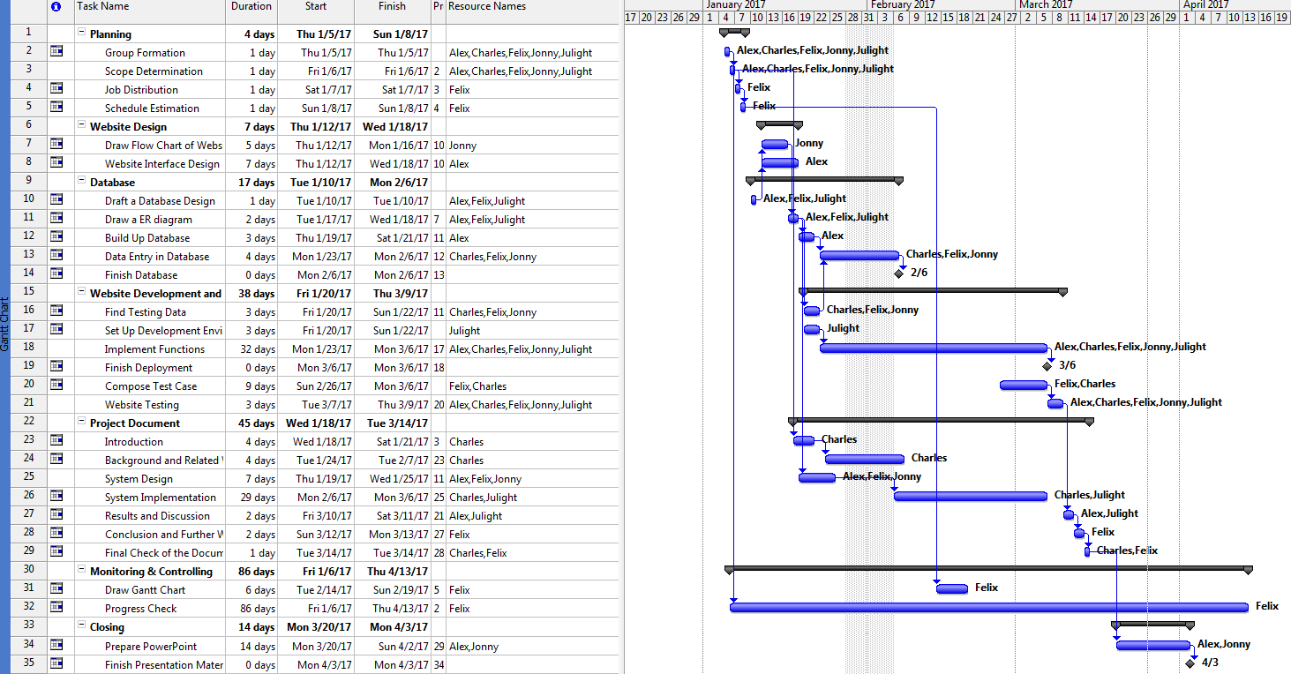

**Appendix B. Peer Assessment Form**

|  |  |  |  |  |  |  |
| --- | --- | --- | --- | --- | --- | --- |
| S:\3rd ITC\2nd ITC\MPI_logos\MPI logo09_C349 CPE.tif  BSc. in Computing 2016/17  COMP321 Information System Implementation  Peer Assessment Form | | | | | | |
| Project number | A4 | | | | | |
| Team members | |  |  |  | | --- | --- | --- | |  | Student ID | Student name | | *1.* | *P-14-0477-4* | Felix, Wong Ka Wai | | *2.* | *P-14-0495-2* | Alex, Lei Sai Kit | | *3.* | *P-14-0479-3* | Jonny, Cheong Io Lon | | *4.* | *P-14-0857-6* | Julight, Zhong Jiachen | | 5. | *P-14-0855-7* | Charles, Yang Haodi | | | | | | |
| Contribution **(**Each row must total to 100%) | | | | | | |
|  | | Member 1 | Member 2 | Member 3 | Member 4 | Member 5 |
| 1. Project leadership | | % | % | % | % | % |
| 2. Data modeling | | % | % | % | % | % |
| 3. User interface design | | % | % | % | % | % |
| 4. Program development | | % | % | % | % | % |
| 5. Solving technical problems | | % | % | % | % | % |
| 6. Testing and sample data | | % | % | % | % | % |
| 7. Report writing | | % | % | % | % | % |
| 8. Preparing / giving presentation | | % | % | % | % | % |

By default, the eight items above have the same weight when calculating the overall contribution percentage. You are welcome to suggest different weight if you consider some aspects should carry more weight.

**Appendix C. Program source code / UML diagram, etc**

If you want to provide more detail as long program source code and UML diagram, and you don’t want to affect the readability of the main text, put them in this appendix. Make suitable reference in the main text.

This appendix is not compulsory.